During these strange and sometimes stressful times, it is natural that you might feel lonely, trapped or stuck in a rut.
There’s lots of evidence which shows that reading can help negative feelings become more positive, by developing empathy and improving relationships with other people.
Try out some of our reading activities to explore stories of survival, understand other people, and to explore the theme of hope.

Stories of survival
Read the survival stories of some of the people below by following the links.
Anne Frank | annefrank.org/en/anne-frank/who-was-anne-frank/ | Ada Blackjack | atlasobscura.com/articles/ada-blackjack-arctic-survivor | Frank Worsley | nzhistory.govt.nz/media/photo/frank-worsley

Fill in the table to help you reflect on the experiences of these people.
Name of survivor | What did they ‘survive’? | How did they survive | What happened after their ordeal?
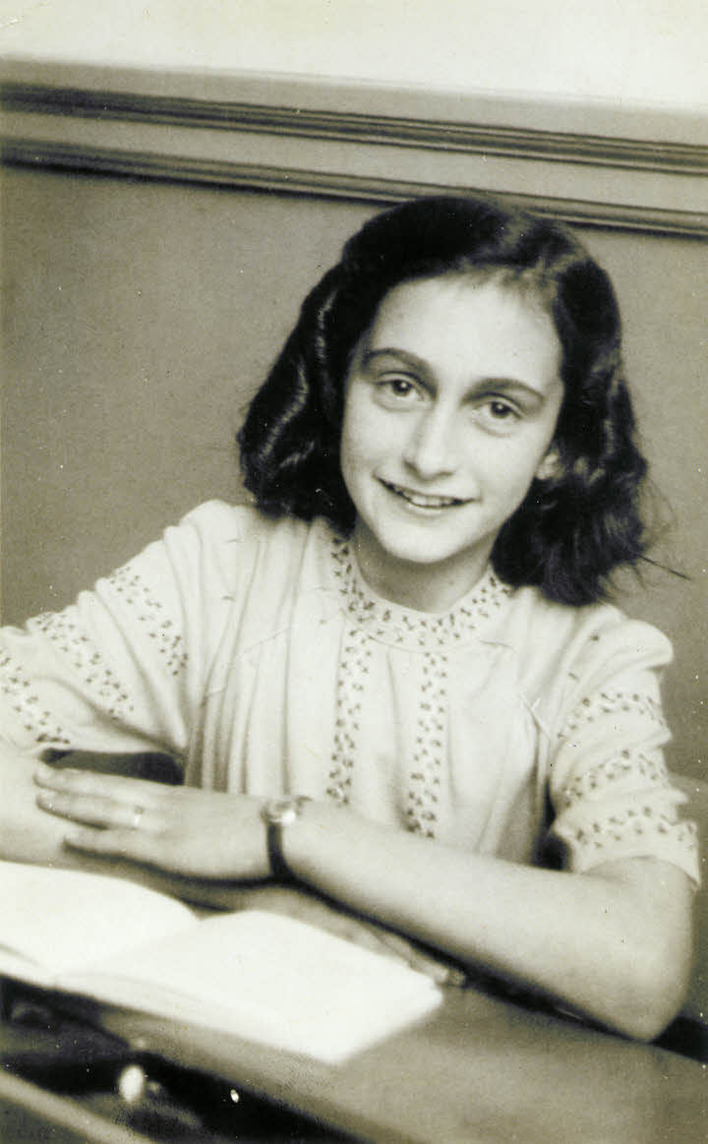  Anne Frank |  | Look at the sections titled ‘Anne has to go into hiding in the Secret Annex’ and ‘Anne keeps a diary’. | Look at the section titled ‘Anne’s diary becomes world famous’.
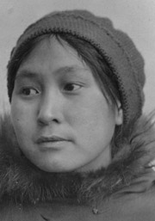  Ada Blackjack |  | Scroll down to the paragraph beginning ‘For six months, Blackjack was alone with Knight.’ | Scroll down and read the last two paragraph which begin ‘On August 20, 1923, almost two years after first landing on Wrangel Island, the schooner Donaldson crested the horizon.’
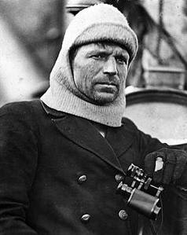  Frank Worsley |  | Read for three paragraphs from ‘Worsley faced some difficulties …’ | Scroll down and read the last two paragraphs which begin ‘Worsley joined Shackleton again in 1921 …’
Now sum up your ‘survival’ story so far. Use the bullet points below to help you.
- What has been difficult about lockdown so far? | - What has helped you overcome the challenge(s)?
- What, for you, has been the biggest challenge? | - How does your experience compare with one or more of the ‘survivors’ you’ve researched?

Survival story in focus: Anne Frank
Below are some questions based on Anne Frank’s diary, in which she recorded her experiences in hiding from Nazi occupation in Amsterdam.
An English translation of Anne’s diary is available here:
archive.org/stream/AnneFrankTheDiaryOfAYoungGirl_201606/Anne-Frank-The-Diary-Of-A-Young-Girl_djvu.txt

Read an extract of the diary and answer the questions which follow.
Find Anne’s entry from Saturday, July 11, 1942, when the Frank family had only just gone into hiding. Read from:
‘Father, Mother and Margot still can't get used to the chiming of the Westertoren clock, which tells us the time every quarter of an hour,’ to ‘That, of course, is a fairly dismal prospect.’

- What did Anne feel about the clock?

- What does Anne say about living in hiding? Look at how she describes the Annex (the part of the house in which she is hiding).

- Look at the paragraph which begins ‘Up to now, our bedroom …’
What has Anne’s father done to her bedroom and how does she feel about it now?

- Read the two paragraphs which begin ‘Last night the four of us went down …’ and ‘The building on our right.’ What scares Anne and what does the family do to try to stop this happening?

- In the paragraph which begins ‘Mr. Kleiman’ Anne describes some of the ways she can avoid boredom. What are these?

- The comment added by Anne in 1942 is a grim reminder of Anne’s fears. What does she describe as ‘a fairly dismal prospect’ and does this seem like ‘a fairly dismal prospect’? Why or why not?

- Anne describes her experience of being in hiding in detail. Fill in the table below to summarise her experience, and compare it with your experience of being in ‘lockdown’ so far. One example has been filled in for you.

 | Anne | You
Living arrangements | In an Annex which she describes as ‘ideal’ and ‘comfortable’. She focuses on the positives.
Things to do
Things which are unsettling
Things to look forward to

Joe Wicks: exercising to feel good
You might have been doing some of Joe Wicks’ workouts while you’ve been in lockdown, but you might not know that he overcame his own difficulties during childhood. If you’ve heard him talking about exercise, you’ll know how passionate he is about sharing its power for lifting our mood and boosting our wellbeing.

Read the article below to find out more about his story: | happiful.com/joe-wicks-on-fatherhood-and-finding-balance/

Answer the questions below to consider how Joe Wicks has built himself a happy and healthy life.
- Joe Wicks overcame some challenges to get where he is now. He says his ‘dysfunctional childhood’ was like any other. What do we learn about his childhood in the first paragraph?

- The second paragraph describes Joe’s rise to success. What imagery is used by the writer to show that this happened quickly?
The word is used.

- The article goes on to explore Joe’s dad’s addiction to drugs. What did Joe learn from his dad?

- In the paragraph just before the photo of Joe, it describes what Joe is like. Write a summary of what he is like.

Reflect
Do you find Joe Wicks’ story motivational?
What have you done to motivate yourself during lockdown?
‘Murkaster’: comparing this town with your home
Read the short story, ‘Murkaster’ by Frank Cottrell-Boyce on pp.12-15 of The Book of Hopes, then answer the questions below.

- Describe Murkaster in your own words, using the information from the story.

- Are you living in a place like Murkaster right now? Why or why not?

- Draw an image or a mind map of either the town or Sunny Hotspur, or both.

- What is the ‘glimpse of yellow’?

- Does the elephants trumpeting together remind you of anything during lockdown?

- What does Cottrell Boyce mean by ‘the city Sunny had lived in but never till that moment seen’? | 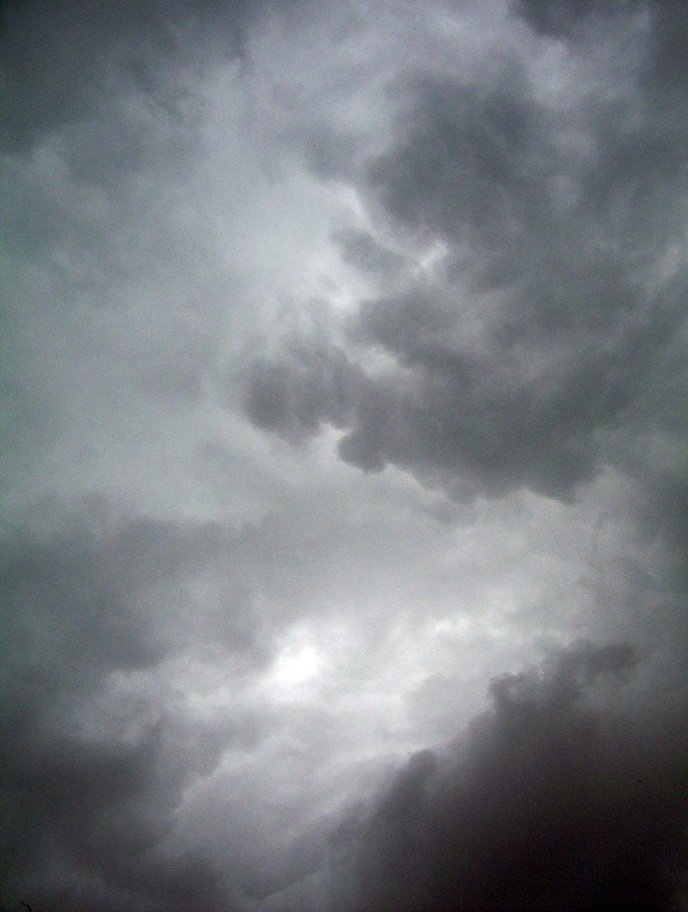
- Have you seen anything new where you live during lockdown?

Poems to help you feel hopeful
The following activities look at three poems from The Book of Hopes. They are:
- ‘Say Something Nice’ by A.F. Harrold (pp.36–38)
- ‘The Store Full of Magical Things’ by Rutendo Tavengerwei (pp.317–318)
- ‘Hope: or, Learning the Language of Birds’ (pp.76–78).

Say Something Nice
Once you have read the poem, use it as a model for your own poem. Replace all the words in italics with other nice things you could say to the people you know. Write out your new version of the poem.

Now go and say something nice to someone you know!

You could send a message, have a phone or videocall, speak to someone you live with or even write a letter or write out your poem and post it to someone.

The Store Full of Magical Things
Read the poem and use it as a model for your own ‘store of magical things’. Replace both the shopkeeper and the items in the store with your own ideas.

Plan your ideas here:
The shopkeeper

What is in the store?

Write your poem
You could change the structure or form of the poem if you’d like to. Alternatively, use the form used by the poet by following the prompts below.

Write your poem by starting with ‘I met …’ and describe the shopkeeper. | Go on to list the magical things: ‘There is …’

Hope: or, Learning the Language of Birds
Read the poem and then answer the following questions about its ideas and its language.
- In the first stanza, there is some personification in this poem. It is then repeated near the end of the poem. Personification is when something which is not human (often nature) is described as moving or behaving in human ways.
Find this example and explain how it helps to bring the ideas alive.

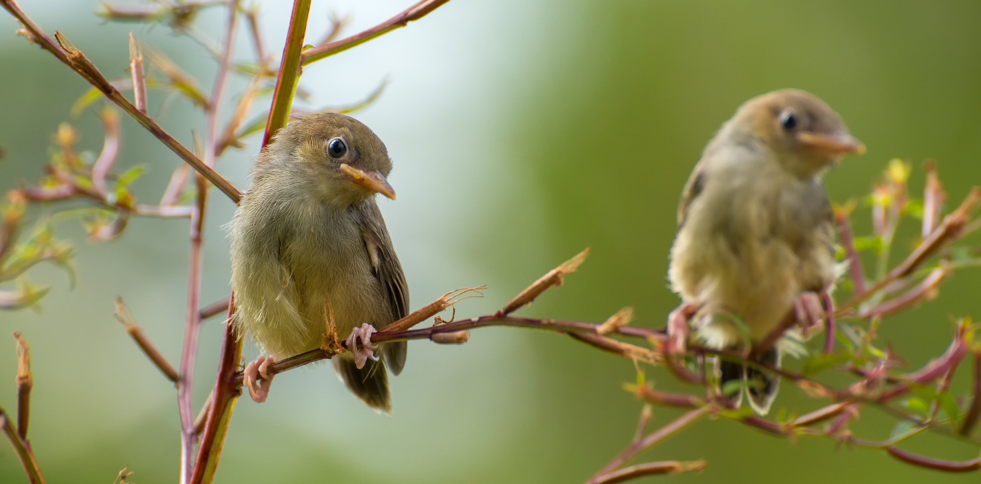

- In the first stanza, single words are used for effect. Find these words and explain what effect they have when you read the poem.

- There is a lot of sensory imagery used in the poem. Put the examples in the table below, using the poem to help you.
‘Planes absent from the sky’ | The sun
‘Cars silent in the streets’ | Stars glowed brighter
Birdsong | The turning of the earth
The silence / just before dawn | The turning of the world

Sights | Sounds | Textures | Things that are noticed because they are not there

- Near the end of the poem there is a line describing the birdsong as ‘a wave of song in an ocean of sky’. What poetic technique is this an example of? How does it work? Do you like it?

- Does this moment in time feel like a ‘time of the great quiet’ to you? What sounds will you associate with your lockdown? What images of hope will you associate with this time?

Independent reading
Stories of survival
While you’re at home, you may want to dip in to some new books. Why not find the autobiographies written about some of the survivors you’ve read about earlier or by someone else whose life story interests you? Alternatively, read some more stories, poems and essays from The Book of Hopes.
Reading for pleasure can help to improve your empathy skills and boost your mood, so find something which is of interest to you!

New ways to enjoy reading
You can also find ways to enjoy books which help you to ‘escape’ this strange new reality. Why not try some of the ideas below to experience books in new ways
- Swap some of your books with friends – taking care to do so safely. Add mini-reviews on sticky notes to share your thoughts and tips.

- Try out some ‘extreme’ reading. Challenge your friends to share photos of themselves reading in unusual places!

- Give a reading challenge a go. Try some of these:
teachitenglish.co.uk/resources/ks3/independent-reading/reading/the-great-reading-race/12842
teachitenglish.co.uk/resources/ks3/independent-reading/reading/fiction-activities/12902

- Listen to audiobooks.

- Watch some ‘author live’ events (you can catch up later instead if you miss these). Listen carefully to the author’s expression and evaluate how they make their books sound funny, serious, scary or how they have created suspense.

- Read ‘around’ your GCSE English Literature texts – find books by the same author, books written at the same time, influential books or take time to re-read your class text.

- Keep a record of books, articles and magazines you read during ‘lockdown’ which have helped you. Share these with your friends.

Answers
Stories of survival
Name of survivor | What did they ‘survive’? | How did they survive? | What happened after their ordeal?
Anne Frank | The Nazi occupation in hiding for two years. Sadly, she was then sent to a concentration camp where she died. | She wrote a diary to help her understand her thoughts and feelings. She was often afraid when she was in hiding. | Her story has lived on. Otto, her father, hoped it would live on as a warning of the dangers of discrimination, racism, and hatred of Jews.
Ada Blackjack | An Arctic expedition. | She had many survival skills: doctor, nurse, companion, servant, huntswoman and woodsman. She set traps to lure foxes, taught herself to shoot birds, built a platform above her shelter so that she could spot polar bears in the distance, and crafted a skin boat. | Ada was reunited with her son, Bennett. Sadly, he was plagued by poor health. She went on to have another son, and later moved to Alaska.
Frank Worsley | He was captain of the Endurance during Sir Ernest Shackleton's Imperial Trans-Antarctic Expedition which was crushed by ice floes. He saved the team. | He led the team in ramming ice floes, helped the scientists, took sightings, went on marches and used his navigation skills to rescue the team. | Worsley wrote and lectured on his Antarctic adventures for many years to come.

Survival story in focus: Anne Frank
- What did Anne feel about the clock?
She finds it reassuring, unlike the rest of her family.

- What does Anne say about living in hiding? Look at how she describes the Annex (the part of the house in which she is hiding).
She doesn’t yet fully know, but she doesn’t hate it. She describes it as feeling like being on holiday. She says that it’s an ideal and comfortable hiding place; she accepts that it’s damp and lopsided but seems to see the positives in her situation.

- Look at the paragraph which begins ‘Up to now, our bedroom …’
What has Anne’s father done to her bedroom and how does she feel about it now?
He has covered the walls with her postcards and pictures, and she thinks it is more cheerful now.

- Read the two paragraphs which begin ‘Last night the four of us went down …’ and ‘The building on our right.’ What scares Anne and what does the family do to try to stop this happening?
Anne is scared that someone will hear them. She was scared that they would hear the sound of the radio, she is careful to not make a sound so that factory workers might hear them, and Margot has been told to not cough at night.

- In the paragraph which begins ‘My. Kleiman’ Anne describes some of the ways she can avoid boredom. What are these?
Canning fruit, reading, and she’s looking forward to playing games.

- The comment added by Anne in 1942 is a grim reminder of Anne’s fears. What does she describe as ‘a fairly dismal prospect’ and does this seem like ‘a fairly dismal prospect? Why or why not?
She is terrified of being shot. This is an understatement, and Anne’s choice of words demonstrates her defiant sense of optimism.

- Anne describes her experience of being in hiding in detail. Fill in the table below to summarise her experience, and compare it with your experience of being in ‘lockdown’ so far.
 | Anne | You
Living arrangements | In an Annex which she describes as ‘ideal’ and ‘comfortable’. She focuses on the positives.
Things to do | Cook, listen to the radio in the office, can fruit, read.
Things which are unsettling | The silence, making a noise which neighbours could hear, not being able to go outside, the fear of being shot.
Things to look forward to | Playing games, making bookshelves, the arrival of the van Daans.

Joe Wicks: exercising to feel good

  - He grew up on a council estate with a roof over his head and food to eat.
  - He went on school trips.
  - His dad was in and out of rehab.

‘catapulted’
- To not make the same mistakes as him. He has avoided drugs his whole life.
- He has a ‘bright-side mentality’ and is sincere.
He has a caring nature.
He is sporty and exercises to feel good.

‘Murkaster’: comparing this town with your home
- It’s a town shrouded by clouds, which means it isn’t on a map. It is forgotten by the world, and lives in isolation from the world. People can only go out in it using a mask and snorkel – these are quite funny images, but the reality is bleak.

- You might liken the ‘grey’ of the town to not existing in a busy, colourful world at the moment, and instead feeling separate from the world outside. You might also compare the ‘masks and snorkels’ to wearing face masks or having to wash your hands.

- You should have used some of the details from the story, such as Sunny’s hairstyle (high and curly, like a cloud) or the town as grey with the ‘eye’ peering through the gloom. Or perhaps you drew the town after Sunny had been lifted by the elephant? That would be a much more colourful picture!

- We probably interpret it as the sun, but it could metaphorically resemble hope.

- Perhaps it makes you think of the clapping on Thursdays, or Italians singing from their balconies, or birdsong.

- Sunny feels connected to her town when she notices the details, especially once she feels the power of the elephants’ sense of community and optimism.

Poems to help you feel hopeful
- ‘the earth was holding her breath’
This is a central image which helps connect the earth with the people to describe time standing still. The idea of the earth holding its breath makes it sound like it’s waiting for something, and there’s a sense of anticipation (or possibly dread).

- They reinforce the sense of anticipation and the short lines help to support the idea of being in suspense, waiting for something to happen.

Sights | Sounds | Textures | Things that are noticed because they are not there
Stars glowed brighter | ‘Cars silent in the streets’ | The sun | ‘Planes absent from the sky’
 | Birdsong | The turning of the earth | The silence / just before dawn
 | The turning of the world

- It’s a metaphor which helps to bring alive the sense of the ‘birdsong’ being just a small part of a larger whole (a moving wave in a larger, more still ocean), which makes it seem like the small ‘wave’ of song can stir up the whole ‘ocean’ of movement. It’s a very natural image, so you might like it!

- You might also feel like the sounds of nature have been really vivid, or perhaps you live near a road and instead the cars have been driving faster while there are fewer cars on the road? Or perhaps it is very still and quiet for you – is it in a comforting or in an eerie sense?

- The images of hope you might have experienced could include the clapping on Thursday evenings, the rainbows in windows, small acts of kindness you’ve either given or received, sending cards to Captain Tom Moore, letters from friends or relatives, or perhaps it’s something else. If you haven’t felt the quiet of nature yet, why don’t you step outside now and listen to the birds or the rain or watch the leaves, or drips or puddles form?

