AQA GCSE
French (9-1)

Foundation Tier Paper 3 Reading
PRACTICE PAPER
F
1

Instructions
- Answer all questions.
- Answer the questions in the spaces provided.
Time allowed: 45 minutes

- In Section A, answer the questions in English. In Section B, answer the questions in French.
In Section C, translate the passage into English.
- Cross through any work you do not want to be marked.

Information
- The marks for the questions are shown in brackets.
- The maximum mark for this paper is 60.
- You must not use a dictionary.

Name:

Please note: The Practice Paper questions and answers have not been written or approved by AQA.

Section A Questions and answers in English

Marriage
1
0
A French online magazine article on personal relationships asks for contributions from its readers. Choose a category for each comment.
Write the correct letter in each box.

A | Married
B | Not married

. [1 mark]
Je vis avec mon petit ami. On n’a pas l’intention de se marier.

Mes parents ont récemment fêté leurs vingt ans de mariage.

Quand j’avais dix ans, mes parents ont décidé de divorcer.

Nous sommes fiancés depuis six mois. On va se marier cet été.
1
0 | 1
0 | 1
0 | 1
0 | 1

. [1 mark]
2

. [1 mark]
3

. [1 mark]
4

Family relationships
2
0
A Belgian teen magazine has looked into how well teenagers get on with their parents. Read this summary of its findings.

62% disent qu’ils s’entendent bien avec leurs parents. 38% trouvent que leur père est trop sévère.
72% n’ont pas le droit de sortir le soir.
31% se disputent toutes les semaines avec leurs parents.
46% s’entendent bien avec un de leurs parents mais pas avec l’autre.
What percentage of teenagers report doing the following? Complete the boxes.

. Having to stay in at night
1
2
0

. Having a good relationship with only one of their parents
2
2
0

. Finding one of their parents too strict
3
2
0

. Arguing with their parents on a weekly basis
4
2
0

[1 mark]

[1 mark]

[1 mark]

[1 mark]

Holidays
3
0
Read this extract from a holiday brochure about the town of Orange. Which three
statements below are true according to the extract? Write the correct letters in the boxes.
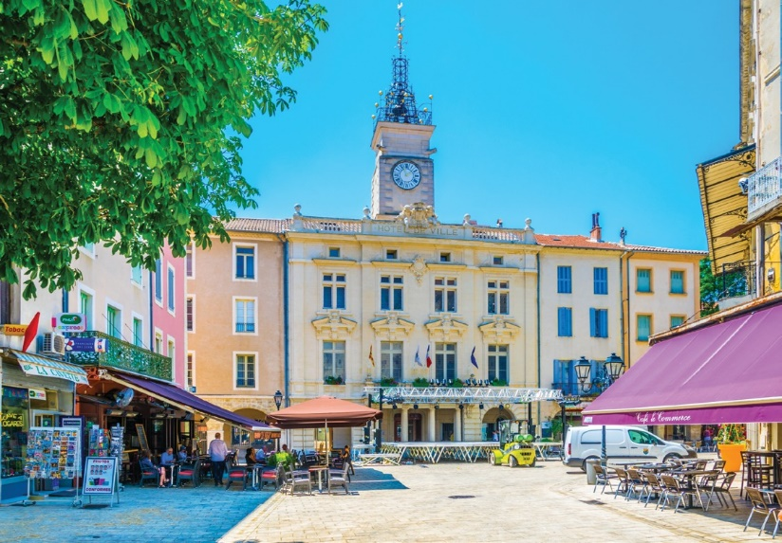

Orange – une destination de vacances de choix

Ville de taille moyenne avec son Arc de Triomphe et son Théâtre Antique romains.
Des hôtels bon marché mais aussi à quatre étoiles.
Des restaurants qui permettent de goûter la cuisine de nombreux pays. Notre marché provençal le jeudi matin.
Des magasins pour tous les goûts.
Un climat doux, presque toute l’année. Des vacances relaxantes garanties.

A | There is a Roman museum in Orange.
B | There is a great variety of hotels.
C | Orange is known for its international restaurants.
D | The weather is usually nice.
E | There aren’t many specialist shops.
F | Market day is on Wednesday.

[3 marks]

Letter of application for a job
4
0
Your French friend is applying for a job. Read her letter of application, then choose the correct answer to complete each sentence and write the letter in the box.
J’ai vu votre annonce dans le journal pour le poste de secrétaire à temps partiel.

J’ai dix-sept ans et j’ai quitté le collège l’été dernier. Je me sers tous les jours de mon ordinateur portable et je suis capable de taper sans difficulté des lettres formelles et informelles.

Au collège, pour mon expérience de travail, on m’a envoyé dans un grand magasin. J’y ai appris, en particulier, l’importance du travail d’équipe.

Je suis honnête et travailleuse. Je suis contente quand un travail est bien fait.

En espérant recevoir une invitation à un entretien d’embauche, je vous prie d’agréer, Monsieur/Madame, l’expression de mes sentiments distingués.

Joëlle Roche
le 8 novembre
Monsieur/Madame,
Joëlle Roche 3, rue de la République 84160 CAMARET

. Joëlle is applying for …
1
4
0

A | a full-time job.
B | a part-time job.
C | an editing job.

. She …
2
4
0

A | is still at school.
B | is sixteen years old.
C | left school last summer.

[1 mark]

[1 mark]

 Continued

Answer the following questions in English.

. What skill relevant to the job is she able to offer?
3
4
0

[1 mark]
. What did she learn from her work experience?
4
4
0

[1 mark]
. Name two of her personal qualities.
5
4
0

[2 marks]

Recycling
5
0
You are staying in a holiday home in northern France with your family.
Read this extract from a leaflet about recycling, issued to all homes by the local council.
Centre de recyclage – ouvert tous les jours

Ramassage des ordures ménagères – le lundi Ramassage des poubelles de recyclage – le mercredi Ramassage des déchets de jardin – le vendredi

Faites un don de vos vieux vêtements à l’association caritative ‘Mode et vie’. Donnez les livres que vous avez déjà lus à la bibliothèque. Merci.

 |  | Write down the correct day of the week when these services are provided.
0 | 5 | . 1 Collection of bins with items to be recycled
 |  | [1 mark]
0 | 5 | . 2 Collection of bins that contain garden waste
 |  | [1 mark]
0 | 5 | . 3 Collection of bins that contain non-recyclable items

[1 mark]
Answer the following questions in English.

. What two items that you no longer want or need are you encouraged to donate?
4
5
0

[2 marks]
. Who or what will those items be given to? (two answers)
5
5
0

[2 marks]

A visit
6
0
Read this extract taken from the novel Manon des sources by Marcel Pagnol and answer the questions which follow in English.
Quand j’étais jeune (mon père était paysan comme vous dans un petit hameau près de Sisteron), nous avions un cousin qui s’appelait Adolphin. Il habitait un autre village pas très éloigné du nôtre, et pourtant, il ne venait jamais nous voir, ni pour les fêtes, ni pour les naissances, pas même pour les morts. Mais de temps en temps (à peu près une fois par an), j’entendais mon père qui disait: Tiens, voilà l’Adolphin qui s’amène*! Il doit avoir besoin de quelque chose!
* s’amène = arrives

. In what way is Adolphin related to the narrator?
1
6
0

[1 mark]
. What did the writer find surprising about Adophin’s attitude?
2
6
0

[1 mark]
. How often did Adolphin visit the narrator?
3
6
0

[1 mark]
. How did the father of the narrator explain the reason for the visit?
4
6
0

[1 mark]

Holiday accommodation
7
0
The parents of your French friend would like to rent a holiday home on the coast. Read the reviews they found on the internet.
For a positive review, write P. For a negative review, write N.
For a positive and a negative review, write P+N.

.
1
Le gîte n’est pas mal du tout. Le jardin est magnifique.

La piscine est super mais le gîte est trop petit pour six personnes.

C’est trop loin de la ville. On se sent un peu isolés.

Ça m’a beaucoup plu. On y retournera.
7
0
[1 mark]

.
2
7
0
[1 mark]

. [1 mark]
3
7
0
. [1 mark]
4
7
0

School rules
8
0
On an exchange visit to France, you go to school with your French friend. Read these school rules (A to F) and link them to the topics listed below.
Find a rule for each topic and write the correct letter in the box.

A | Il est interdit de fumer.
B | On doit arriver au collège à l’heure.
C | Il est essentiel de faire ses devoirs.
D | On ne doit pas utiliser son portable en classe.
E | Il ne faut pas se maquiller ni porter de bijoux.
F | On ne doit pas manger en classe.

. Punctuality [1 mark]
1
8
0

. The use of mobile phones in lessons [1 mark]
2
8
0

. Wearing make-up [1 mark]
3
8
0

Section B Questions and answers in French

Les inégalités sociales
9
0
Quelles sont les solutions à ces problèmes? Ecrivez la bonne lettre dans chaque case.
Les solutions
A | Construire plus de logements
B | Créer plus d’emplois
C | Réduire l’utilisation du plastique
D | Combattre la discrimination raciale
E | A travail égal, salaire égal

Les problèmes

. Les femmes sont moins bien payées que les hommes. [1 mark]
1
9
0

. La vie est vraiment difficile quand on est SDF. [1 mark]
2
9
0

. Il y a trop de chômage. [1 mark]
3
9
0

La technologie
0
1
Lisez ces commentaires en ligne sur une tablette.
Dans chaque case, écrivez P si l’opinion donnée est positive, N si elle est négative
ou P+N si elle est à la fois positive et négative.

. 1
Lent mais pratique.

Prix élevé. Dommage, parce que c’est un bon ordinateur portable.

Rapide, bien pour l’école.

Pour le prix, cette tablette pourrait être mieux.
0
1
[1 mark]
. 2
0
1
[1 mark]
. [1 mark]
3
0
1
.
4
0
1
[1 mark]

Le temps libre
1
1
Max vous envoie un email. Lisez son email et répondez aux questions en français.
Salut,
Ça va? Tu m’as demandé de te parler de ce que je fais après l’école ou pendant les vacances.
Eh bien, la natation est mon activité préférée. J’aime aussi faire du patin à glace.
A part le sport, j’aime bien sûr passer du temps avec mes copains. On va souvent voir un film ensemble. S’il fait beau, j’aime bronzer sur la plage avec mon frère.
Et toi, qu’est-ce que tu aimes faire quand tu as du temps libre? À bientôt,
Max
From: Subject:
email.address@email.com

. Quel est le sport préféré de Max?
1
1
1

[1 mark]
. A part le sport, qu’est-ce qu’il fait avec ses copains pendant son temps libre?
2
1
1

[1 mark]
. Quand il y a du soleil, que fait-il?
3
1
1

[1 mark]

Au restaurant
2
1
Vous allez au restaurant pendant vos vacances en France. Lisez le menu.
Notre menu à 25 euros
~ Hors d’œuvres ~ Pâté de foie d’agneau Soupe de légumes Pâté de crabe

~ Plats principaux ~ Steak au poivre Saumon en croûte Lasagne aux épinards Moules marinières

Légumes au choix (frites, petits pois, carottes, courgettes)

~ Fromages et desserts ~ Plateau de fromages Crème glacée
Gâteau au chocolat Fruits (au choix)

Service compris
Ecrivez vos réponses en français.
Identifiez …

. un hors-d’œuvre pour un végétarien.
1
2
1

[1 mark]
. un plat principal pour quelqu’un qui veut manger des fruits de mer.
2
2
1

[1 mark]
. un dessert pour quelqu’un qui n’aime pas les choses sucrées.
3
2
1

[1 mark]

Le bénévolat
3
1
Lisez cet appel aux bénévoles issu par Les restos du cœur.
Les restos du cœur
Appel aux volontaires

Nous avons besoin de bénévoles, libres entre midi et 14 heures, pour servir des repas chauds aux personnes démunies de notre ville.

Nous recherchons aussi une autre personne capable de préparer ces repas. Cette personne doit être libre de 9 heures à midi.

Enfin, nous espérons trouver quelqu’un pour nous aider à faire la vaisselle entre 14 et 16 heures.

Aider les autres, c’est notre plaisir! Contactez-nous en ligne.
Lisez ces réponses à l’appel. Choisissez les trois personnes que Les restos du cœur vont choisir et écrivez les lettres dans les cases.

A | Je fais souvent la cuisine chez moi. Je suis libre le matin.
B | Je suis libre jusqu’à 10 heures du matin si ça vous intéresse.
C | Je veux bien aider après 14 heures mais pas pour faire la vaisselle.
D | Je suis disponible après 16 heures.
E | J’ai déjà travaillé à la cantine d’un collège. J’ai l’habitude de servir le déjeuner.
F | Je peux vous aider le soir si vous voulez.
G | Moi, je suis volontaire pour la vaisselle et je peux être disponible l’après-midi.
H | Ce que je peux vous offrir, c’est de préparer les repas du soir.

[3 marks]

Section C Translation into English

Your brother’s French friend has shared this post on Facebook. Help your brother by translating it into English for him.
4
1
Selon mes parents, je dois continuer mes études. Moi, je n’ai pas encore décidé. J’espère devenir mécanicien. C’est un métier passionnant. Pour mon stage en entreprise, le mois prochain, je travaillerai dans un garage près de chez moi.

[9 marks]

END OF QUESTIONS

References
Q6. Extract from Manon des sources, Marcel Pagnol

