What is an ecosystem?

1. Define ‘ecosystem’:

Example:

2. Define ‘Biome’:

Example:

3. Food chains and food webs:

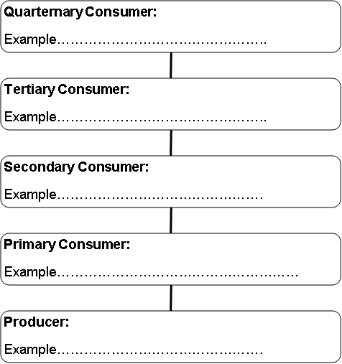

4. Match the key words to the definitions – use a ruler:

Ecosystem | Organisms that consume dead animals or plants
Biome | A diagram that shows all the linkages between producers and consumers in an ecosystem.
Producers | The recycling of nutrients between living organisms and the environment. There are nutrient stores in Biomass, Litter and Soil
Consumers | Organisms such as bacteria that break down plant and animal material
Food chain | The living and non-living components of an environment and the interrelationships that exist between them
Food web | Organisms that obtain their energy from a primary source such as the sun
Scavengers | Organisms that obtain their energy by eating other organisms
Decomposers | A line of linkages between producers and consumers
Nutrient cycling | Global scale ecosystem eg TRF or Desert

5. Outline how biotic factors and abiotic factors are inter-linked:

…………………………………………………………………………………………………………………………………………………………….…………………………………………………………………………………………………………………………………………………………….…………………………………………………………………………………………………………………………………………………………….…………………………………………………………………………………………………………………………………………………………….……………………………………………………………………………………………………………………………………………………………….

