Geog your memory...
Define these three key terms:  HDI –  Development Gap –  Top down aid –  Bottom’s up aid - | What are the characteristics of these ecosystems:  Tundra Grassland T Deciduous Forest  Tropical Rainforest Polar Hot Desert

Colour code the physical and human causes of climate change.  - Orbital changes (the way the earth moves around the sun).  - Solar output (the amount of energy from the sun).  - Burning fossil fuels – releasing CO₂ into the atmosphere.  - Volcanic eruptions can cause short-term changes to climate.  - Deforestation – cutting down trees. | Label this diagram showing a destructive plate margin.  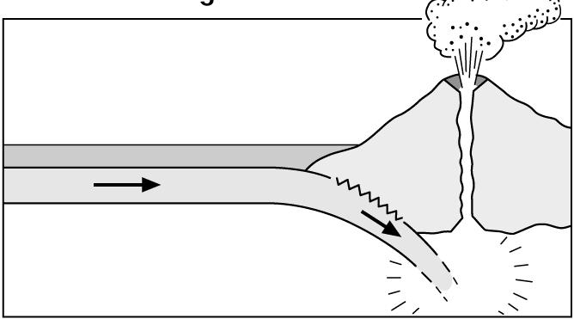

Case Study – Deforestation in Amazon Rainforest
Colour code the boxes to show causes, impacts and management.
Location: __________________________________________________________________________________ _____________________________________________________________________________________________

65% of deforestation was due to cattle ranching – farmers moving animals around to use the land for food and grazing. | Deforestation will release some of the carbon stored in the rainforest into the atmosphere contributing to global warming. | Replanting trees every time one is cut down. The Brazilian government ensure that it is the same type of tree that was cut down.
Mining industry creates lots of jobs for the people in Peru – the Buenaventura mining company employs over 3000 people. | Selective logging – where only some trees are cut down, these trees are also taken out of the rainforest via helicopter. | Landless farmers cut down the trees so they have land in order to farm, some farmers need more land as their current land is unusable.
Ecotourism is encouraged, only a small number of visitors are allowed at a time. | Farming is a huge industry in Brazil, in 2011 $6.9 billion was made through trading cattle. | 55 million tons of top soil is being lost because of soil erosion each year.
Logging contributes over £1 billion to the economy of Brazil every year. | Population growth has meant that people are building houses in the rainforest as there is little land in cities. | International hardwood agreement has reduced illegal logging and promoted sustainable management.
Exam Question: For a tropical rainforest you have studied, assess the extent to which deforestation benefits the people who live there. (9 marks)

