Geog your memory...
Describe the formation of a tropical storm. Use these words to help you: Warm water, low pressure, warm air sucked upwards, pulling drier, cooler air, warm moist air, storm surge, strong winds. | 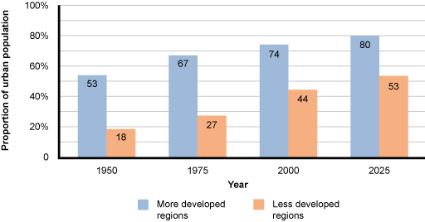  Describe the graph to show growth of urban areas.

Evidence for North-South divide – T or F? How could you edit the F ones to make them T – do it?  - Decline of industry has happened in south west.  - Health is generally worse in the north than the south.  - Houses are more expensive in the north than the south.  - Wages are lower in the north than the south.  - Transport connecting north and south is good. | Annotate this photograph to show characteristics of cold environments.  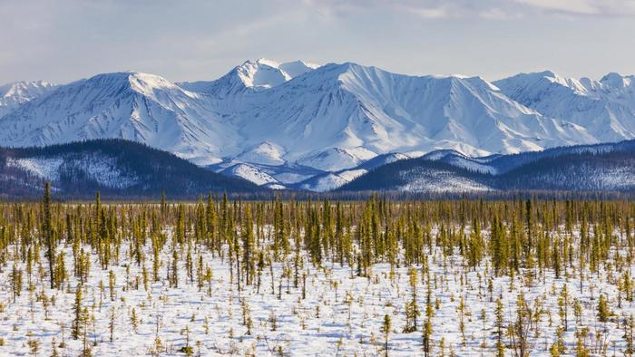

Case Study – Nepal Earthquake

Location: __________________________________________________________________________________
Date: ________________ Number of deaths: ________________ Richter scale: ________________

Primary effects | Secondary effects | Immediate responses | Long term responses
Exam Question: Evaluate the effectiveness of the immediate and long term responses to the earthquake in Nepal. ( 6 marks)

