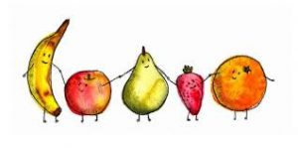
Geog your memory...
Explain how these management techniques can reduce the effects of hazards. Try and include an example. (2m each)  Prediction –  Planning –  Protection – | 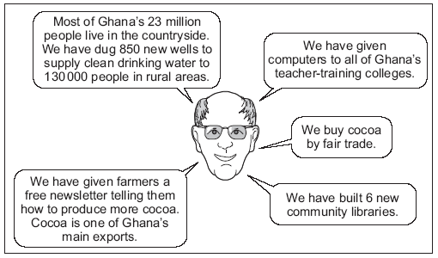  Cadbury has tried to help reduce the development gap between Ghana and the UK. Explain how these impacts will increase quality of life.  (3m)

What mitigation strategies do we have for climate change? (2m each)  Hydrogen buses  Afforestation  Carbon Capture  International Agreements | Complete the sentences to describe the location of biomes. (1m each)  - _____________________________ are found near the equator in Central and South America, parts of Africa and Asia.  - _______________________ are found in central Africa (Kenya, Zambia, Tanzania), northern Australia and central South America (Venezuela and Brazil).  - _______________________ surrounds the North and South poles, they have an extremely cold climate.

Case Study – Rio de Janeiro (10m)
Location: __________________________________________________________________________________ ____________________________________________________________________________________________

Challenges or solutions?

Unemployment rates in the favelas are over 20%. | In 2013 only 55% of the city had a local family health clinic. | In Rio, only half of children continue their education beyond the age of 14.
Guanabara Bay is highly polluted, over 200 tonnes of raw sewage pours in to the bay each day. | Overseas aid has been used to build 12 new sewage works and 5km of sewage pipes have been built to decrease pollution. | The authorities have tried to improve access to education by giving grants to help them afford the cost of schooling.
Drug trafficking and street crime are often controlled by powerful gangs. | Health clinics have been built within the favelas and are clearly signposted. | Pacifying police units (UPP’s) were established to reclaim favelas from drug dealers/gang leaders.
Exam Question: Using a named example of a city in a LIC or NEE, discuss the challenges created by urban growth. (9 marks)

