Name
Class
B
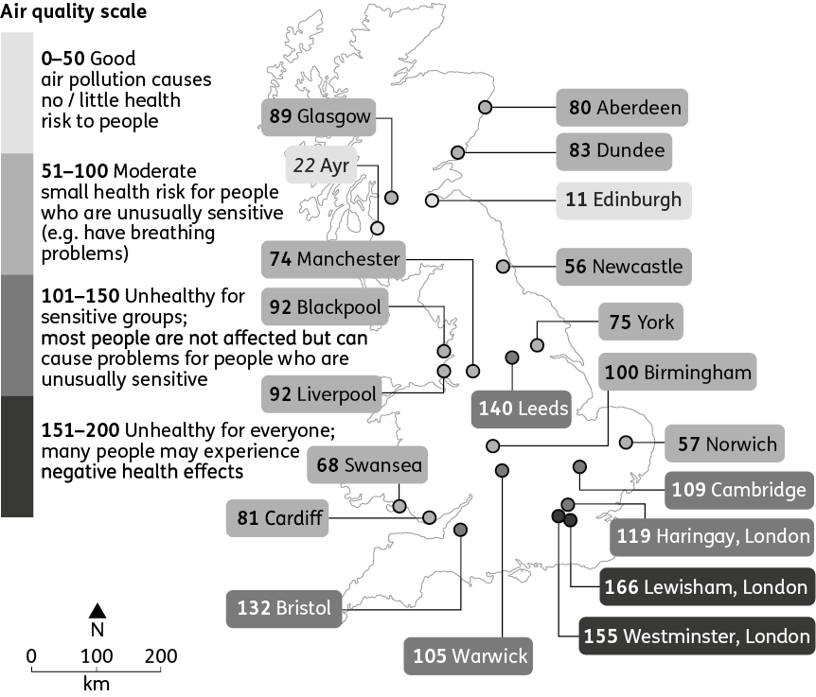
Air quality around Great Britain
1. Use map B to answer the following questions.
(a) Identify which part of Great Britain has the worst air quality. North or south?

(b) Identify which country within Great Britain has the most cities with good air quality.

(c) For each country (Scotland, Wales and England), write a sentence or two to describe its air quality.

The data refers to urban (built-up) areas, so make sure that you name key cities in your description. A good description would refer to a range of values – in this case from the least to most polluted cities in each country.

Tip!

C
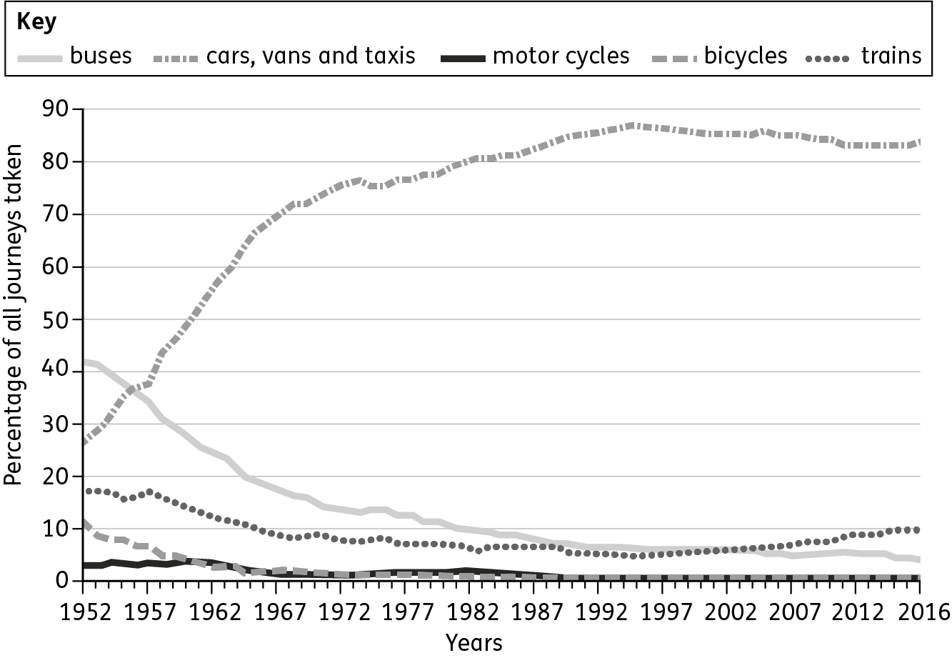
Changes in the way we travel, 1952–2016
2. Use chart C to fill in the blanks of this paragraph.
Since 1952 the amount of car use has while the use of buses, rail and
bicycles has and motorcycle use has .
3. Study the impacts of traffic congestion. Some of the negative impacts are listed below. Complete the table on the next page by putting each impact under the correct heading. Include any other negative impacts that you can think of!

- economic – about money, jobs, business and trade
- social – about society/community, family,
health and education
- environmental – about land/scenery, plants/animals, air and water

Tip!
Noise pollution
Air pollution causes 40,000 deaths a year
People could be doing other things
Increase in air pollution and carbon dioxide emissions
Air pollution increases the risk of lung or heart disease
Wasted fuel
Waste of drivers’ time
Air pollution causes coughs and difficulty breathing
People feel angry and frustrated
Most cars use petrol, which is finite
Air pollution triggers asthma attacks
Traffic blocks the routes of emergency services

Economic impacts | Social impacts | Environmental impacts
Wasted fuel costs | People feel angry | Increase in air pollution
Impacts of traffic congestion
4. Suggest the types of people who might be more at risk from the negative health impacts of air pollution.

5. State one advantage and one disadvantage of using electric cars.
Advantage:
Disadvantage:

Tip!

Are words always necessary? A good symbol should be instantly recognisable.
6. Look at photo I. Design a new sign for Birmingham’s planned clean air zone.
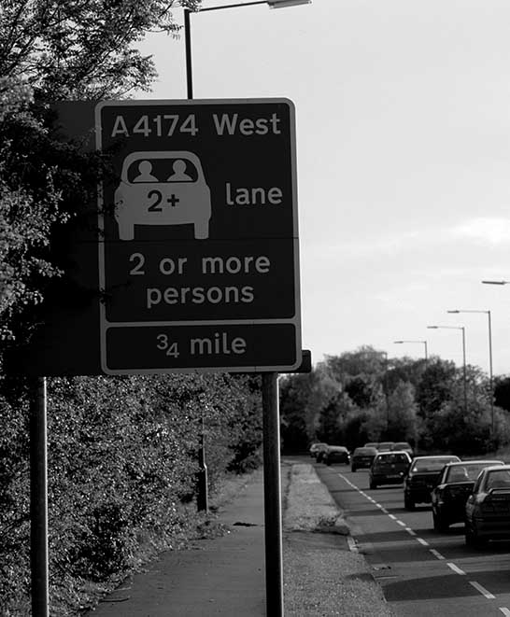
I

London’s congestion zone operates from
Monday to Friday
7. Look at chart E.
(a) In 2018, there were 38 million vehicles on the UK’s roads.
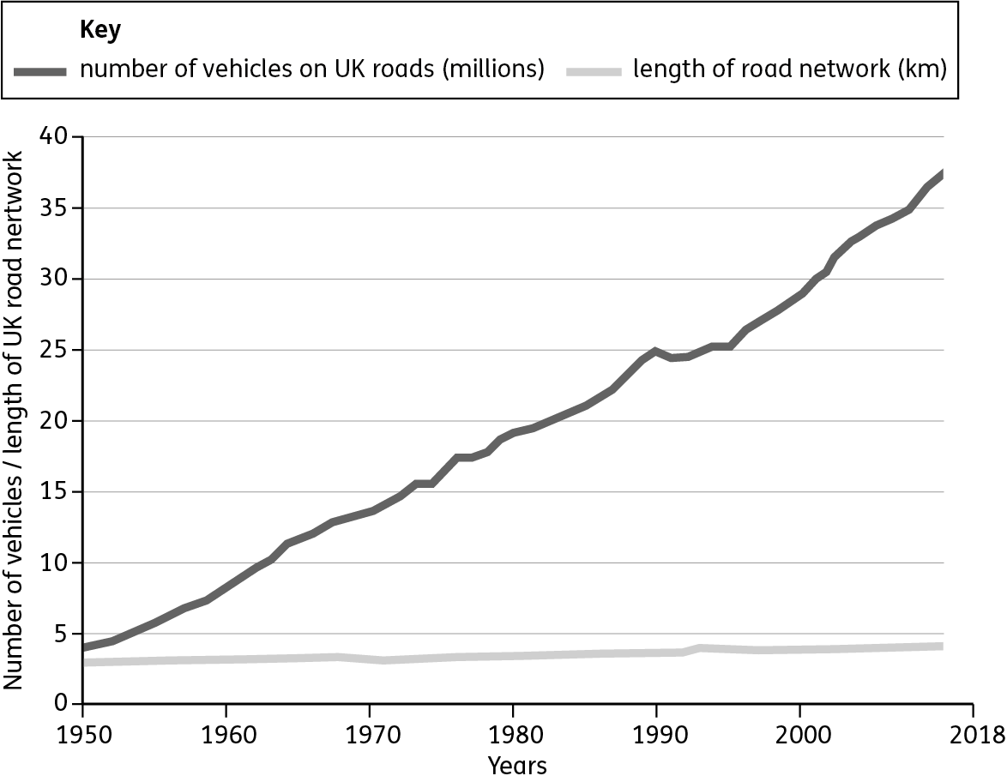
E
The number of cars on the road and the total length of roads in the UK
(b) Explain what evidence tells us there is a lot of traffic congestion on the UK’s roads. (Use data to back up your points)
The chart clearly shows

