Name
Class
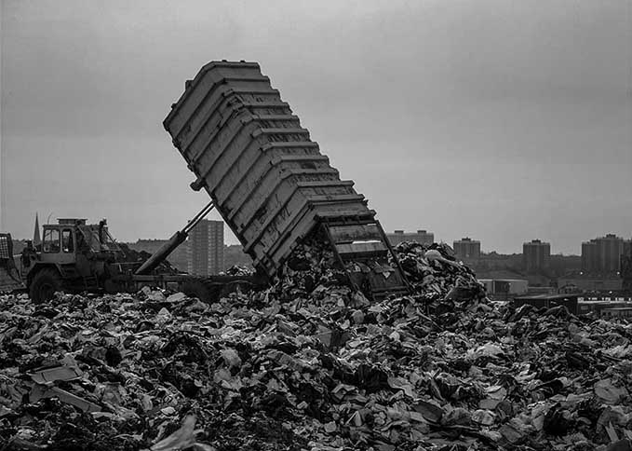
A

Landfill site in Northern Ireland
1. Write a new caption for photo A to describe the scene and explain what a landfill site is.

Captions must be kept short and describe the scene in as few words as possible.

Tip!

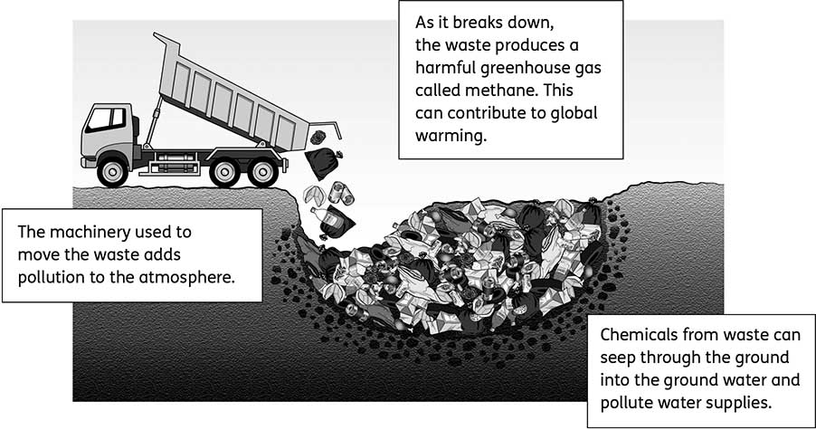
B
The problems of landfill
2. Look at diagram B. Outline (briefly describe and explain) each of the three problems, which you can see.

Look for the key words and idea behind the problem. Pollution can relate to air (gases, dust, etc.), water (chemicals, etc.), noise (loud and/or persistent) or visual elements (unsightly buildings, etc.).

Tip!

C
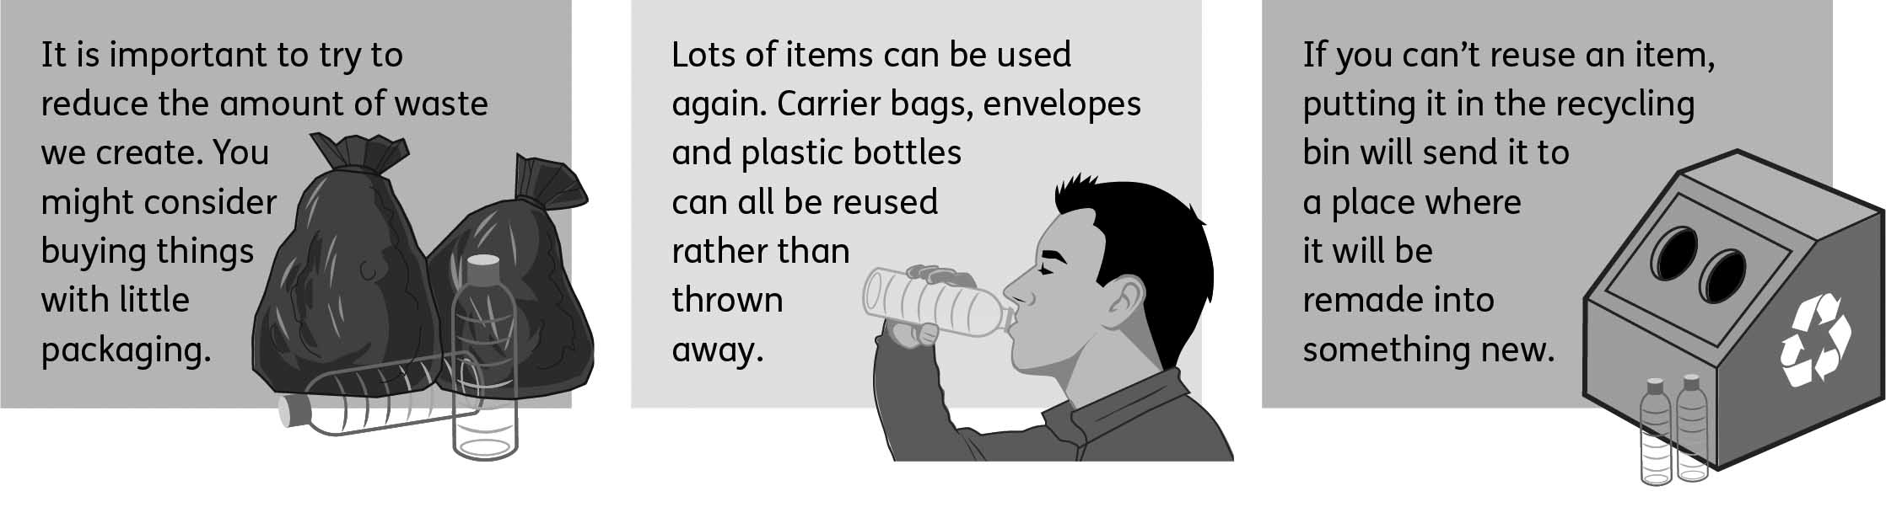
The three Rs
3. Look at artwork C. In pairs or small groups:
(a) Explain all three Rs in a single sentence.
‘Reduce, reuse, recycle’ is all about

(b) Suggest two more ways to reduce the amount of waste produced.

(c) Suggest two more things that can be reused again.

(d) Explain why all three Rs are needed to help reduce the amount of waste we produce.
All three Rs are needed for waste reduction because

4. Imagine the government has identified an area that will become a new landfill site. The site is next to your school field. Write a persuasive (strong and convincing) letter to the government to explain why you do not want the new landfill site next to your school field.

- noise
- pollution
- chemicals
- environmental impact

Hints
The proposed landfill site next to our school field is completely inappropriate for a number
of reasons. Firstly

5. Use the Internet to find examples of things made with recycled materials such as plastic, glass and rubber. Make a list. Did any things surprise you?

F
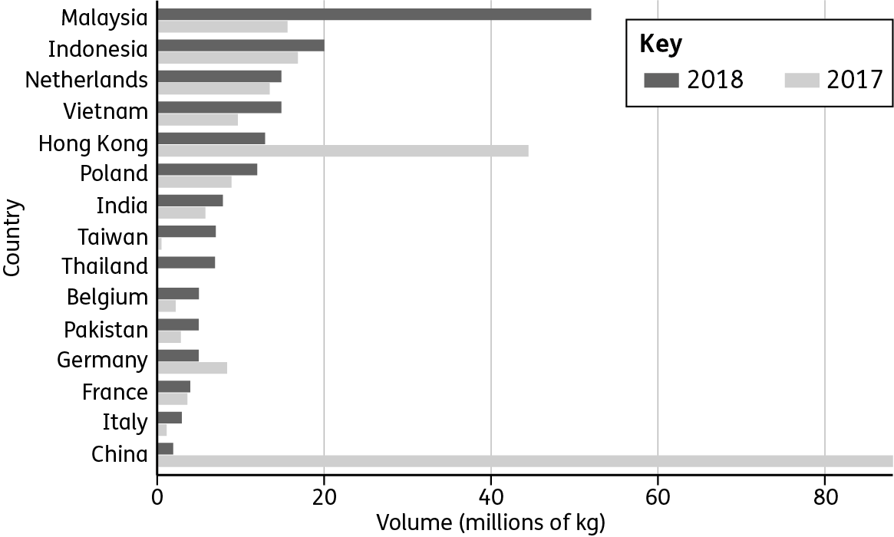
UK plastic waste exports, January–April 2018
6. Look at chart F.
(a) State which three countries the UK exported most of its plastic waste to in 2017.
C
H
I
(b) State which four countries the UK exported most of its plastic waste to in 2018.
M
I
N
V
(c) State how much plastic waste in kg the UK exported to Indonesia in 2018.

Tip!

Look for a dramatic change between the numbers for 2017 and those for 2018.

