Name
Class
A
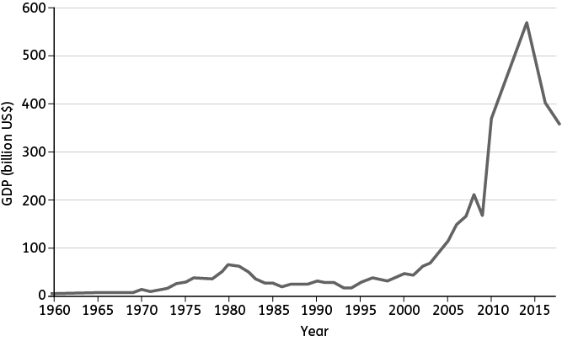
Changes in Nigeria’s wealth, 1960–2017
1. Use graph A to answer the following.
(a) State the GDP in US$ in 1990.
(b) State the GDP in US$ in 2014.
(c) Choose the word that makes each sentence below correct.
GDP stayed fairly high / low between 1960 and the early 1990s.
There was a rapid / slow increase in GDP between the early 1990s and 2014.
GDP increased / decreased between 2014 and 2017.
2. What is a Newly-Emerging Economy?

A good answer will not just give the definition, but at least one example too.

Tip!

Hints

life expectancy, education, healthcare, sanitation
3. Suggest two reasons why quality of life
often gets better as a country gets wealthier.
1

2

4. Jobs can be directly or indirectly linked to an industry. Jobs involved in actually making films, such as actor, are directly linked. Jobs that support the industry, for example in hotels where actors stay while filming, are indirectly linked.
(a) In pairs or small groups, identify two jobs that are directly linked to the film industry.
1
2
(b) Identify two jobs that are indirectly linked.
1
2
(c) What effect would a growing film industry have on jobs that are indirectly linked?
A growing film industry does not just benefit those directly employed. For example,

5. Explain how having Nigerian films shown at film festivals in other countries and watched on Netflix can help Nigeria’s film industry.
As the audience broadens, more

E
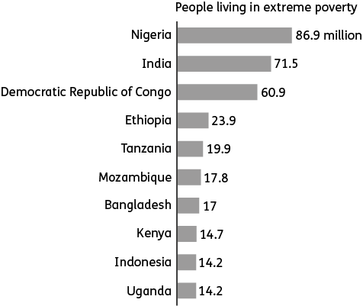
Countries with the most people living in extreme poverty
6. Study graph E.
(a) State the correct continent for each country.
Nigeria: Africa. India:

(b) State the continent that has most people living in extreme poverty.

F
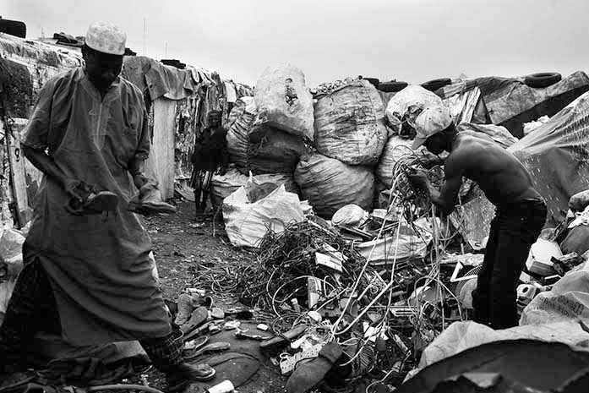

Scavenging in a rubbish dump for things to sell, Lagos
7. Look at photo F. What are the people collecting? What do you think they might use those
items for?

8. Explain why it is good for Nigeria’s economy not to rely on oil for all of its wealth.

Think about how and why the global demand for oil changes. How will this affect Nigeria? Will Nigeria always have oil?

Tip!

9. Complete this flow diagram to show the effects of oil spills in the Niger Delta.
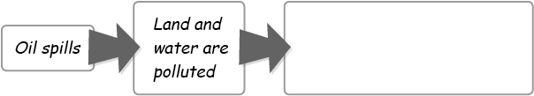

10. Complete a spider diagram to show the effects of deforestation in Nigeria. Put the word ‘deforestation’ in the middle, with the effects branching off it. Add branches to develop each point.
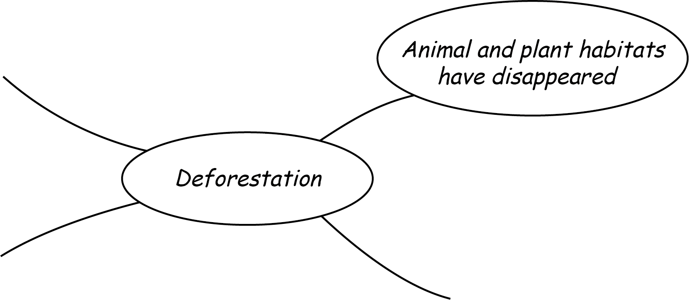

I
Year | Percentage of Nigerian land that is forested
1990 | 19
1995 | 17
2000 | 14
2005 | 12
2010 | 10
2015 | 8
The amount of forest in Nigeria has been decreasing
11. Draw a pictogram of the information in table I.
Use this scale: = 2% of forested land.
