Name
Class
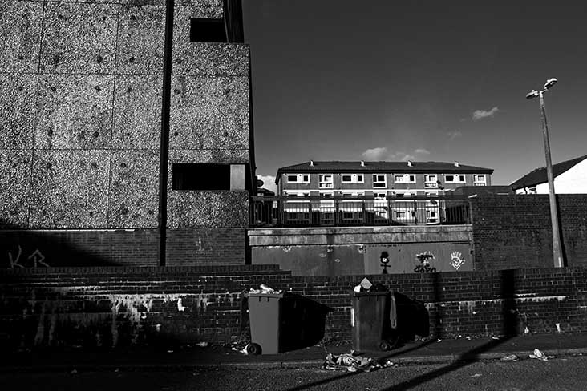
A

In 2017, 14 million people in the UK lived in poverty
1. Look at photo A. Explain how you know this area is poor.
Evidence showing the area’s poverty includes

2. Write a list of ‘essential items’ you would include in Rowntree’s shopping basket for a
family today.

B
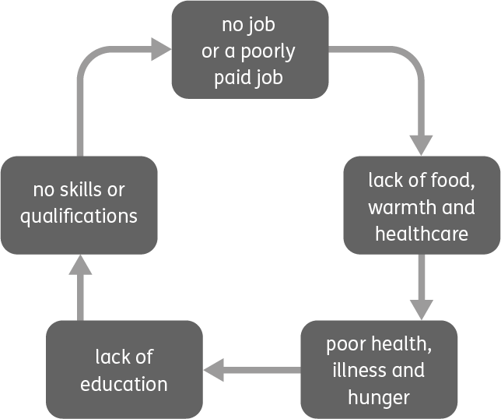
The cycle of poverty
3. Use diagram B to explain how attending school and getting some qualifications could make the difference between staying in or getting out of poverty.
Attending school and working hard for the best qualifications manageable is crucial because

Design a poster about poverty in the UK. Using the internet and your own knowledge, add key statistics and information to this piece of work, as well as pictures.
4.

C
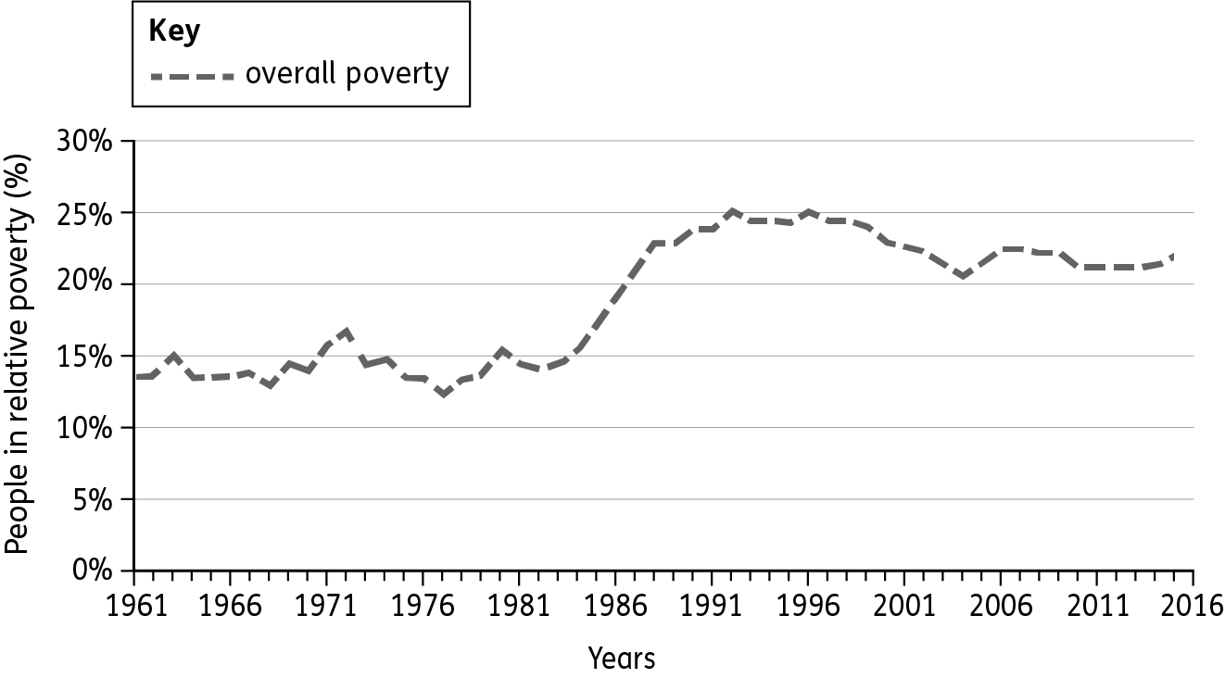
Changes in the percentage of people in poverty since 1961
5. Use chart C to answer the following questions.
(a) In 2016, the overall poverty rate in the UK was 23%. Add the data for 2016 and complete the overall poverty line.
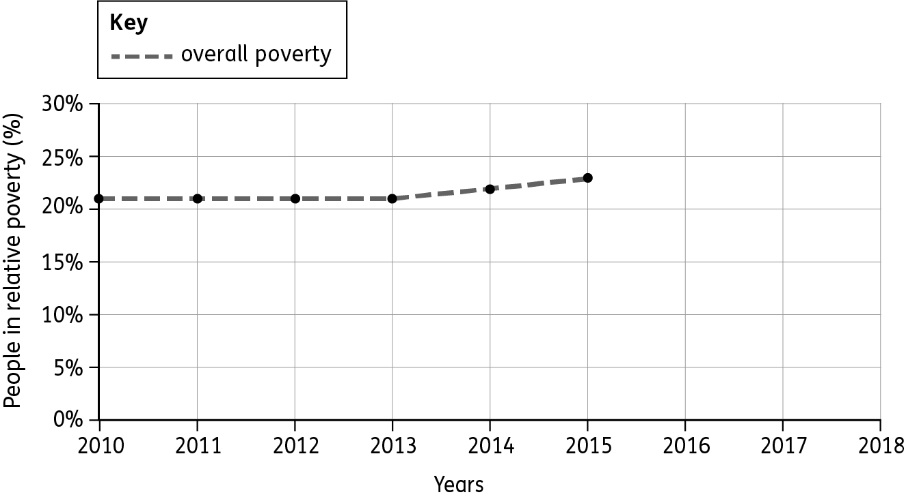
(b) State which of the following are true or false.
Between 2011 and 2016, the overall poverty rate decreased. True False
Between 1961 and 2016, the overall poverty rate increased. True False
The poverty rate fell between 1996 and 2005. True False
The poverty rate fell between 1981 and 1994. True False
The poverty rate was at its lowest in 1982. True False

(c) In one or two sentences, describe what happened to the overall poverty rate between
1961 and 2016.

When describing a trend, use data from the chart to support your answer. Always work in sequence. For example, start by stating the poverty rate in 1961 and work towards 2016. Use adjectives like ‘steady’, ‘rising quickly’, ‘falling gently’, ‘fluctuating’ etc. and state years (and values) at high points, low points and where there is any significant change.

Tip!

‘I dropped out of school when I was 15. Although I wish I had an education, my parents were away a lot and didn’t encourage me to go to school. I tried and tried to find a job, but no one would take me without qualifications. When my parents kicked me out, I had to fend for myself. I moved into a flat but, without a job, I couldn’t afford the rent. So the landlord kicked me out of there too. My friends have moved away to university, so I can’t stay at theirs. Sleeping on the streets was my only option. I wasn’t prepared for the loneliness, fear and discomfort of sleeping rough. It was cold and it made me unwell.’
6. Using Aaron’s story (above), Internet research and your own knowledge, create a spider diagram to give the different reasons for homelessness in the UK.
Some of the reasons for homelessness in the UK

7. (a) Using this unit, outline the different ways that homeless people or people in poverty can
be helped.

(b) Name some organisations in the UK, who help people living in poverty.

F
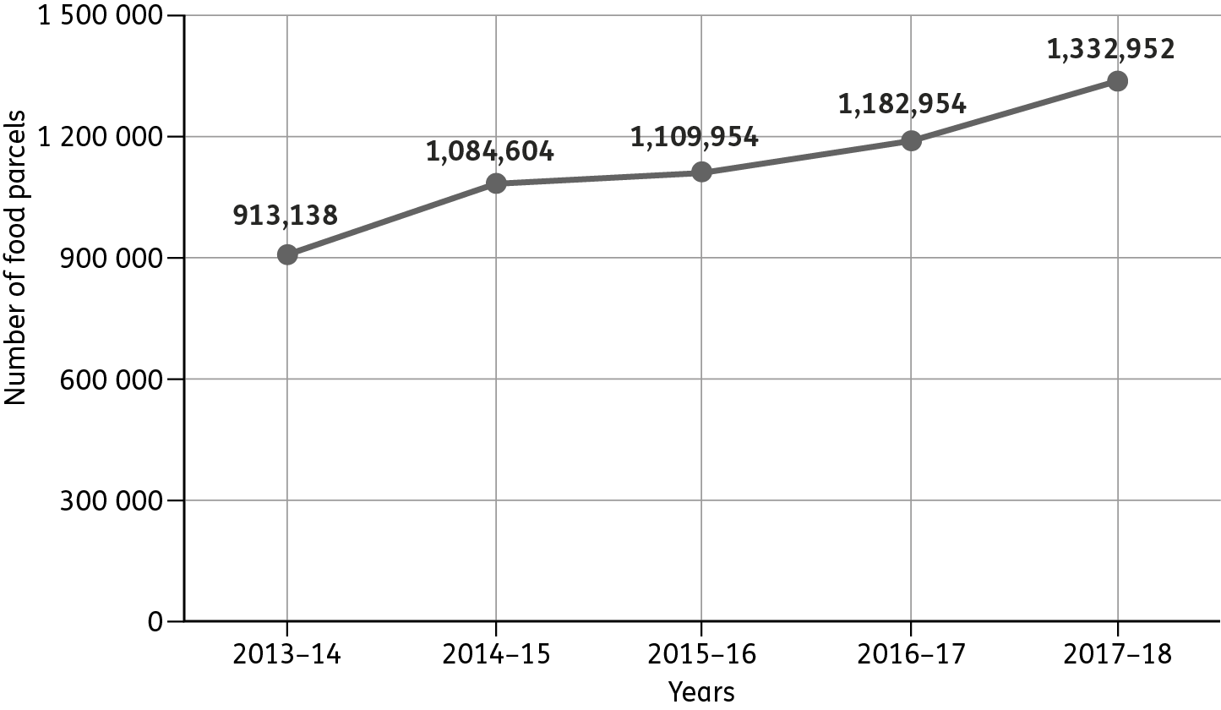
The number of food parcels given out by food banks in the UK, 2013–18
8. Use chart F to answer these questions.
(a) State how many food parcels were given out from 2013 to 2014.

(b) State how many food parcels were given out from 2017 to 2018.

(c) Calculate the difference in the number of food parcels given out in 2013–14 and 2017–18.

(d) Describe how the number of people needing food parcels has changed over time.
Use evidence from the chart to support your answer. (See Tip for Q5c.)
In 2013–14 the number of food parcels given to people in need was

9. Create an advert to encourage people to donate to the local food bank. Focus on how their donation will help people. Use a separate piece of paper for this.

