Name

7. (a) Give one advantage of the UK exporting its waste to other countries.

(b) Give two disadvantages of the UK exporting its waste to other countries.
1

2

(c) Should the UK continue to export its waste to other countries? Explain your answer.

There is no right or wrong answer to this question because it is your opinion that is being sought. However, opinion only has value if supported (justified) by hard facts (evidence) from the unit and your general knowledge.

Tip!

8. Complete the table listing the advantages and disadvantages of deposit return schemes.
Advantages | Disadvantages

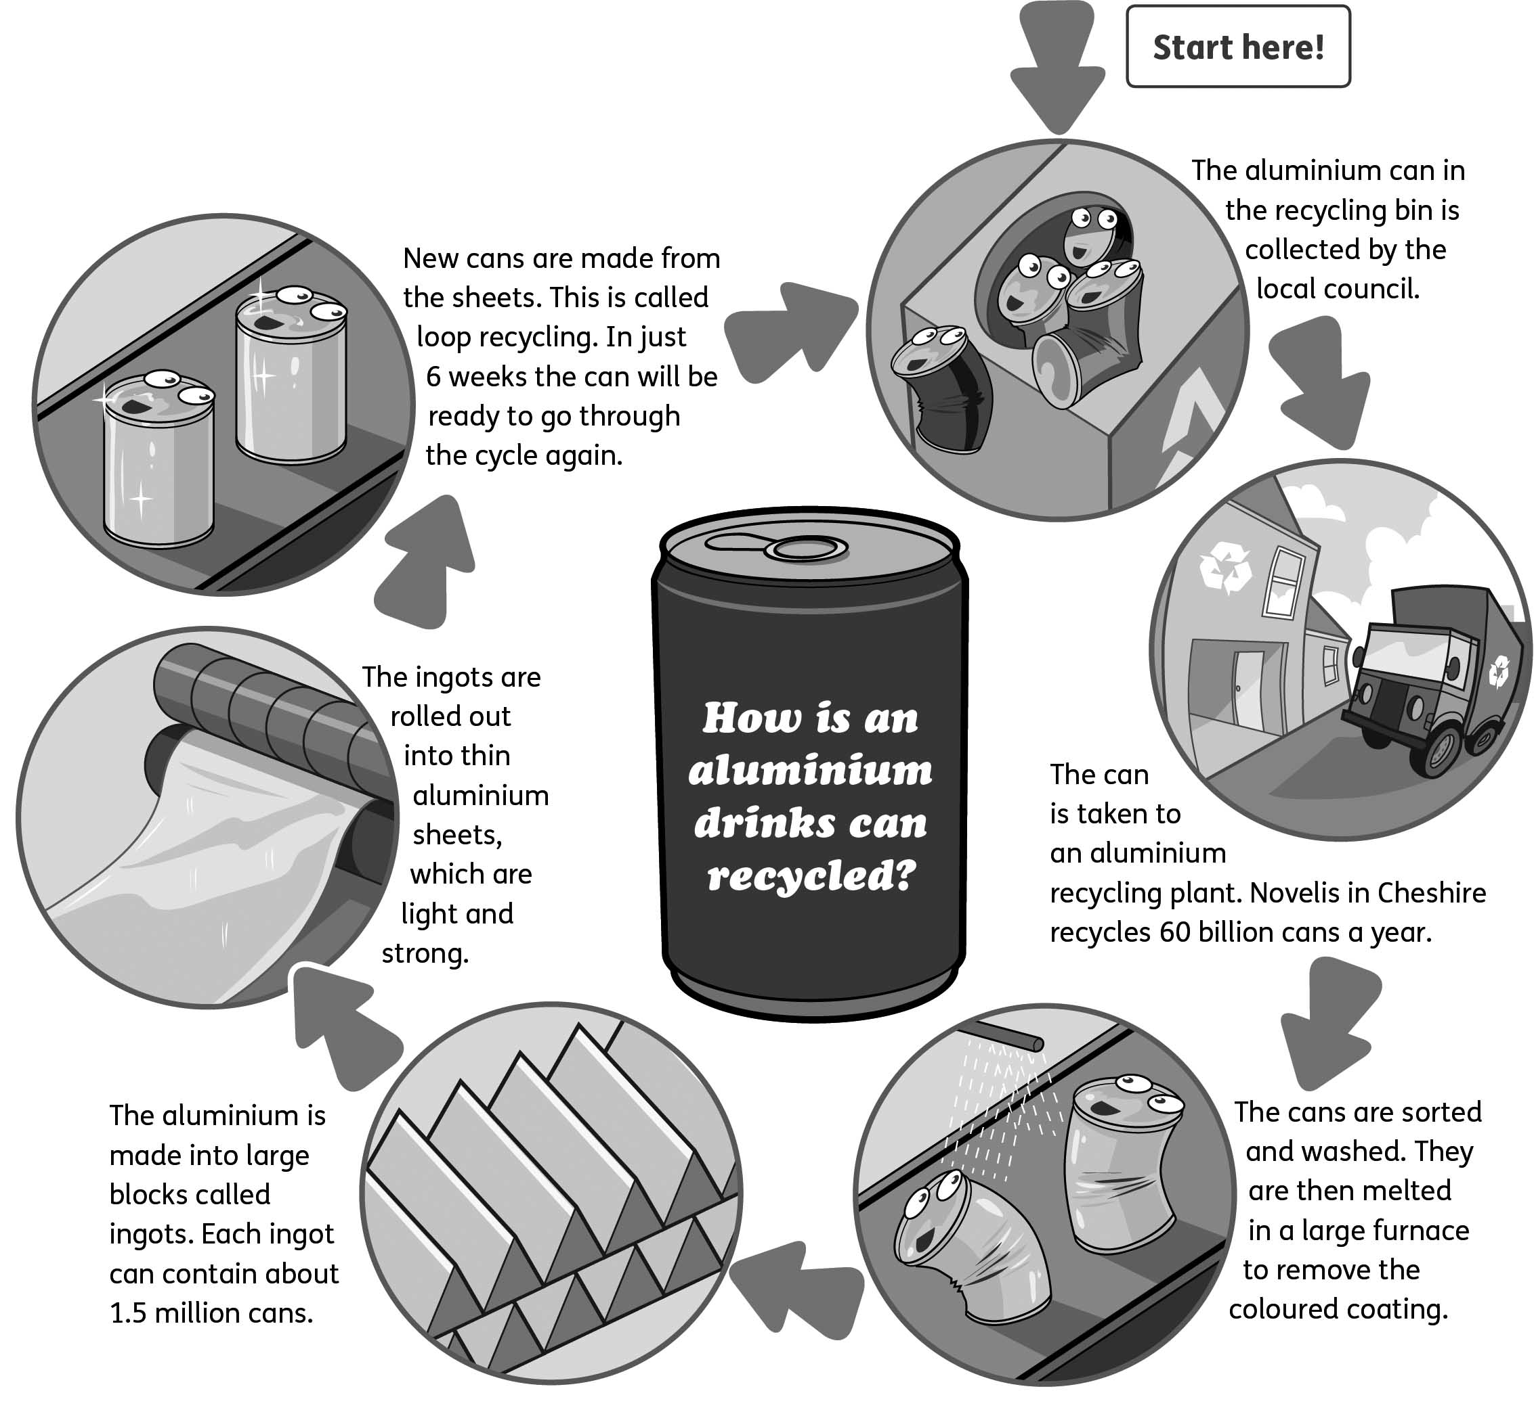
E
The journey of a drinks can
9. Use the Internet to research how plastic bottles are recycled. Then create a flow diagram on the next page like diagram E above to explain the process.

