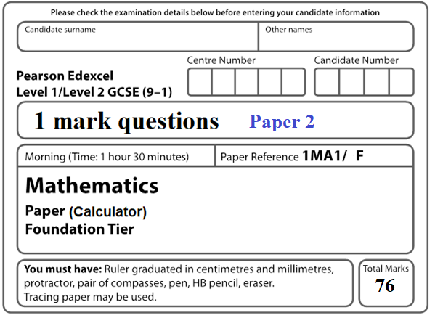

**Instructions**

* Use **black** ink or ball-point pen.
  + **Fill in the boxes** at the top of this page with your name,  
    centre number and candidate number.
* Answer **all** questions.
* Answer the questions in the spaces provided  
  *– there may be more space than you need.*
* You must **show all your working.**
* Diagrams are **NOT** accurately drawn, unless otherwise indicated.
* **Calculators may be used.**

**Information**

* The total mark for this paper is **76**.
* The marks for **each** question are shown in brackets  
  *– use this as a guide as to how much time to spend on each question.*

**Advice**

* Read each question carefully before you start to answer it.
* Keep an eye on the time.
* Try to answer every question.
* Check your answers if you have time at the end.

**1** David sells CDs in a shop.

The tally chart shows information about the number of CDs David sold

on Monday, on Tuesday and on Wednesday.

|  |  |  |
| --- | --- | --- |
|  | **Tally** | **Frequency** |
| **Monday** |  | 12 |
| **Tuesday** |  | 18 |
| **Wednesday** |  | 8 |

Write down **one** thing that is wrong with the tally chart.

......................................................................................................................................................

......................................................................................................................................................

**(1)**

**2** David drew this pictogram to show the information for Tuesday and Wednesday.

(Refer to table in Question 1)



Write down **one** thing that is wrong with this pictogram.

......................................................................................................................................................

......................................................................................................................................................

**(1)**

**3 A** path is made of white tiles and grey tiles.

of the tiles are white.

Write down the ratio of white tiles to grey tiles.

.......................................................

**(1)**

**4** Find the value of 

.......................................................

**(1)**

**5** Write 0.23 as a percentage.

....................................................... %

**(1)**

**6** Write down two factors of 12

......................................... , .........................................

**(1)**

**7** Here is a number machine.

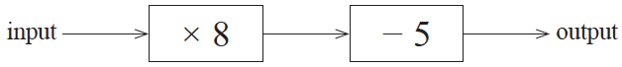

Work out the output when the input is 6

......................................................

**(1)**

**8** You can use this graph to change between stones and kilograms.

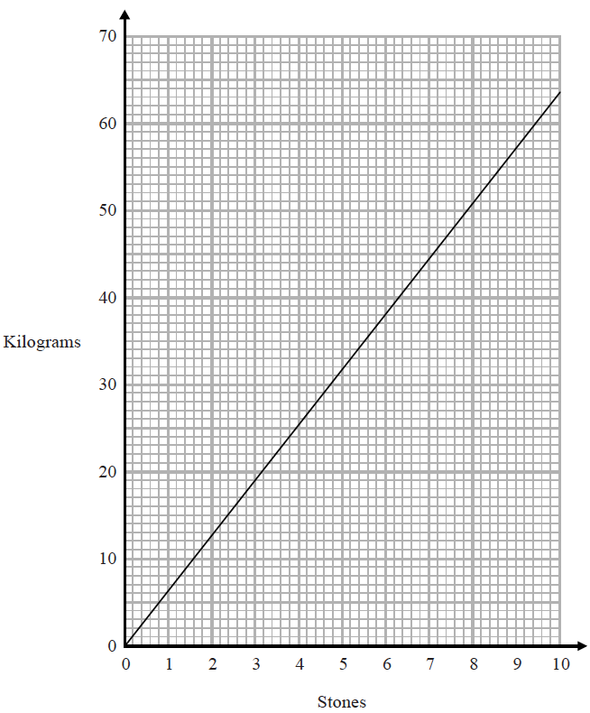

Change 3 stones to kilograms.

....................................................... kilograms

**(1)**

**9** Here are four digits.

|  |  |  |  |
| --- | --- | --- | --- |
| 5 | 6 | 1 | 9 |

Write down the smallest possible two digit number that can be made with two of the digits.

.......................................................

**(1)**

**10** The pictogram shows information about the number of vinyl records sold in a shop on

Monday and on Tuesday.

|  |  |  |  |
| --- | --- | --- | --- |
| Monday |  |  | Key:    represents  8 vinyl records |
| Tuesday |  |  |
|  |
| Wednesday |  |  |  |
| Thursday |  |  |  |

Write down the number of vinyl records sold on Monday,

.......................................................

**(1)**

**11** A teacher asks the students in Year 6 what type of transport they use to get to school.

The dual bar chart shows some of the results.



7 girls walk to school.

Show this information on the dual bar chart.

......................................................

**(1)**

**12** Find 

.......................................................

**(1)**

**13** Here is part of a train timetable.

|  |  |  |  |
| --- | --- | --- | --- |
| **Brighton** | 07 22 | 07 29 | 07 32 |
| **London** | 09 00 | 08 32 | 08 48 |

Graham gets to the station in Brighton at 07 15

Work out how many minutes he has to wait until 07 22

....................................................... minutes

**(1)**

**14** A teacher asks the students in Year 6 what type of transport they use to get to school.

The dual bar chart shows some of the results.



What is the most popular type of transport used by the boys?

......................................................

**(1)**

**15** On the grid, reflect the shaded shape in the mirror line.



**(Total for Question 10 is 1 mark)**

**___________________________________________________________________________**

**16** Solve *x* + *x* + *x* = 51

*x* = ......................................................

**(1)**

**17** Here are the first 4 terms of a sequence.

|  |  |  |  |
| --- | --- | --- | --- |
| 2 | 9 | 16 | 23 |

Write down the next term in the sequence.

.......................................................

**(1)**

**18** Write down two factors of 15

.......................................................

**(1)**

**19** Write 19% as a fraction.

.......................................................

**(1)**

**20** Write 0.75 as a fraction.

.......................................................

**(1)**

**21** The first term of a sequence of numbers is 24

The term-to-term rule of this sequence is ‘add 8’

Josie says,

“No number in this sequence is in the 5 times table.”

Give an example to show that Josie is wrong.

.......................................................

**(1)**

**22** Write 0.31 as a fraction.

.......................................................

**(1)**

**23** An ordinary fair dice is thrown once.

On the probability scale below, mark with a cross (×) the probability that the dice

lands on an odd number.



**(1)**

**24** Here are four digits.

|  |  |  |  |
| --- | --- | --- | --- |
| 7 | 3 | 4 | 9 |

Use three of these digits to write down the largest possible 3-digit number.

.......................................................

**(1)**

**25** Here is a number machine.

|  |  |  |  |  |  |  |
| --- | --- | --- | --- | --- | --- | --- |
| input |  | ×5 |  | –2 |  | output |

Work out the **output** when the input is 8

.......................................................

**(1)**

**26** Here is a 4-sided spinner.



The table shows the probabilities that when the spinner is spun it will land on 1, on 3 and on 4

|  |  |  |  |  |
| --- | --- | --- | --- | --- |
| **Number** | 1 | 2 | 3 | 4 |
| **Probability** | 0.2 |  | 0.4 | 0.1 |

The spinner is spun once.

Work out the probability that the spinner will land on 2

.......................................................

**(1)**

**27** Find the value of 

.......................................................

**(1)**

**28** The diagram shows five shapes on a centimetre grid.



Two of the shapes are congruent.

Write down the letters of these two shapes.

............................ and ............................

**(1)**

**29** Simplify *a* × *b* × 7

.......................................................

**(1)**

**30** Write 0.3 as a percentage.

.......................................................%

**(1)**

**31** Here is a rectangle.



Coby has to find the perimeter of this rectangle.

He writes,

Perimeter = 7 × 3

What mistake has Coby made?

..................................................................................................................................................................................................................................................................................................................................................................................................................................................................

**(1)**

**32** Write  as a decimal.

......................................................

**(1)**

**33** Simplify *t* × *t*

......................................................

**(1)**

**34** Here is a 4-sided spinner.



The table shows the probabilities that when the spinner is spun it will land on 1, on 3 and on 4

|  |  |  |  |  |
| --- | --- | --- | --- | --- |
| **Number** | 1 | 2 | 3 | 4 |
| **Probability** | 0.2 | 0.3 | 0.4 | 0.1 |

The spinner is spun once.

Which number is the spinner least likely to land on?

.......................................................

**(1)**

**35** Rehan is asked to find the range of the numbers 3 1 8 7 5

Here is his working.

Range = 5 – 3 = 2

This is wrong.

Explain why.

......................................................................................................................................................

......................................................................................................................................................

**(1)**

**36** Write 3.42 × 104 as an ordinary number.

....................................................................

**(1)**

**37** Write 1.452 × 103 as an ordinary number.

.......................................................

**(1)**

**38** Write 4.7 × 10 – 1 as an ordinary number.

......................................................

**(1)**

**39** Simplify 3*m* – *m* − *m* + 3*m*

.......................................................

**(1)**

**40** Write down a 6 digit number that has 4 as its thousands digit.

You can only use the digit 4 once.

......................................................

**(1)**

**41** Write  as a percentage.

......................................................%

**(1)**

**42** You can use this graph to change between inches and centimetres.



Change 74 cm to inches.

...................................................... inches

**(1)**

**43** Write down a square number that is also an odd number.

.......................................................

**(1)**

**44** Change 1.5 kilometres to metres.

....................................................... metres

**(1)**

**45** Simplify *y* × *y* × *y*

.......................................................

**(1)**

**46** The probability that a new fridge has a fault is 0.015.

What is the probability that a new fridge does **not** have a fault?

......................................................

**(1)**

**47** Change 35 cm to mm.

...................................................... mm

**(1)**

**48** The diagram shows two shapes drawn on a centimetre grid.



Write down the mathematical name of quadrilateral **Q**.

......................................................

**(1)**

**49** Chrissy drew this graph to show the percentage of buses that got to a bus stop on time

for six months.



Describe the trend in the percentage of buses that got to the bus stop on time.

......................................................................................................................................................

**(1)**

**50** Annie and Lily share some money in the ratio 4 : 3

What fraction of the money does Lily get?

......................................................

**(1)**

**51** (72)*y* = 710

Find the value of *y*.

*y* = .....................................................

**(1)**

**52** Change 4560 g into kg.

.......................................................kg

**(1)**

**53** Here is a grid of squares.



Write down the ratio of the number of shaded squares to the number of unshaded squares.

.......................................................

**(1)**

**54** Four biased coins, A, B, C and D are thrown.

The probability that each coin will land on Heads is shown in the table.

|  |  |
| --- | --- |
| **Coin** | **Probability** |
| A | 0.33 |
| B | 0.033 |
| C |  |
| D | 30% |

Julie says,

“The probability that coin C will land on Heads is the same as the probability that

coin C will land on Tails.”

Is she correct?

Give a reason for your answer.

......................................................................................................................................................

......................................................................................................................................................

......................................................................................................................................................

**(1)**

**55** *p*3 × *px* = *p*9

Find the value of *x*.

*x* = .....................................................

**(1)**

**56** Simplify 

......................................................

**(1)**

**57** Here is a 3-D shape.



Write down the number of edges of this 3-D shape.

.......................................................

**(1)**

**58** Write 0.00562 in standard form.

.......................................................

**(1)**

**59**  Write 4.96 × 10−3 as an ordinary number.

.......................................................

**(1)**

**60** Change 7.3 m into mm.

.......................................................mm

**(1)**

**61** Write the number 0.000 075 47 in standard form.

....................................................................

**(1)**

**62** Write 32 460 000 in standard form.

.......................................................

**(1)**

**63** Here are the first five terms of a Fibonacci sequence.

|  |  |  |  |  |
| --- | --- | --- | --- | --- |
| 3 | 3 | 6 | 9 | 15 |

Write down the next two terms of the sequence.

............................ , ............................

**(1)**

**64** The table shows some information about the dress sizes of 25 women.

|  |  |
| --- | --- |
| **Dress size** | **Number of women** |
| 8 | 2 |
| 10 | 9 |
| 12 | 8 |
| 14 | 6 |

Find the median dress size.

.......................................................

**(1)**

**65** William needs to work out the size of angle *y* in this diagram.

**

William writes

|  |  |
| --- | --- |
| **Working** | **Reason** |
| angle *EGH* = 57° | because corresponding angles are equal |
| *y* = 180° – 57°  *y* = 123° | because angles on a straight line add up to 180° |

One of William’s reasons is wrong.

Write down the correct reason.

......................................................................................................................................................

......................................................................................................................................................

**(1)**

**66** Factorise 5 – 10*m*

......................................................

**(1)**

**67** The diagram shows a cube of side length 2 cm.



Draw a cuboid that can be made with 6 of these cubes.

Write the dimensions of the cuboid on your diagram.

**(1)**

**68** Write 7357 correct to 3 significant figures.

.......................................................

**(1)**

**69** When a drawing pin is dropped it can land point down or point up.

Lucy, Mel and Tom each dropped the drawing pin a number of times.

The table shows the number of times the drawing pin landed point down and the number

of times the drawing pin landed point up for each person.

|  |  |  |  |
| --- | --- | --- | --- |
|  | **Lucy** | **Mel** | **Tom** |
| **point down** | 31 | 53 | 16 |
| **point up** | 14 | 27 | 9 |

Rachael is going to drop the drawing pin once.

Whose results will give the best estimate for the probability that the drawing pin will

land point up?

Give a reason for your answer.

...................................................................................................................................................... ......................................................................................................................................................

**(1)**

**70** The table shows information about the heights of 80 plants.

|  |  |
| --- | --- |
| **Height (*h* cm)** | **Frequency** |
| 10 < *h* ⩽ 20 | 7 |
| 20 < *h* ⩽ 30 | 13 |
| 30 < *h* ⩽ 40 | 14 |
| 40 < *h* ⩽ 50 | 12 |
| 50 < *h* ⩽ 60 | 16 |
| 60 < *h* ⩽ 70 | 18 |

Find the class interval that contains the median.

..................................................................................

**(1)**

**71** Factorise *x*2 + 6*x* + 9

......................................................

**(1)**

**72** Here is a list of numbers.

|  |  |  |  |  |  |  |  |
| --- | --- | --- | --- | --- | --- | --- | --- |
| 4 | 6 | 9 | 10 | 15 | 27 | 30 | 40 |

From the list, write down all the numbers that are powers of 3

.................................................................................

**(1)**

**73** Harley’s house has a value of £160 000 correct to 2 significant figures.

Write down the least possible value of the house.

£ .......................................................

**(1)**

**74** The table shows information about the heights of 80 children.

|  |  |
| --- | --- |
| **Height (*h* cm)** | **Frequency** |
| 130 < *h* ⩽ 140 | 4 |
| 140 < *h* ⩽ 150 | 11 |
| 150 < *h* ⩽ 160 | 24 |
| 160 < *h* ⩽ 170 | 22 |
| 170 < *h* ⩽ 180 | 19 |

Find the class interval that contains the median.

...........................................................................

**(1)**

**75** Here are six graphs.

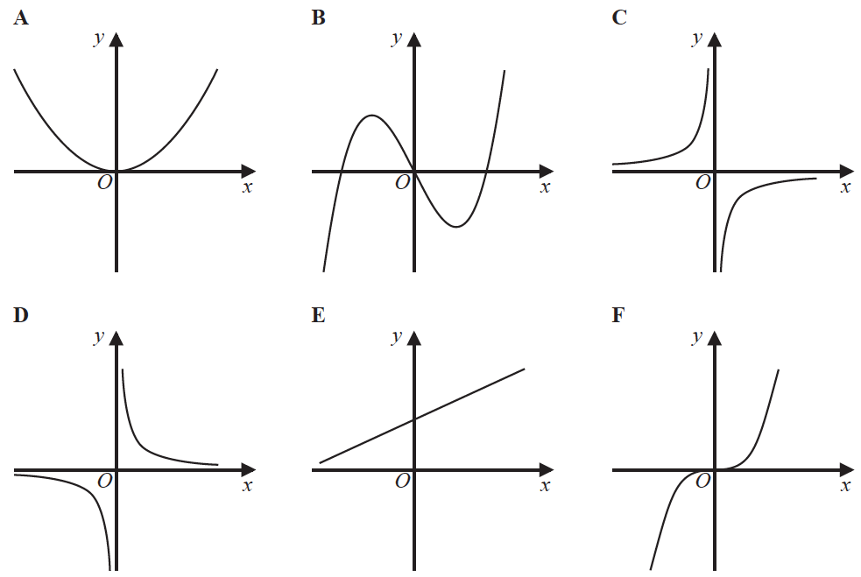

Write down the letter of the graph that could have the equation *y* = 

.......................................................

**(1)**

**76** Find the value of the reciprocal of 1.6.

Give your answer as a decimal.

.......................................................

**(1)**

**TOTAL FOR PAPER IS 77 MARKS**