Name …………………………………………………………

Starters (Higher)

|  |  |  |  |  |  |
| --- | --- | --- | --- | --- | --- |
| No. | Question | √ | No. | Question | √ |
| 1 | Calculations & Estimations (C) |  | 21 | Stem & Leaf Diagrams (C) |  |
| 2 | Calculations & Estimations (C/B) |  | 22 | Inequalities (B) |  |
| 3 | Prime Factors, HCF, LCM (C) |  | 23 | Distance-Time Graphs (B) |  |
| 4 | Fractions ( x and - ) (C) |  | 24 | Plotting Graphs (C/B) |  |
| 5 | Compound Interest (C) |  | 25 | Plotting Graphs 2 (C/B) |  |
| 6 | Similar shapes & ratio (B) |  | 26 | Real Life Graphs (B/A) |  |
| 7 | Standard Form (C/B) |  | 27 | Y = mx + c (and parallel lines) (B) |  |
| 8 | Algebra (simplifying, expanding, factorising) (C) |  | 28 | Grouped distributions & finding the median (C) |  |
| 9 | Algebra (expressions 1) (C) |  | 29 | Sequences & the nth term (C) |  |
| 10 | Algebra (expressions 2) (C/B) |  | 30 | Surveys & Histograms (B/A) |  |
| 11 | Substitution & Changing the subject of a formula (B) |  | 31 | Scattergraphs (C) |  |
| 12 | Dimension Theory (B/A) |  | 32 | Estimated Mean (C) |  |
| 13 | Trial & Improvement (C) |  | 33 | 2 way tables (C) |  |
| 14 | Expand, Simplify & Factorise (C) |  | 34 | Probability Trees (B) |  |
| 15 | Expressions & Solving (C) |  | 35 | Cumulative Frequency (B) |  |
| 16 | BIDMAS (C) |  | 36 | Vectors (A) |  |
| 17 | Solving Equations (C) |  | 37 | Circles (C) |  |
| 18 | Simultaneous Equations (B) |  | 38 | Similar Triangles (C/B) |  |
| 19 | Straight Line graphs (C) |  | 39 | Transformations: Rotations (C) |  |
| 20 | Factorising quadratics (B) |  | 40 | Pythagoras & Trigonometry (C/B) |  |

—————————————————————————————————————————

# **Question 1**

Tom uses his calculator to multiply 17.8 by 0.97.

His answer is 18.236.

**(a) Without** finding the exact value of 17.8  0.97, explain why his

answer must be wrong. **(1 mark)**

# Sally estimates the value of :



to be 8.

**(b)** Write down three numbers Sally could use to get her estimate.

…………..  …………….

…………….. **(2 marks)**

**(c)** Calculate the value of

21.7  32.1

16.20  2.19

Give your answer correct to 3 significant figures **(3 marks)**

—————————————————————————————————————————

# **Question 2**



Imran uses this formula to calculate the value of *F*.

Imran estimates the value of *F* without using a calculator.

*a* = 49.8 and *b* = 30.6

**(a) i)** Write down approximate values for *a* and *b* that Imran could use

to estimate the value of *F*.

**ii)** Work out the estimate for the value of *F* that these approximations give.

**iii)** Use your calculator to work out the accurate value for *F*.

Use *a* = 49.8 and *b* = 30.6.

Write down all the figures on your calculator display. **(4 marks)**

—————————————————————————————————————————

# **Question 3**

(a) The number 175 can be written as a product of its prime factors

175 = 52  7

Write as a product of its prime factors

**(i)** 50

**(ii)** 140 **(4 marks)**

**(b)** Find the Highest Common Factor of 75 and 90.

...............................

**(2 marks)**

**(c)** Find the Lowest Common Multiple of 75 and 90.

...............................

**(2 marks)**

—————————————————————————————————————————

# **Question 4**



Give your answer as a fraction in its simplest form.

...............................

**(2 marks)**



...............................

**(2 marks)**

—————————————————————————————————————————

# **Question 5**

(a) £5000 is invested for 3 years at 4% per annum **compound** interest.

Work out the **total interest** earned over the three years.

£ ........................

**(3 marks)**

(b)

 

£ ............................

**(3 marks)**

—————————————————————————————————————————

# **Question 6**



*BC* is parallel to *DE*.

*AB* is twice as long as *BD*.

*AD* = 36 cm and *AC* = 27 cm.

**(a)** Work out the length of *AB*.

*AB* = ............... cm

**(2 marks)**

**(b)** Work out the length of *AE*.

*AE* = ............... cm

**(3 marks)**

—————————————————————————————————————————

# **Question 7**

*p* = 8  103

*q* = 2  104

**(a)** Find the value of *p*  *q*.

Give your answer in **standard form.** **(2 marks)**

**(b)** Find the value of *p* + *q*.

Give your answer as an **ordinary number**. **(2 marks)**

—————————————————————————————————————————

# **Question 8**

**(a)** Simplify *y*3  *y*4

...............................

**(1 mark)**

**(b)** Expand and simplify 5(2*x* + 3)  2(*x*  1)

...............................

**(2 marks)**

**(c) (i)** Factorise 4*a* + 6

...............................

**(ii)** Factorise completely 6*p*2  9*pq*

...............................

**(3 marks)**

**(d)** Find the value of

**(i)** 102 ...............................

**(ii)** 70 ...............................

**(2 marks)**

—————————————————————————————————————————

# **Question 9**



The perimeter of the pentagon is 200 cm.

Work out the value of *x*. **(3 marks)**

—————————————————————————————————————————

# **Question 10**

In the diagram, each side of the square *ABCD* is (3 + *x*) cm.

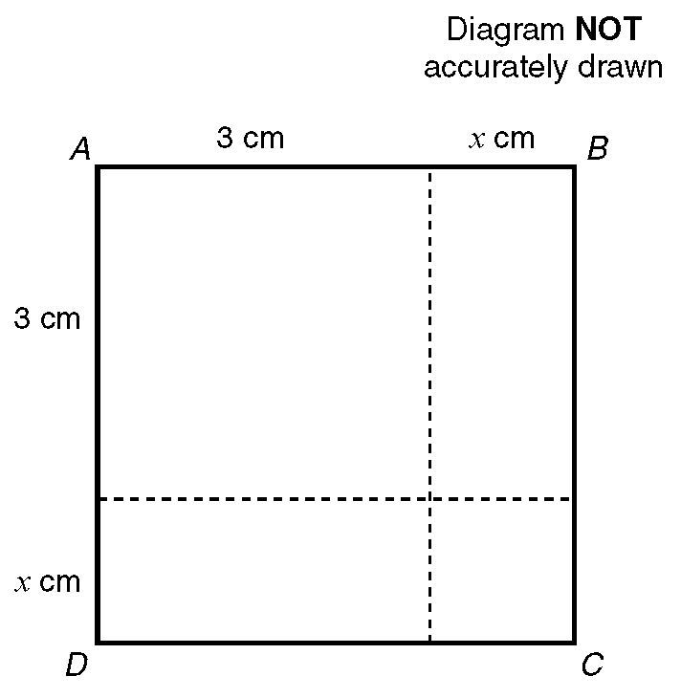

**(a)** Write down an expression in terms of *x* for the area, in cm2, of the square *ABCD*.

The actual area of the square *ABCD* is 10cm2.

**(b)** Show that *x* 2 + 6*x* = 1

—————————————————————————————————————————

# **Question 11**

**(a)** Calculate the value of *v* when *u* = 6, *a* = 5 and *s* = 0.8 using the formula:

*v* 2 = *u* 2 + 2*as*

Give your answer to one significant figure.

**(b)** Make *u* the subject of the formula *v* 2 = *u* 2 + 2*as*.

—————————————————————————————————————————

# **Question 12**

Here are 3 expressions.



*r*, *l* and *h* are lengths.

**, 2, 3 and 4 are numbers and have no dimension.

Put a tick in the correct column to show whether the expression can be used for

length, area, volume or none of these. **(3 marks)**

# _____________________________________________________

# **Question 13**

The equation

*x*3  5*x* = 38

has a solution between 3 and 4.

Use a trial and improvement method to find this solution.

Give your answer correct to 1 decimal place.

You must show **ALL** your working.

*x* = .....................

**(4 marks)**

—————————————————————————————————————————

# **Question 14**

**(a)** Expand and simplify

(*x* + 5)(*x*  3) **(2 marks)**

**(b)** Factorise completely

6*a*2  9*ab* **(2 marks)**

**(c)** Simplify **(i)** 2*a* + 4*b* + *a*  2*b*

Expand **(ii)** 3(*a* + 2) **(3 marks)**

**(d)** Expand and simplify

2(*x*  1) + 3(2*x* + 1) **(2 marks)**

—————————————————————————————————————————

# **Question 15**

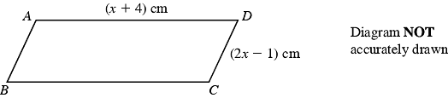

*ABCD* is a parallelogram.

*AD* = (*x* + 4) cm,

*CD* = (2*x*  1) cm.

The perimeter of the parallelogram is 24 cm.

**(i)** Use this information to write down an equation, in terms of *x*.

.......................................................

**(1 mark)**

**(ii)** Solve your equation.

*x* = ........................

**(2 marks)**

—————————————————————————————————————————

# **Question 16**

Tayub said, "When *x*  3, then the value of 4*x*2 is 144".

Bryani said, "When *x*  3, then the value of 4*x*2 is 36".

**(a)** Who is right?

Explain why. **(2 marks)**

**(b)** Work out the value of 4(*x*  1)2 when *x*  3.

...............................

**(1 mark)**

—————————————————————————————————————————

# **Question 17**

Solve the equations:

**(a)** 3*y* + 7 = 28

**(b)** 2(3*p* + 2) = 19

**(c)** 3*t*  4 = 5*t*  10

—————————————————————————————————————————

# **Question 18**

(a) Solve the simultaneous equations

3*x* + 2*y* = 11

*x  y* = 7

(b) Solve the simultaneous equations

6*x* + 2*y* = 21

4*x* + 3*y* = 19

*x* = ……………………

*y* = …………………….

**(4 marks)**

—————————————————————————————————————————

# **Question 19**

**(a)** On the grid below, draw the graphs of

**i)** *x* + *y* = 4

**ii)** *y* = *x* + 2

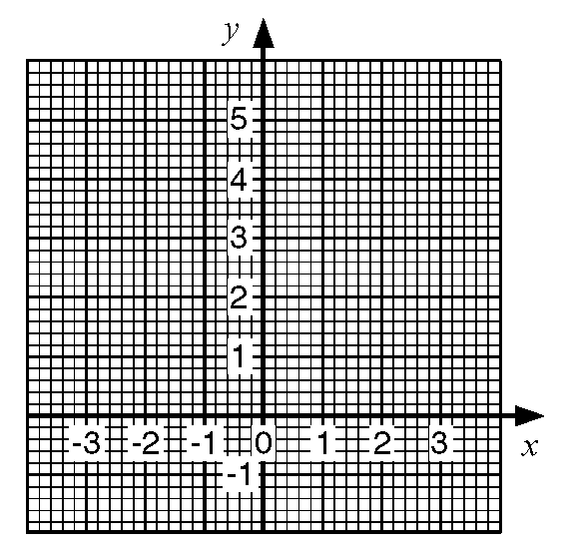

**(b)** Use the graphs to solve the simultaneous equations

*x* + *y* = 4

*y* = *x* + 2

—————————————————————————————————————————

# **Question 20**

 **(2 marks)**

**(b)** **i)** Factorise *x2* + 4*x*  12

Hence, or otherwise,

**ii)** Solve *x2* + 4*x*  12 = 0 **(4 marks)**

—————————————————————————————————————————

# **Question 21**

Here are the times, in minutes, taken to change some tyres.

5 10 15 12 8 7 20 35 24 15

20 33 15 25 10 8 10 20 16 10

**(a)** Draw a stem and leaf diagram to show these times. **(3 marks)**

—————————————————————————————————————————

# **Question 22**

*y* is an integer and 2 < *y*  2.

**(a)** Write down all the possible values of *y*. **(2 marks)**

**(b)** **i)** Solve the inequality 3*n* > 8.

**ii)** Write down the smallest integer which satisfies the inequality

3*n* > 8. **(2 marks)**

**(c)** 2 < *x*  1 *y* > 2 *y* < *x* + 1

*x* and *y* are integers.

On the grid, mark with a cross (), each of the six points which satisfies

**all** these 3 inequalities.

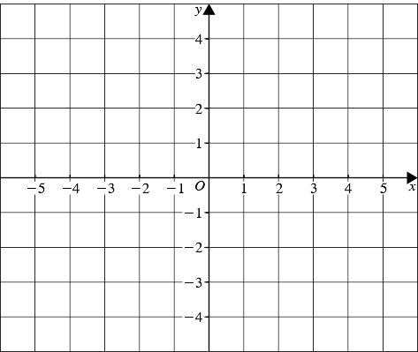

**(3 marks)**

—————————————————————————————————————————

# **Question 23**

The diagram shows part of a distance/time graph for a bus after if had left a bus stop.

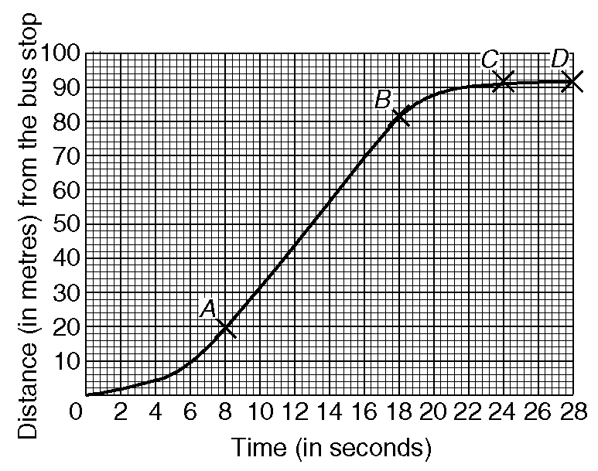

**(a)** Use the graph to find the distance the bus travelled in the first 20 seconds after

it had left the bus stop.

**(b)** Describe fully the journey of the bus represented by the parts *AB*,*BC* and *CD*

of the graph.

—————————————————————————————————————————

# **Question 24**

**(a)** Complete this table of values for

*y* = 3*x*  1



**(2 marks)**

**(b)** On the grid below, draw the graph of *y* = 3*x*  1



**(2 marks)**

**(c)** Use your graph to find the value of *x* when *y* = 6.5

*x* = ......................

**(1 mark)**

—————————————————————————————————————————

# **Question 25**

**(a)** Complete the table of values for *y* = 2*x*2



**(2 marks)**

**(b)** On the grid draw the graph of *y* = 2*x*2



**(2 marks)**

**(c)** Use your graph to find

**(i)** the value of *y* when *x* = 2.5,

*y* = …………………

**(ii)** the values of *x* when *y* = 12.

*x* = …………… or *x* = ……………..

**(2 marks)**

—————————————————————————————————————————

# **Question 26**

The diagram shows four empty containers.

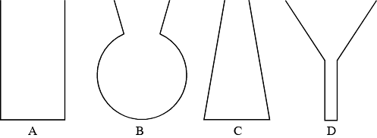

Water is poured at a constant rate into each of these containers.

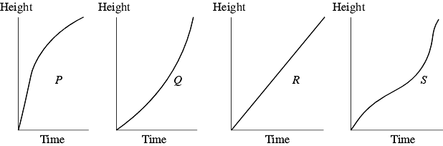

Each sketch graph shows the relationship between the height of water in a container and the time as the water is poured in.

Write the letter of each graph in the correct place in the table.



**(3 marks)**

—————————————————————————————————————————

# **Question 27**

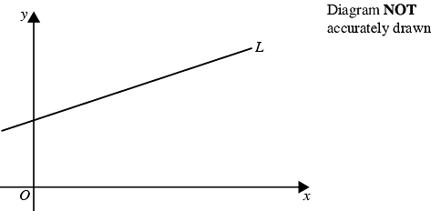

The straight line *L* is parallel to the line with equation 2*y* = *x* + 60.

**(a)** Find the gradient of line *L.*

...............................

**(2 marks)**

The straight line *L* passes through the point (0, 7).

**(b)** Find an equation for the line *L*.

...............................

**(2 marks)**

—————————————————————————————————————————

# **Question 28**

A garage keeps records of the costs of repairs to its customers' cars.

The table gives information about the costs of all repairs which were less than £250

in one week.



**(a)** Find the class interval in which the median lies

...............................

**(2 marks)**

There was only one further repair that week, not included in the table.

That repair cost £1000.

Dave says 'The class interval in which the median lies will change.'

**(b)** Is Dave correct? Explain your answer.

..............................................................................................................................

..............................................................................................................................

**(1 mark)**

The garage also sells cars.

It offers a discount of 20% off the normal price for cash.

Dave pays £5200 cash for a car.

**(c)** Calculate the normal price of the car.

£ ............................

**(3 marks)**

—————————————————————————————————————————

# **Question 29**

The first five terms of an arithmetic sequence are

2, 5, 8, 11, 14

Write down, in terms of *n*, an expresson for the *n*th term of this sequence.

...............................

**(2 marks)**

—————————————————————————————————————————

# **Question 30**

Alan is doing a survey of the heights of boys and girls in Year 7.

He first takes a random sample of 70 boys from Year 7.

**(a)** Suggest a suitable method that Alan could use to take a

random sample. **(2 marks)**

The table and the incomplete histogram show information about the boys' heights

in this sample of 70 boys.





**(b)** Use the information in the table to complete the histogram. **(3 marks)**

—————————————————————————————————————————

# **Question 31**

The table lists the weights of twelve books and the number of pages in each one.



This information is presented below as a scatter graph.

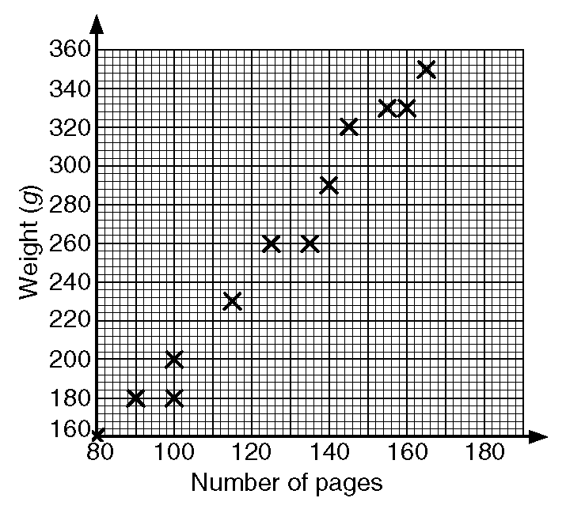

**(a)** Draw a line of best fit on your scatter graph.

**(b)** Use your line of best fit to estimate

**i)** the number of pages in a book of weight 280 g,

**ii)** the weight, in grams, of a book with 110 pages.

—————————————————————————————————————————

# **Question 32**

Jason grows potatoes.

He weighed 100 potatoes and recorded the weights to the nearest gram.

The table shows information about the weights (*w*) of the 100 potatoes.



**(a)** Work out an estimate for the mean weight of these potatoes.

.................... g

**(4 marks)**

**(b)** Find the class interval that contains the median.  **(2 marks)**

—————————————————————————————————————————

# **Question 33**

200 adults were asked which one of English, Mathematics or Science they enjoyed most.

The two-way table shows some information about their answers.



Complete the two-way table. **(3 marks)**

—————————————————————————————————————————

# **Question 34**

A bag contains 3 black beads, 5 red beads and 2 green beads.

Gianna takes a bead at random from the bag, records its colour and replaces it.

She does this two more times.

Work out the probability that, of the three beads Gianna takes, exactly two are

the same colour.

...............................

**(5 marks)**

—————————————————————————————————————————

# **Question 35**



**(a)** On the grid draw a cumulative frequency graph for the table.



**(b)** Use your cumulative frequency graph to estimate the interquartile range of

the floor areas of the houses.

The houses on the estate with the greatest floor areas are called luxury houses.

10% of the houses are luxury houses.

**(c)** Use your graph to estimate the minimum floor area for a luxury house.

—————————————————————————————————————————

# **Question 36**

*Q* is the midpoint of the side *PR* and *T* is the midpoint of the side *PS* of triangle *PRS*.

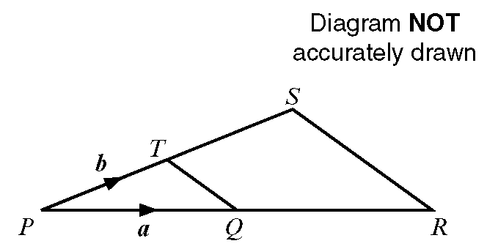

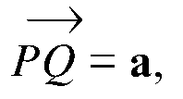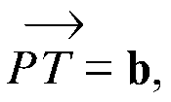

**(a)** Write down, in terms of **a** and **b**, the vectors

**i)** 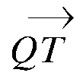

**ii)** 

**iii)** 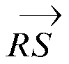

**(b)** Write down one geometrical fact about *QT* and *RS* which could be deduced

from your answers to part **(a)**.

—————————————————————————————————————————

# **Question 37**

A circle has a radius of 32 cm.

Work out the circumference of the circle.

Give your answer correct to the nearest centimetre.

.................. cm

**(2 marks)**

—————————————————————————————————————————

# **Question 38**

Triangle *ABC* is similar to triangle *PQR*.

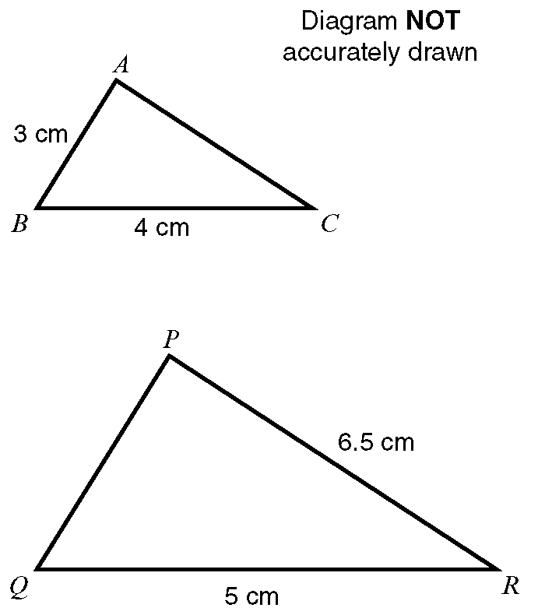

Angle *ABC* = angle *PQR*.

Angle *ACB* = angle *PRQ*.

Calculate the length of:

**i)** *PQ*

**ii)** *AC*

—————————————————————————————————————————

# **Question 39**



**(a)** Describe fully the single transformation that maps shape **P** onto shape **Q**.

**(2 marks)**

**(b)** Rotate shape **P** 90° anticlockwise about the point *A* (1, 1). **(2 marks)**

—————————————————————————————————————————

# **Question 40**

Calculate the length of *AB*.

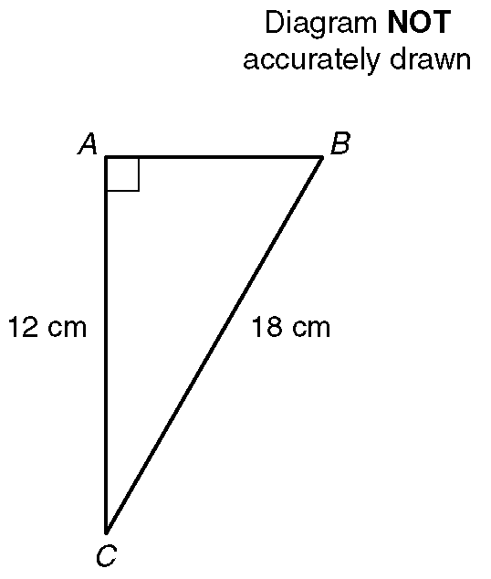

Give your answer correct to 1 decimal place.

---------------------------------------------------------------------------------------------------------------------------------



The diagram represents a rectangle which is 6 cm long.

A diagonal makes an angle of 23 with a 6 cm side.

Calculate the length of a diagonal.

Give your answer correct to 3 significant figures. **(3 marks)**