Name …………………………………………………………

Grade 4 consolidation

|  |  |  |  |  |  |
| --- | --- | --- | --- | --- | --- |
| No. | Question | √ | No. | Question | √ |
| 1 | Calculations & Estimations (C) |  | 20 | Inequalities (B) |  |
| 2 | Prime Factors, HCF, LCM (C) |  | 21 | Plotting Graphs (C) |  |
| 3 | Fractions ( x and - ) (C) |  | 22 | Plotting Graphs 2 (C/B) |  |
| 4 | Compound Interest (C) |  | 23 | Grouped distributions & finding the median (C) |  |
| 5 | Similar shapes & ratio (B) |  | 24 | Sequences & the nth term (C) |  |
| 6 | Standard Form (C/B) |  | 25 | Scattergraphs (C) |  |
| 7 | Algebra (simplifying, expanding, factorising)(C) |  | 26 | Estimated Mean (C) |  |
| 8 | Algebra (expressions 1) (C) |  | 27 | 2 way tables (C) |  |
| 9 | Algebra (expressions 2) (C/B) |  | 28 | Cumulative Frequency (B) |  |
| 10 | Substitution & Changing subject of a formula (C/B) |  | 29 | Circles (C) |  |
| 11 | Trial & Improvement (C) |  | 30 | Similar Triangles (C/B) |  |
| 12 | Expand, Simplify & Factorise (C) |  | 31 | Transformations: Rotations (C) |  |
| 13 | Expressions & Solving (C) |  | 32 | Pythagoras (C) |  |
| 14 | BIDMAS (C) |  | 33 | Probability 1 (C) |  |
| 15 | Solving Equations (C) |  | 34 | Probability 2 (C) |  |
| 16 | Simultaneous Equations (B) |  | 35 | Angles (D/C) |  |
| 17 | Straight Line graphs (C) |  | 36 | Volume (D) |  |
| 18 | Factorising quadratics (B) |  | 37 | Bearings (C) |  |
| 19 | Stem & Leaf Diagrams (C) |  | 38 | Trigonometry (B) |  |

—————————————————————————————————————————

# **Question 1**

Tom uses his calculator to multiply 17.8 by 0.97.

His answer is 18.236.

**(a) Without** finding the exact value of 17.8  0.97, explain why his

answer must be wrong. **(1 mark)**

# Sally estimates the value of :



to be 8.

**(b)** Write down three numbers Sally could use to get her estimate.

…………..  …………….

…………….. **(2 marks)**

**(c)** Calculate the value of

21.7  32.1

16.20  2.19

Give your answer correct to 3 significant figures **(3 marks)**

—————————————————————————————————————————

# **Question 2**

(a) The number 175 can be written as a product of its prime factors

175 = 52  7

Write as a product of its prime factors

**(i)** 50

**(ii)** 140 **(4 marks)**

**(b)** Find the Highest Common Factor of 75 and 90.

...............................

**(2 marks)**

**(c)** Find the Lowest Common Multiple of 75 and 90.

...............................

**(2 marks)**

—————————————————————————————————————————

# **Question 3**



Give your answer as a fraction in its simplest form.

...............................

**(2 marks)**



...............................

**(2 marks)**

—————————————————————————————————————————

# **Question 4**

(a) £5000 is invested for 3 years at 4% per annum **compound** interest.

Work out the **total interest** earned over the three years.

£ ........................

**(3 marks)**

(b)

 

£ ............................

**(3 marks)**

—————————————————————————————————————————

# **Question 5**



*BC* is parallel to *DE*.

*AB* is twice as long as *BD*.

*AD* = 36 cm and *AC* = 27 cm.

**(a)** Work out the length of *AB*.

*AB* = ............... cm

**(2 marks)**

**(b)** Work out the length of *AE*.

*AE* = ............... cm

**(3 marks)**

—————————————————————————————————————————

# **Question 6**

*p* = 8  103

*q* = 2  104

**(a)** Find the value of *p*  *q*.

Give your answer in **standard form.** **(2 marks)**

**(b)** Find the value of *p* + *q*.

Give your answer as an **ordinary number**. **(2 marks)**

—————————————————————————————————————————

# **Question 7**

**(a)** Simplify *y*3  *y*4

...............................

**(1 mark)**

**(b)** Expand and simplify 5(2*x* + 3)  2(*x*  1)

...............................

**(2 marks)**

**(c) (i)** Factorise 4*a* + 6

...............................

**(ii)** Factorise completely 6*p*2  9*pq*

...............................

**(3 marks)**

**(d)** Find the value of

**(i)** 102 ...............................

**(ii)** 70 ...............................

**(2 marks)**

—————————————————————————————————————————

# **Question 8**



The perimeter of the pentagon is 200 cm.

Work out the value of *x*. **(3 marks)**

—————————————————————————————————————————

# **Question 9**

In the diagram, each side of the square *ABCD* is (3 + *x*) cm.

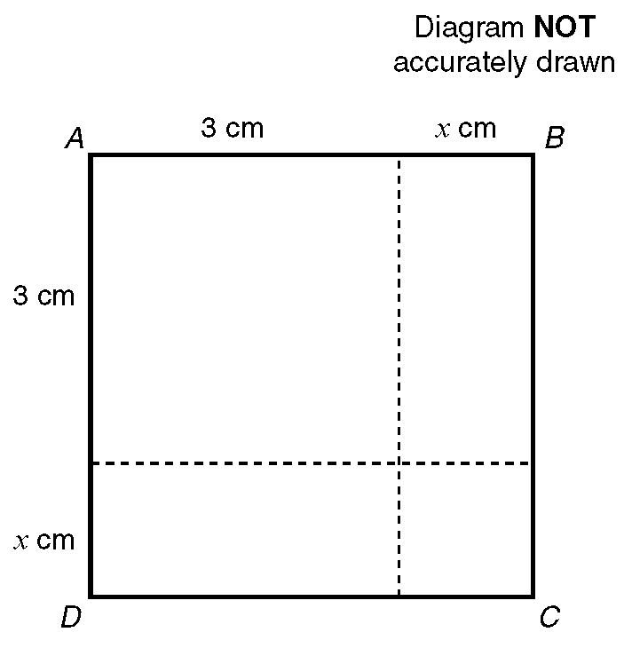

**(a)** Write down an expression in terms of *x* for the area, in cm2, of the square *ABCD*.

The actual area of the square *ABCD* is 10cm2.

**(b)** Show that *x* 2 + 6*x* = 1

—————————————————————————————————————————

# **Question 10**

**(a)** Calculate the value of *v* when *u* = 6, *a* = 5 and *s* = 0.8 using the formula:

*v* 2 = *u* 2 + 2*as*

Give your answer to one significant figure.

**(b)** Make *u* the subject of the formula *v* 2 = *u* 2 + 2*as*.

—————————————————————————————————————————

# **Question 11**

The equation

*x*3  5*x* = 38

has a solution between 3 and 4.

Use a trial and improvement method to find this solution.

Give your answer correct to 1 decimal place.

You must show **ALL** your working.

*x* = .....................

**(4 marks)**

—————————————————————————————————————————

# **Question 12**

**(a)** Expand and simplify

(*x* + 5)(*x*  3) **(2 marks)**

**(b)** Factorise completely

6*a*2  9*ab* **(2 marks)**

**(c)** Simplify **(i)** 2*a* + 4*b* + *a*  2*b*

Expand **(ii)** 3(*a* + 2) **(3 marks)**

**(d)** Expand and simplify

2(*x*  1) + 3(2*x* + 1) **(2 marks)**

—————————————————————————————————————————

# **Question 13**

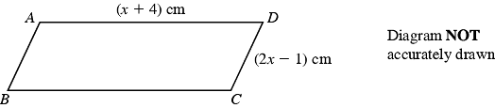

*ABCD* is a parallelogram.

*AD* = (*x* + 4) cm,

*CD* = (2*x*  1) cm.

The perimeter of the parallelogram is 24 cm.

**(i)** Use this information to write down an equation, in terms of *x*.

.......................................................

**(1 mark)**

**(ii)** Solve your equation.

*x* = ........................

**(2 marks)**

—————————————————————————————————————————

# **Question 14**

Tayub said, "When *x*  3, then the value of 4*x*2 is 144".

Bryani said, "When *x*  3, then the value of 4*x*2 is 36".

**(a)** Who is right?

Explain why. **(2 marks)**

**(b)** Work out the value of 4(*x*  1)2 when *x*  3.

...............................

**(1 mark)**

—————————————————————————————————————————

# **Question 15**

Solve the equations:

**(a)** 3*y* + 7 = 28

**(b)** 2(3*p* + 2) = 19

**(c)** 3*t*  4 = 5*t*  10

—————————————————————————————————————————

# **Question 16**

(a) Solve the simultaneous equations

3*x* + 2*y* = 11

*x  y* = 7

(b) Solve the simultaneous equations

6*x* + 2*y* = 21

4*x* + 3*y* = 19

*x* = ……………………

*y* = …………………….

**(4 marks)**

—————————————————————————————————————————

# **Question 17**

**(a)** On the grid below, draw the graphs of

**i)** *x* + *y* = 4

**ii)** *y* = *x* + 2

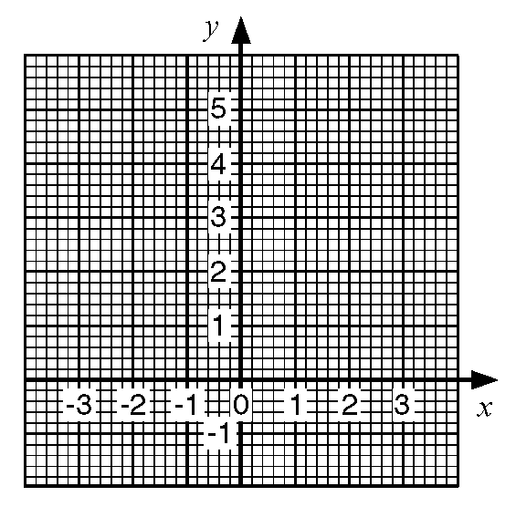

**(b)** Use the graphs to solve the simultaneous equations

*x* + *y* = 4

*y* = *x* + 2

—————————————————————————————————————————

# **Question 18**

 **(2 marks)**

**(b)** **i)** Factorise *x2* + 4*x*  12

Hence, or otherwise,

**ii)** Solve *x2* + 4*x*  12 = 0 **(4 marks)**

—————————————————————————————————————————

# **Question 19**

Here are the times, in minutes, taken to change some tyres.

5 10 15 12 8 7 20 35 24 15

20 33 15 25 10 8 10 20 16 10

**(a)** Draw a stem and leaf diagram to show these times. **(3 marks)**

—————————————————————————————————————————

# **Question 20**

*y* is an integer and 2 < *y*  2.

**(a)** Write down all the possible values of *y*. **(2 marks)**

**(b)** **i)** Solve the inequality 3*n* > 8.

**ii)** Write down the smallest integer which satisfies the inequality

3*n* > 8. **(2 marks)**

**(c)** 2 < *x*  1 *y* > 2 *y* < *x* + 1

*x* and *y* are integers.

On the grid, mark with a cross (), each of the six points which satisfies

**all** these 3 inequalities.

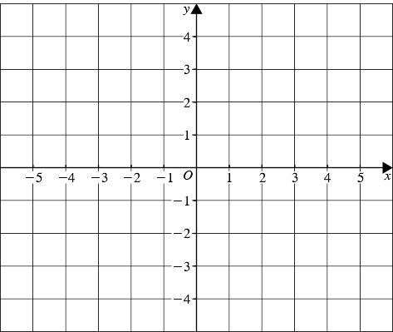

**(3 marks)**

—————————————————————————————————————————

# **Question 21**

**(a)** Complete this table of values for

*y* = 3*x*  1



**(2 marks)**

**(b)** On the grid below, draw the graph of *y* = 3*x*  1



**(2 marks)**

**(c)** Use your graph to find the value of *x* when *y* = 6.5

*x* = ......................

**(1 mark)**

—————————————————————————————————————————

# **Question 22**

**(a)** Complete the table of values for *y* = 2*x*2



**(2 marks)**

**(b)** On the grid draw the graph of *y* = 2*x*2



**(2 marks)**

**(c)** Use your graph to find

**(i)** the value of *y* when *x* = 2.5,

*y* = …………………

**(ii)** the values of *x* when *y* = 12.

*x* = …………… or *x* = ……………..

**(2 marks)**

—————————————————————————————————————————

# **Question 23**

A garage keeps records of the costs of repairs to its customers' cars.

The table gives information about the costs of all repairs which were less than £250

in one week.



**(a)** Find the class interval in which the median lies

...............................

**(2 marks)**

There was only one further repair that week, not included in the table.

That repair cost £1000.

Dave says 'The class interval in which the median lies will change.'

**(b)** Is Dave correct? Explain your answer.

..............................................................................................................................

..............................................................................................................................

**(1 mark)**

The garage also sells cars.

It offers a discount of 20% off the normal price for cash.

Dave pays £5200 cash for a car.

**(c)** Calculate the normal price of the car.

£ ............................

**(3 marks)**

—————————————————————————————————————————

# **Question 24**

The first five terms of an arithmetic sequence are

2, 5, 8, 11, 14

Write down, in terms of *n*, an expresson for the *n*th term of this sequence.

...............................

**(2 marks)**

—————————————————————————————————————————

# **Question 25**

The table lists the weights of twelve books and the number of pages in each one.



This information is presented below as a scatter graph.

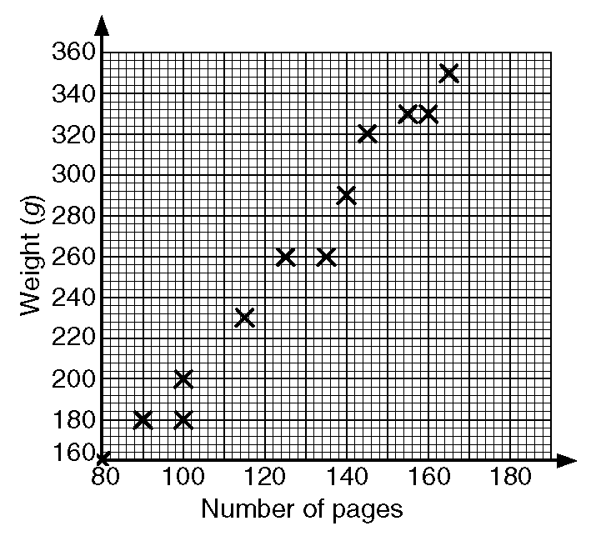

**(a)** Draw a line of best fit on your scatter graph.

**(b)** Use your line of best fit to estimate

**i)** the number of pages in a book of weight 280 g,

**ii)** the weight, in grams, of a book with 110 pages.

—————————————————————————————————————————

# **Question 26**

Jason grows potatoes.

He weighed 100 potatoes and recorded the weights to the nearest gram.

The table shows information about the weights (*w*) of the 100 potatoes.



**(a)** Work out an estimate for the mean weight of these potatoes.

.................... g

**(4 marks)**

**(b)** Find the class interval that contains the median.  **(2 marks)**

—————————————————————————————————————————

# **Question 27**

200 adults were asked which one of English, Mathematics or Science they enjoyed most.

The two-way table shows some information about their answers.



Complete the two-way table. **(3 marks)**

—————————————————————————————————————————

# **Question 28**



**(a)** On the grid draw a cumulative frequency graph for the table.



**(b)** Use your cumulative frequency graph to estimate the interquartile range of

the floor areas of the houses.

—————————————————————————————————————————

# **Question 29**

A circle has a radius of 32 cm.

Work out the circumference of the circle.

Give your answer correct to the nearest centimetre.

.................. cm

**(2 marks)**

—————————————————————————————————————————

# **Question 30**

Triangle *ABC* is similar to triangle *PQR*.

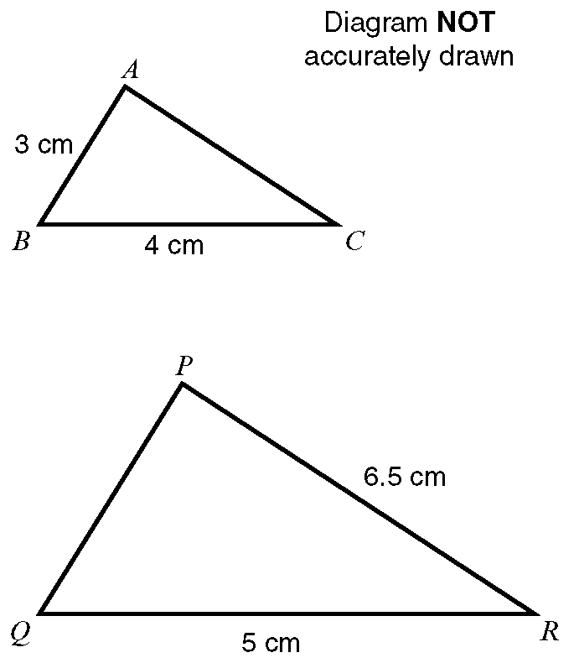

Angle *ABC* = angle *PQR*.

Angle *ACB* = angle *PRQ*.

Calculate the length of:

**i)** *PQ*

**ii)** *AC*

—————————————————————————————————————————

# **Question 31**



**(a)** Describe fully the single transformation that maps shape **P** onto shape **Q**.

**(2 marks)**

**(b)** Rotate shape **P** 90° anticlockwise about the point *A* (1, 1). **(2 marks)**

—————————————————————————————————————————

# **Question 32**

Calculate the length of *AB*.

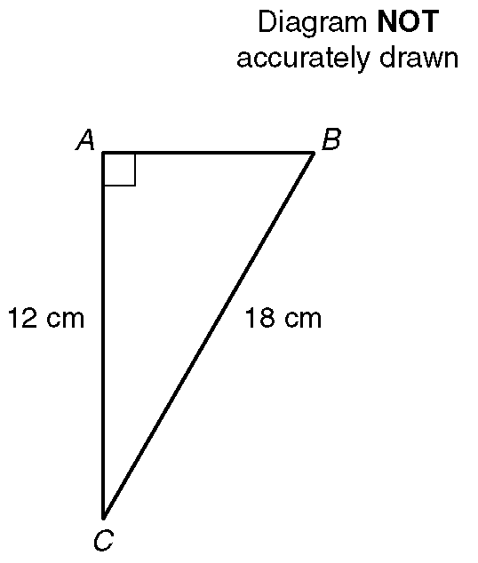

Give your answer correct to 1 decimal place.

—————————————————————————————————————————

# **Question 33**

Martin bought a packet of mixed flower seeds.

The seeds produce flowers that are Red or Blue or White or Yellow.

The probability of a flower seed producing a flower of a particular colour is:



**(a)** Write down the most common colour of a flower. **(1 mark)**

Martin chooses a flower seed at random from the packet.

**(b) i)** Work out the probability that the flower produced will be White.

**ii)** Write down the probability that the flower produced will be Orange.

**(3 marks)**

—————————————————————————————————————————

# **Question 34**

The probability that it will snow in London on Christmas Day in any year is 0.08

**(a)** Work out the probability that it will **not** snow in London on Christmas Day.

...............................

**(1 mark)**

**(b)** Work out an estimate for the number of Christmas Days in the next

50 years on which it will snow in London.

...............................

**(2 marks)**

—————————————————————————————————————————

# **Question 35**



In the diagram PQ and RS are straight lines.

**(a) i)** Work out the value of *a*.

**ii)** Give a reason for your answer.

**(b) i)** Work out the value of *b*.

**ii)** Give a reason for your answer.

**(c) i)** Work out the value of *c*.

**ii)** Give a reason for your answer.

—————————————————————————————————————————

# **Question 36**

In this question you **must** write down the units of your answer.

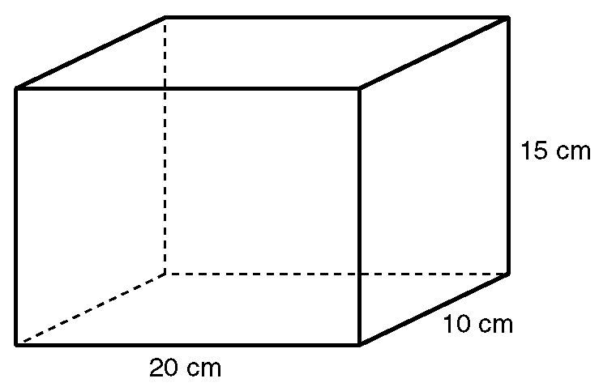

**(a)** Work out the area of the base of the solid shape.

**(b)** **i)** Work out the volume of the solid shape.

**ii)** Write this volume in litres.

—————————————————————————————————————————

# **Question 37**

The diagram shows the position of Colwyn Bay and the position of Blackpool.

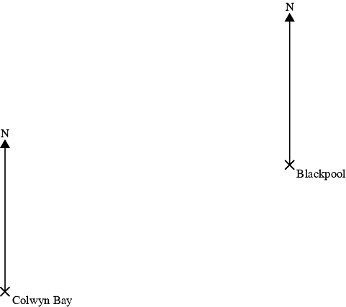

The bearing of a ship from Colwyn Bay is 032º.

The bearing of the ship from Blackpool is 290 º .

In the space above, draw an accurate diagram to show the position of the ship.

Mark this position with a cross **(X)**. Label it S. **(3 marks)**

—————————————————————————————————————————

# **Question 38**



The diagram represents a rectangle which is 6 cm long.

A diagonal makes an angle of 23 º with a 6 cm side.

Calculate the length of a diagonal.

Give your answer correct to 3 significant figures. **(3 marks)**