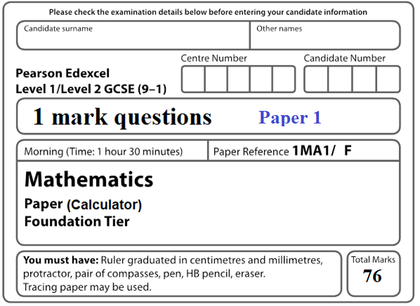

**Instructions**

* Use **black** ink or ball-point pen.
  + **Fill in the boxes** at the top of this page with your name,  
    centre number and candidate number.
* Answer **all** questions.
* Answer the questions in the spaces provided  
  *– there may be more space than you need.*
* You must **show all your working.**
* Diagrams are **NOT** accurately drawn, unless otherwise indicated.
* **Calculators may be used.**

**Information**

* The total mark for this paper is **76**.
* The marks for **each** question are shown in brackets  
  *– use this as a guide as to how much time to spend on each question.*

**Advice**

* Read each question carefully before you start to answer it.
* Keep an eye on the time.
* Try to answer every question.
* Check your answers if you have time at the end.

**1** Write these numbers in order of size.

Start with the smallest number.

|  |  |  |  |  |
| --- | --- | --- | --- | --- |
| 8 | −4 | 1 | −7 | −2 |

......................................................

**(1)**

**2** Here is a list of numbers.

|  |  |  |  |  |  |
| --- | --- | --- | --- | --- | --- |
| 7 | 8 | 15 | 16 | 18 | 22 |

Write down the number from the list that is a multiple of 6

.......................................................

**(1)**

**3** Find the value of 6 5

.......................................................

**(1)**

**4** Find  of 30

.......................................................

**(1)**

**5** Write the number 8375 correct to the nearest thousand.

.......................................................

**(1)**

**6** Here is a different number machine.

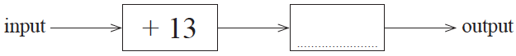

When the input is 17, the output is 10

Complete the number machine.

**(1)**

**7** Here are four digits.

|  |  |  |  |
| --- | --- | --- | --- |
| 5 | 6 | 1 | 9 |

Write down the three digit number closest to 200 that can be made with three of the digits.

.......................................................

**(1)**

**8** Write the following numbers in order of size.

Start with the smallest number.

|  |  |  |  |  |
| --- | --- | --- | --- | --- |
| –3 | 4 | 0 | –1 | 2 |

.............................................................................................................

**(1)**

**9** Write a number in each box to make the calculation correct.



56.3 + = 100

**(1)**

**10** Write 478 to the nearest hundred.

.......................................................

**(1)**

**11** The table shows the lengths of five rivers.

|  |  |
| --- | --- |
| **River** | **Length (km**) |
| Trent | 297 |
| Don | 112 |
| Severn | 354 |
| Thames | 346 |
| Mersey | 113 |

Write down the rivers in order of length.

Start with the shortest river.

......................................................................................................................................................

......................................................................................................................................................

**(1)**

**12** Here is a list of numbers.

|  |  |  |  |  |  |  |  |  |
| --- | --- | --- | --- | --- | --- | --- | --- | --- |
| 21 | 22 | 23 | 24 | 25 | 26 | 27 | 28 | 29 |

From the numbers in the list, write down a number that is a multiple of **both** 4 and 6.

......................................................

**(1)**

**13** Write  as a decimal.

.......................................................

**(1)**

**14** The pictogram shows information about the number of vinyl records sold in a shop on

Monday and on Tuesday.

|  |  |  |  |
| --- | --- | --- | --- |
| Monday |  |  | Key:    represents  8 vinyl records |
| Tuesday |  |  |
|  |
| Wednesday |  |  |  |
| Thursday |  |  |  |

Write down the number of vinyl records sold on Tuesday.

.......................................................

**(1)**

**15** Work out the value of 35

......................................................

**(1)**

**16** Write down a multiple of 8 that is between 41 and 60

.......................................................

**(1)**

**17** Solve 2 *f* + 7 = 18

*f* = ......................................................

**(1)**

**18** Here is a list of numbers.

|  |  |  |  |  |  |  |
| --- | --- | --- | --- | --- | --- | --- |
| 12 | 15 | 14 | 17 | 22 | 19 | 13 |

Bridgit says,

“To work out the median you find the middle number,

so the median of these numbers is 17”

Bridgit’s answer is **not** correct.

What is wrong with Bridgit’s method?

......................................................................................................................................................

......................................................................................................................................................

**(1)**

**19** Work out  of 720

.......................................................

**(1)**

**20** Write 3758 correct to the nearest 1000

.......................................................

**(1)**

**21** Write the number 2538 correct to the nearest hundred.

.........................................

**(1)**

**22`** Solve  = 3

*y* = ......................................................

**(1)**

**23** The table shows the lengths of five rivers.

|  |  |
| --- | --- |
| **River** | **Length (km**) |
| Trent | 297 |
| Don | 112 |
| Severn | 354 |
| Thames | 346 |
| Mersey | 113 |

Ami says,

“The River Thames is more than three times as long as the River Don.”

Show that Ami is correct.

......................................................................................................................................................

......................................................................................................................................................

**(1)**

**24** Write down a multiple of 6 that is between 40 and 50.

......................................................

**(1)**

**25** Simplify *y* + 3 *y* – 2 *y*

.......................................................

**(1)**

**26** Four biased coins, A, B, C and D are thrown.

The probability that each coin will land on Heads is shown in the table.

|  |  |
| --- | --- |
| **Coin** | **Probability** |
| A | 0.33 |
| B | 0.033 |
| C |  |
| D | 30% |

Which coin is least likely to land on Heads?

.......................................................

**(1)**

**27** Here is a list of numbers.

|  |  |  |  |  |  |  |  |  |
| --- | --- | --- | --- | --- | --- | --- | --- | --- |
| 21 | 22 | 23 | 24 | 25 | 26 | 27 | 28 | 29 |

From the numbers in the list, write down a square number.

......................................................

**(1)**

**28** Here are four different digits.

|  |  |  |  |
| --- | --- | --- | --- |
| 8 | 2 | 1 | 6 |

Put one of these digits in each box to give the smallest possible answer to the sum.

You must use each digit only once.



**(1)**

**29** Write 1.59 correct to 1 decimal place.

......................................................

**(1)**

**30** This is part of a bus timetable between Bury and Manchester.

|  |  |  |  |  |  |  |
| --- | --- | --- | --- | --- | --- | --- |
| **Bury** | 08 25 | 08 55 | 09 15 | 09 30 | 09 45 | 10 05 |
| Whitefield | 08 34 | 09 04 | 09 24 | 09 39 | 09 54 | 10 14 |
| Heaton Park | 08 46 | 09 16 | 09 36 | 09 51 | 10 06 | 10 27 |
| Cheetham | 08 56 | 09 26 | 09 46 | 10 01 | 10 16 | 10 37 |
| **Manchester** | 09 05 | 09 35 | 09 55 | 10 10 | 10 25 | 10 48 |

How many minutes should the 08 25 bus take to go from Bury to Manchester?

....................................................... minutes

(**1**)

**31**



On the diagram above, draw a diameter of the circle.

**(1)**

**32** Write the number two million in figures.

.......................................................

**(1)**

**33** Simplify 5*p –* 3*p + p*

......................................................

**(1)**

**34**  + = 1

**(1)**

**35** Simplify 3 *f* × 5 *g*

......................................................

**(1)**

**36** Here are the first 4 terms of a sequence.

|  |  |  |  |
| --- | --- | --- | --- |
| 2 | 9 | 16 | 23 |

Work out the 10th term of the sequence.

.......................................................

**(1)**

**37** An ordinary fair dice is thrown once.

Write down the probability that the dice lands on a number greater than 4

.......................................................

**(1)**

**38** Here is a 3-D shape.



Write down the name of this 3-D shape.

.......................................................

**(1)**

**39** Simplify 2 × *n* × *p* × 4

.......................................................

**(1)**

**___________________________________________________________________________**

**40** The scatter diagram shows information about 12 girls.

It shows the age of each girl and the best time she takes to run 100 metres.



Write down the type of correlation.

..............................................................................................................

**(1)**

**41** Write 3% as a fraction.

.......................................................

**(1)**

**42** Change 1756 grams to kilograms.

.......................................................kg

**(1)**

**43** The first term of a sequence of numbers is 24

The term-to-term rule of this sequence is ‘add 8’

Is 85 a number in this sequence?

Give a reason for your answer.

......................................................................................................................................................

......................................................................................................................................................

**(1)**

**44** Victoria throws an ordinary fair 6-sided dice once.

She says,

“The probability of getting a 3 is half the probability of getting a 6”

Is Victoria correct?

You must explain your answer.

......................................................................................................................................................

......................................................................................................................................................

**(1)**

**45** Write down the value of the 4 in the number 542.3

.......................................................

**(1)**

**46** Asma was asked to compare the following two numbers.

*A* = 6.212 × 108 and *B* = 4.73 × 109

She says,

“6.212 is bigger than 4.73 so *A* is bigger than *B*.”

Is Asma correct?

You must give a reason for your answer.

......................................................................................................................................................

......................................................................................................................................................

......................................................................................................................................................

**(1)**

**47** Change 7700 millilitres to litres.

...................................................... litres

**(1)**

**48** Change 4 kilometres into metres.

.......................................................metres

**(1)**

**49** Change 0.32 kilograms to grams.

...................................................... grams

**(1)**

**50** Factorise 4*m* + 12

.......................................................

**(1)**

**51** Bill wants to increase 150 by 3%

He writes down

150 × 1.3 = 195

Bill’s method is wrong.

Explain why.

......................................................................................................................................................

......................................................................................................................................................

**(1)**

**52** The table shows information about the numbers of points scored by 30 students in a quiz.

|  |  |
| --- | --- |
| **Number of points** | **Frequency** |
| 0 | 4 |
| 1 | 3 |
| 2 | 7 |
| 3 | 5 |
| 4 | 6 |
| 5 | 5 |

Find the modal number of points.

.......................................................

**(1)**

**53** Jenny is asked to find the value of 12 – 2 × 4

Here is her working.

12 – 2 × 4 = 10 × 4 = 40

Jenny’s answer is wrong.

Explain what Jenny has done wrong.

......................................................................................................................................................

......................................................................................................................................................

**(1)**

**54**



Rotate trapezium **T** 180° about the origin.

Label the new trapezium **A**.

**(1)**

**55** Four biased coins, A, B, C and D are thrown.

The probability that each coin will land on Heads is shown in the table.

|  |  |
| --- | --- |
| **Coin** | **Probability** |
| A | 0.33 |
| B | 0.033 |
| C |  |
| D | 30% |

Which coin is most likely to land on Heads?

.......................................................

**(1)**

**56** There are *y* boats on a lake.

There are 7 people in each boat.

Write an expression, in terms of *y*, for the total number of people in the boats.

.......................................................

**(1)**

**57** Rosie and Dan share some sweets.

Dan gets  of the sweets.

Write down the ratio of the number of sweets Rosie gets to the number of sweets Dan gets.

......................................................

**(1)**

**58** On the diagram below, draw a segment of the circle.

Shade the segment.



**(1)**

**59** Here is a list of numbers.

|  |  |  |  |  |  |  |  |  |
| --- | --- | --- | --- | --- | --- | --- | --- | --- |
| 21 | 22 | 23 | 24 | 25 | 26 | 27 | 28 | 29 |

Write down all the prime numbers in the list.

............................................................................................................

**(1)**

**60** Work out the cube root of 64

.......................................................

**(1)**

**61** Here is a triangle.

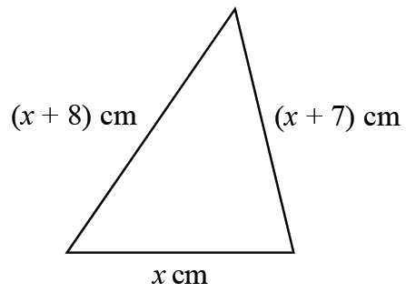

Iram solves a problem about this triangle to find the value of *x*.

Her answer is

*x* = −2

Explain why Iram’s answer must be wrong.

..................................................................................................................................................................................................................................................................................................................................................................................................................................................................

**(1)**

**62** Mary needs to work out the size of angle *x* in this diagram.

**

She writes

*x* = 63° because base angles of an isosceles triangle are equal.

Mary is wrong.

Explain why.

......................................................................................................................................................

......................................................................................................................................................

**(1)**

**63**



Translate trapezium **T** by the vector 

Label the new trapezium **B**.

**(1)**

**___________________________________________________________________________**

**64** Write the ratio 4.5 : 2.25 in the form *n* : 1

.......................................................

**(1)**

**65** The diagram shows five shapes on a centimetre grid.



Write down the name of shape **E**.

.......................................................

**(1)**

**66** Catherine says,

“2 is the only even prime number.”

Is Catherine right?

You must give a reason for your answer.

......................................................................................................................................................

......................................................................................................................................................

**(1)**

**67** Chrissy drew this graph to show the percentage of buses that got to a bus stop on time

for six months.



Write down **one** thing that is wrong with the graph.

......................................................................................................................................................

......................................................................................................................................................

**(1)**

**68** In the table below, put a tick (✓) in the box next to the identity.

|  |  |
| --- | --- |
| 3*h* + 2 = 14 |  |
| 3*a* + 4*b* – 2*c* |  |
| *A* = *πr*2 |  |
| 5*m* – 3*m* = 2*m* |  |
| *x* + 7 ⩽ 12 |  |

**(1)**

**69** Sally wants to decrease 150 by 3%

Complete this statement to show how Sally can decrease 150 by 3%

150 × ............................... = ...............................

**(1)**

**70** Write 56.78 correct to one significant figure.

......................................................

**(1)**

**71** Here are six graphs.

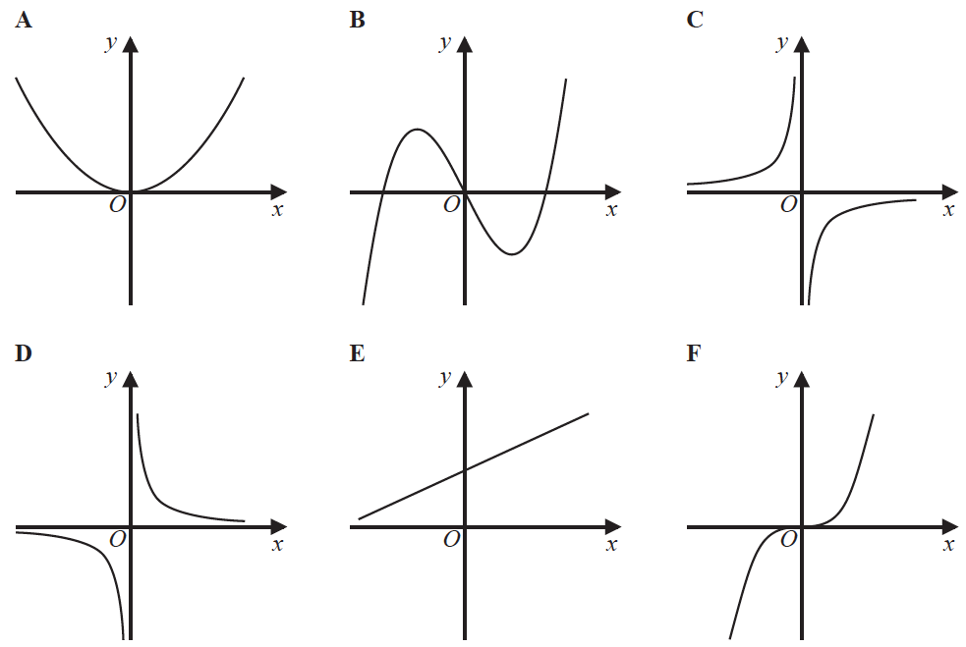

Write down the letter of the graph that could have the equation *y* = *x*3

.......................................................

**(1)**

**72** Simplify *m*3 + *m*3

......................................................

**(1)**

**73** Harley’s house has a value of £160 000 correct to 2 significant figures.

Write down the greatest possible value of the house.

£ .......................................................

**(1)**

**74** 3 of the 25 women have a shoe size of 7.

Zoe says that if you choose at random one of the 25 women, the probability that she has

either a shoe size of 7 or a dress size of 14 is  because



Is Zoe correct?

You must give a reason for your answer.

......................................................................................................................................................

......................................................................................................................................................

**(1)**

**75** Andy throws an ordinary fair 6-sided dice twice.

He says,

“The probability of getting a 6 on both throws is”

Is Andy correct?

You must explain your answer.

......................................................................................................................................................

......................................................................................................................................................

**(1)**

**76** Write 37 cm3 in mm3

.......................................................mm3

**(1)**

**TOTAL FOR PAPER IS 76 MARKS**