Maths Emporium
Best Value A
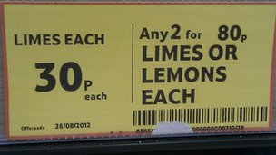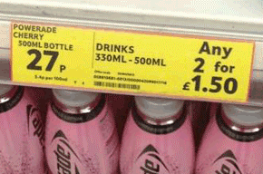

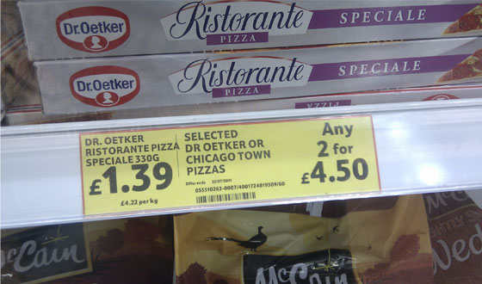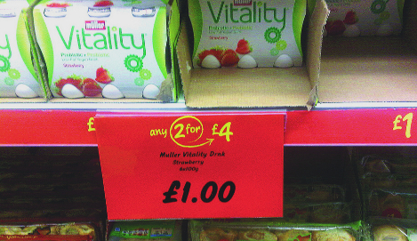

Introduction
Past papers aren’t just for practising your mathematics skills – they also useful for learning the basics you’ll need for all sorts of practical activities such as being able to work out the bargains when you go shopping. Supermarkets get it wrong from time to time – make sure that you don’t.

Information
The marks for individual recipes are shown in round brackets: e.g. (2).
There are 9 questions in this booklet. The total mark is 35.
Questions marked with a * sign will require working to be shown.
Calculators may be used in all questions.

Advice
Show all stages in any calculations.
Work steadily through the paper. Do not spend too long on one recipe.
If you cannot answer a question, leave it and attempt the next one.
Return at the end to those you have left out.
*1. A shop sells coffee in 3 different sizes of jar.
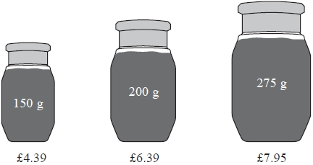
A 150 g jar of coffee costs £4.39
A 200 g jar of coffee costs £6.39
A 275 g jar of coffee costs £7.95
Which size of jar is the best value for money?
You must show all your working.

(Total 4 marks)
___________________________________________________________________________

*2. Tea bags are sold in three sizes of box.
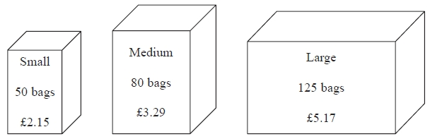

A small box of 50 tea bags costs £2.15
A medium box of 80 tea bags costs £3.29
A large box of 125 tea bags costs £5.17
Which size of box is the best value for money?
(Total 4 marks)
___________________________________________________________________________

*3. A shop sells toothpaste in 3 different sizes of tube.
A 70 ml tube of toothpaste costs £1.79
A 100 ml tube of toothpaste costs £2.75
A 150 ml tube of toothpaste costs £3.99
Which size of tube is the best value for money?
You must show all your working.
(Total 4 marks)
___________________________________________________________________________

*4. The same type of computer is sold in two shops.
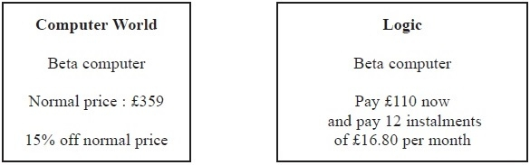
What is the difference in the cost of a Beta computer in Computer World and the cost of a Beta computer in Logic?
You must show all your working.
£ ...........................................................
(Total 5 marks)
___________________________________________________________________________

*5. Plants are sold in three different sizes of tray.
A small tray of 30 plants costs £6.50
A medium tray of 40 plants costs £8.95
A large tray of 50 plants costs £10.99
Kaz wants to buy the tray of plants that is the best value for money.
Which size tray of plants should she buy?
You must show all your working.
(Total 4 marks)
___________________________________________________________________________

*6. Milk is sold in two sizes of bottle.
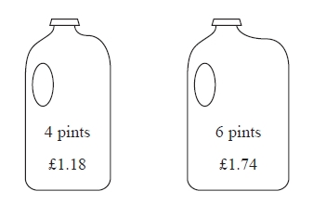
A 4 pint bottle of milk costs £1.18
A 6 pint bottle of milk costs £1.74
Which bottle of milk is the best value for money?
You must show all your working.
(Total 3 marks)
___________________________________________________________________________

*7. Ketchup is sold in three different sizes of bottle.
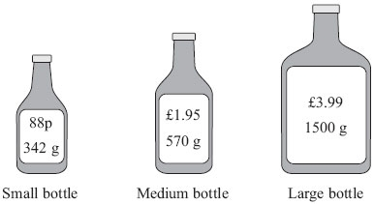

A small bottle contains 342 g of ketchup and costs 88p
A medium bottle contains 570 g of ketchup and costs £1.95
A large bottle contains 1500 g of ketchup and costs £3.99
Which bottle is the best value for money?
You must show your working.

(Total 4 marks)
___________________________________________________________________________

8.
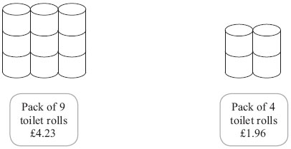
A pack of 9 toilet rolls costs £4.23
A pack of 4 toilet rolls costs £1.96
Which pack gives the better value for money?
You must show all your working.

...........................................................
(Total 3 marks)
___________________________________________________________________________

*9. Matches are sold in three sizes of box.
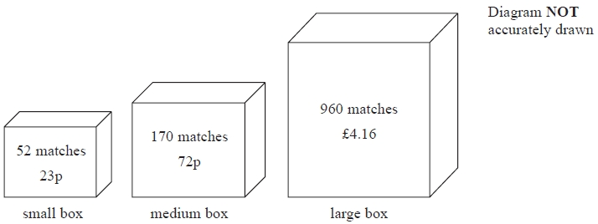
A small box contains 52 matches and costs 23p.
A medium box contains 170 matches and costs 72p.
A large box contains 960 matches and costs £4.16
Which size of box is the best value for money?
Show how you got your answer.

(Total 4 marks)
TOTAL FOR PAPER IS 35 MARKS

