Media language
Complete the quiz on media language.

Quick revision: Media language terminology
Answer the revision questions below. These are revision so you should know the answers, if you are unsure, use the internet to help
1
The GCSE Media studies theoretical framework is based on four key areas. What are the 4 key areas?

2
What is the name of the theorist who argues that all narratives feature eight key characters, including the villain and the helper?

3
What character usually comes into conflict with the protagonist?

4
What is the word to communicate a deeper meaning in a media product? For example, a red rose might be used to _________ romance

5
What is the word for when everything is calm and balanced in a narrative? This is often at the start, before any conflict occurs.

6
A camera shot that looks down on an object or character from a great height gives the audience a bird's- ____ view

7
What is the camera shot that looks up at an object or character from below?

8
What is the name of the theorist that who states that narratives move from equilibrium through disruption to resolution?

9
What is a key feature of most advertising products: a short phrase that communicates important information about a product or brand?

10
What do you call a media product that combines elements from two or more genres, for example, a rom-com?

11
Mise-en-_____ : the placement of everything within a frame

Section 2
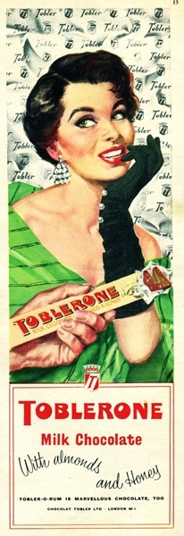
Analysis of visual codes Answer ALL questions
This Toblerone advert is from the 1950s. It will help you to revise the codes and conventions of historical adverts and to practice for the unseen analysis in the Component 1 exam.

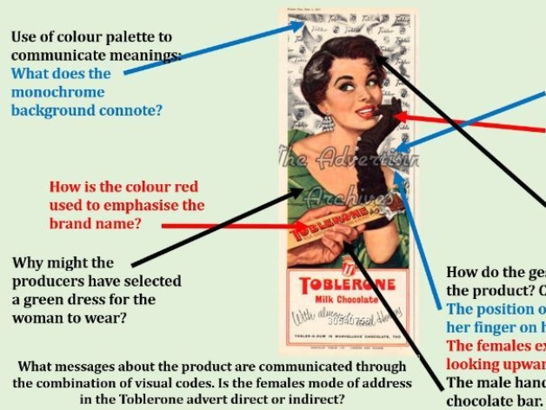

12
This is a long answer question, make sure you answer all of the questions. Analyse the use of visual codes in this advertisement, using the questions below: Use of colour palette to communicate meanings: what does the monochrome background connote?
How is the colour red used to emphasise the brand name?
Why might the producers have selected a green dress for the woman to wear?

What are the connotations of the dress code?
Consider the selection of: the off - the- shoulder silk dress.
Accessories: the long black glove with pearl buttons and large diamond earrings. The woman's short hairstyle and bold make-up.

How do the gesture codes help to sell the product?
Consider: The position of the female's hand with her finger on her lip. The female's expression: smiling, looking upwards out of the frame. The male hand offering her the chocolate bar.

13
What messages about the product are communicated through the combination of visual codes?

14
Is the female's mode of address in the Toblerone advert direct or indirect?

Section 3
Technical codes - camera shots
You will need to give examples of the types of shots used in print and audio-visual products. It is important to consider the distance and angle of the shot, and to analyse the meanings created.
You are being asked below to explain the type of shot, Explain its purpose (What does this type of shot communicate? why might it be used?)
An example: Extreme close-up - Shows the emotion in a character's face. Allows the audience to understand or identify with them.
15
Close-up What does this type of shot communicate? Why might it be used?

16
medium close-up What does this type of shot communicate? Why might it be used?

17
Long shot What does this type of shot communicate? Why might it be used?

18
High-angle shot What does this type of shot communicate? Why might it be used?

19
Low-angle shot What does this type of shot communicate? Why might it be used?

Representation
Section 1
Stereotypes
A stereotype is an exaggerated and oversimplified portrayal of a person or social group. Stereotypes are a mean of 'labelling' or categorising people using features such as appearance, accent, social class or occupation. Media producers can reinforce stereotypical representations of a particular social group, or might subvert stereotypes in a media text These statements below relate to media stereotypes. Decide which are true and which are false.
1
stereotypes are usually positive
[Control]true
[Control]false
2
less powerful groups in society are often stereotyped
[Control]true
[Control]false
3
sitcoms rarely use stereotypes
[Control]true
[Control]false
4
stereotypes usually stay the same over time
[Control]true
[Control]false
5
older people are often stereotyped as being weak or fail
[Control]true
[Control]false
6
younger people are often stereotyped as good students
[Control]true
[Control]false
7
woman have often been stereotyped as domesticated and maternal, while men were shown to spend long hours outside the home
[Control]true
[Control]false

Section 2
Areas of representation: gender, age and ethnicity
The time and place in which a product is created will affect the way that representations are constructed. It is important, therefore, to consider social, cultural and historical contexts when studying representations of gender, age and ethnicity. Stereotypes that are used might also develop over time due to changing attitudes and values in society.
8
Gender
In your studies, you will analyse the ways the media products construct representations of masculinity and femininity. Representation of gender changes over time. Stereotypical representations of gender so still exist, however, in some media products.

For example, some people may think that there children toys are designed for either boys or girls. What do you think about this statement? What might a toy that was designed for a girl look like? What might a toy that was designed for a boy look like?

9
Look at these media texts from the 1950's and 1960's. (if the images are not clear enough lookup advertisements from the 50's and 60's)
Write down any of the words that you think best sums up how women were represented in Media texts in the 1950’s/60’s
SUBMISSIVE DOMINANT MOTHERS WIVES CAREER WOMEN PRETTY NURTURING THIN INDEPENDENT PERFECT COMPLICATED SIMPLE ETHNICALLY DIVERSE WHITE
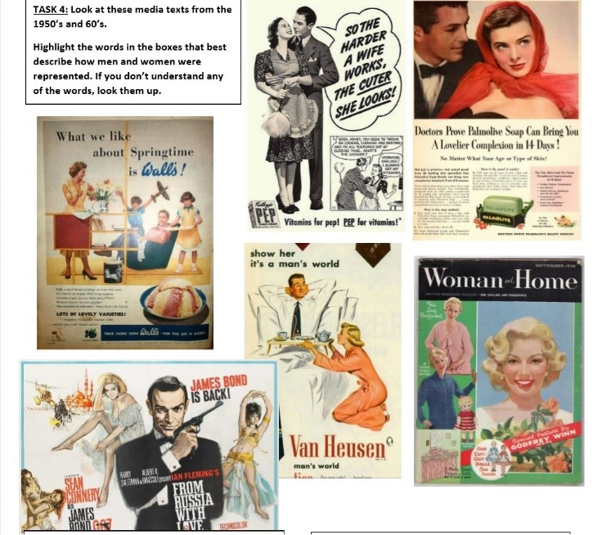

10
Same question but this time write down the words you think best represent the men in Media texts in the 1950’s/60’s STRONG DOMINANT WEAK SIMPLE SMART PROFESSIONAL SCARED IN CONTROL HOMEMAKERS HANDSOME NURTURING PROVIDERS PROTECTORS CLEAN CUT ETHNICALLY DIVERSE WHITE

11
Times change and that means that the way the media represents things change. Look at these representations of men and women in contemporary (modern) media texts and write a short paragraph about how you think representations of men and women have changed since the 1950’s.
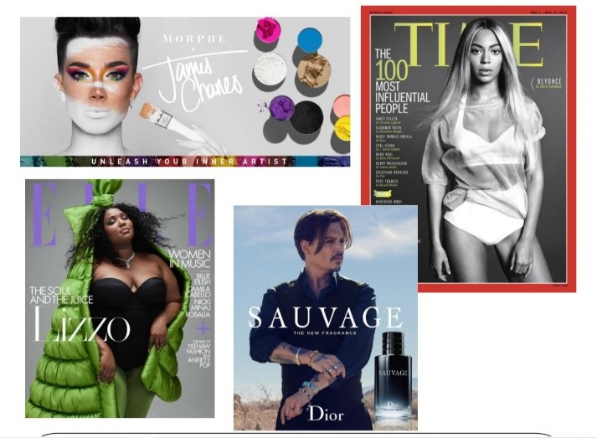

12
Age
You need to be able to analyse the representation of different age groups in the media.
List three aspects of stereotypes associated with teenagers and three stereotypes linked to older people.

13
Ethnicity
A person's ethnicity relates to their natural, cultural or religious identity.
Do you think how ethnicity is represented in the media will change in the next few months? Explain your answer.

Media Industries
The study of media industries looks at how organisations and media producers create media products. You will need to consider how processes of production, distribution and circulation affect media forms and platforms.

MEDIA INDUSTRY QUIZ! See whether you know the answers to any of these questions already. If you don’t know the answer carry out a bit of research and find out what it is!
Section 1
1.Name two companies that Disney owns

2.If a film is rated 12A who can go and see it?

3.What 2 UK national newspapers does Rupert Murdoch’s company News Corps own?

4.How do magazine publishers use digital media to make magazine content available online?

5.What different channels does the BBC have?

6.Who regulates TV and radio?

7.What is a PEGI rating in relation to gaming?

8.What different ways can a music artist release their songs?

9.What does ASA stand for in relation to advertising?

10.What company produces the James Bond films?

11.What does BBC stand for?

12.What company does Simon Cowell own?

Section 2
Media regulation
Complete the text using the words below.

The role of the regulator varies across different media 1. ______________________. In some cases, the regulator offers advice or guidance to media companies about the 2. _________________________ that they should uphold. IPSO, for example, has an Editors' Code of Practice that includes a list of 3. _________________________ or 'rules' that newspaper must abide by. Some regulatory bodies monitor media 4. _____________________ to ensure that they follow these rules. This might also involve responding to 5. ____________________, for example from members of the public, if the rules have been broken. The main purpose of regulation is to protect the public, especially younger people, from unsuitable or potentially harmful content in media 6. ______________________. There are some key 7. ______________________ that feature in the regulatory guidelines for most media industries, including violence, bad language and sexual content. The Video Standards Council, for example, manages the PEGI ratings system in the UK. This system 8. ________________________ video games into different age 9.________________________, which helps families to decide whether a game is suitable to play.

GUIDELINES CLASSIFIES INDUSTRIES PRODUCTS CATEGORIES ELEMENTS STANDARDS ORGANISATIONS COMPLAINTS

Audiences
In studying audiences, you are examining media consumers and consumption, including how media producers target and communicate with audiences, how audiences respond to media products, and how audiences can themselves become producers of media content.

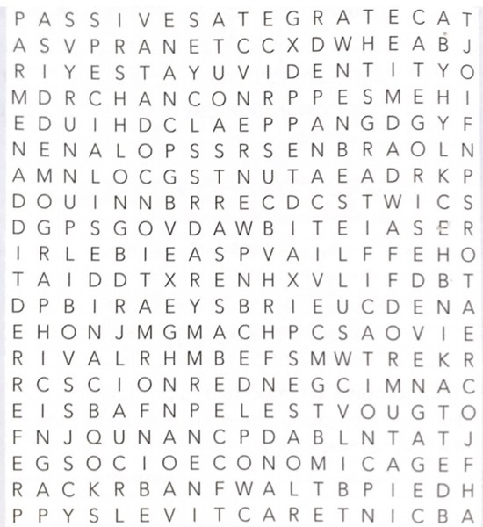

Audience Terminology
Fill in the blanks below. The first letter of the word is given as a clue. All words can be found in this word search attached (use if you are stuck).

Revision tip: Make a list of the terminology from this exercise and try to include it when you practice writing exam questions.

1
Media products communicate with the audience through a mode of a__________.

2
Media products a__________ to the target audience through elements such as use of stars, genre conventions and so on.

3
Media producer c_____________ audiences into different groups to help them to target their products effectively.

4
Digital technologies have enabled people to become c__________ of media content, for example by constructing their own blog sites.

5
G__________ is important for media producers to consider when targeting audience, as males and females may have different interest

6
The key audience theory that you need to study argues that people choose media products to fulfil a particular use or g____________.

7
One reason why people choose to consume a media product is to feel a sense of personal i__________, for example they might relate to a character in a television program.

8
A reason why people choose media products is to find out about the world and to gain i_____________.

9
Some types of media product, for example video games, allow audiences to engage more and become i___________

10
If a media audience consumes a product without actively selecting them they are said to be p__________.

11
The t________ audience is the main group fo people that a product is aimed at.

12
Some media products are created for a large, mass audience while others are intended for a smaller, s___________ audience.

Section 2
Large or specialised audience?

Use the following list of questions to decide if the audience for a media product is large or more specialised.
Look at each of the following set products:
The Sun The Archers Luther Uptown Funk Roar
Note: these are some of the set products you will be studying in detail over the next two years.

13
The Sun
Does The Sun have a mass audience or a more specialised audience?
Consider and write about the following: Is the product suitable for different age groups? If so, this will widen the potential audience.
Is the content or narrative based on easily understandable ideas or themes, such as good versus evil? These tend to appeal to a 'mass' audience.
Are both males and females being targeted, or is the product specifically aimed at men or women? Targeting one gender will limit the potential audience.
Does the product use intertextual references? If the references are to popular products, then maybe more people will recognise them. If the references are more 'niche', fewer people are likely to engage with the product.
How easy is it to access the product? A wide distribution circulation across different platforms will allow a large audience to consume the product.
Is the product available in many different countries? Global distribution allows more people to have access to the product.

14
The Archers
Does The Archers have a mass audience or a more specialised audience?
Consider and write about the following: Is the product suitable for different age groups? If so, this will widen the potential audience.
Is the content or narrative based on easily understandable ideas or themes, such as good versus evil? These tend to appeal to a 'mass' audience.
Are both males and females being targeted, or is the product specifically aimed at men or women? Targeting one gender will limit the potential audience.
Does the product use intertextual references? If the references are to popular products, then maybe more people will recognise them. If the references are more 'niche', fewer people are likely to engage with the product.
How easy is it to access the product? A wide distribution circulation across different platforms will allow a large audience to consume the product.
Is the product available in many different countries? Global distribution allows more people to have access to the product.

15
Luther
Does Luther have a mass audience or a more specialised audience?
Consider and write about the following: Is the product suitable for different age groups? If so, this will widen the potential audience.
Is the content or narrative based on easily understandable ideas or themes, such as good versus evil? These tend to appeal to a 'mass' audience.
Are both males and females being targeted, or is the product specifically aimed at men or women? Targeting one gender will limit the potential audience.
Does the product use intertextual references? If the references are to popular products, then maybe more people will recognise them. If the references are more 'niche', fewer people are likely to engage with the product.
How easy is it to access the product? A wide distribution circulation across different platforms will allow a large audience to consume the product.
Is the product available in many different countries? Global distribution allows more people to have access to the product.

16
Roar -Katy Perry
Does Roar have a mass audience or a more specialised audience?
Consider and write about the following: Is the product suitable for different age groups? If so, this will widen the potential audience.
Is the content or narrative based on easily understandable ideas or themes, such as good versus evil? These tend to appeal to a 'mass' audience.
Are both males and females being targeted, or is the product specifically aimed at men or women? Targeting one gender will limit the potential audience.
Does the product use intertextual references? If the references are to popular products, then maybe more people will recognise them. If the references are more 'niche', fewer people are likely to engage with the product.
How easy is it to access the product? A wide distribution circulation across different platforms will allow a large audience to consume the product.
Is the product available in many different countries? Global distribution allows more people to have access to the product.

17
Uptown Funk - Bruno Mars
Does Uptown Funk have a mass audience or a more specialised audience?
Consider and write about the following: Is the product suitable for different age groups? If so, this will widen the potential audience.
Is the content or narrative based on easily understandable ideas or themes, such as good versus evil? These tend to appeal to a 'mass' audience.
Are both males and females being targeted, or is the product specifically aimed at men or women? Targeting one gender will limit the potential audience.
Does the product use intertextual references? If the references are to popular products, then maybe more people will recognise them. If the references are more 'niche', fewer people are likely to engage with the product. How easy is it to access the product?
A wide distribution circulation across different platforms will allow a large audience to consume the product.
Is the product available in many different countries? Global distribution allows more people to have access to the product.

18
One of the ways that audiences might be categorised is by age.
Give the approximate age range of the following groups:
Baby Boomer
Generation X
Millennial

Section 3
Mode of address

The mode of address can be either direct or indirect. Look at each quote below and decide whether it is using a direct or indirect mode of address.

19
'How far would you go to be beautiful?'
[ ]Direct
[ ]indirect
20
Man up! How to be a man in 2016 (it's not as hard as you think)
[ ]Direct
[ ]Indirect
21
Tragedy sparks calls for action across Europe.
[ ]Direct
[ ]Indirect
22
As PM flies to meet EU leaders you tell him ...
[ ]Direct
[ ]Indirect

Section4
Uses and Gratification - Key theory

This theory states that media audiences are active and choose to consume different types of media products to fulfil particular needs. Blumer and Katz identified four main uses and gratifications that audiences gain from media products
Information
Personal Identity
Social interaction
Entertainment/Diversion

How might each of the following products fulfil the uses and gratification proposed by Bulmer and Katz?
Newspapers Viedo games Radio drama Television drama or sitcom Music videos Music websites

Example Radio drama: Information - Listener might find out about the current issues in society that is represented in the storylines, satisfying their need to be informed about what is happening in the world.

23
How might newspaper products fulfil the uses and gratification proposed by Bulmer and Katz?

24
How might Viedo games fulfil the uses and gratification proposed by Bulmer and Katz?

25
How might television drama or sitcom fulfil the uses and gratification proposed by Bulmer and Katz?

26
How might music videos fulfil the uses and gratification proposed by Bulmer and Katz?

27
How might music websites fulfil the uses and gratification proposed by Bulmer and Katz?

