GCSE PE 01/05/2020
Recap of last lesson:
Make a list of the SKILL related fitness aspects of a sport you take part in. Create a table with the skill related aspects in the left-hand column. In the right-hand column explain how you use these components when playing or performing.

Fitness Test
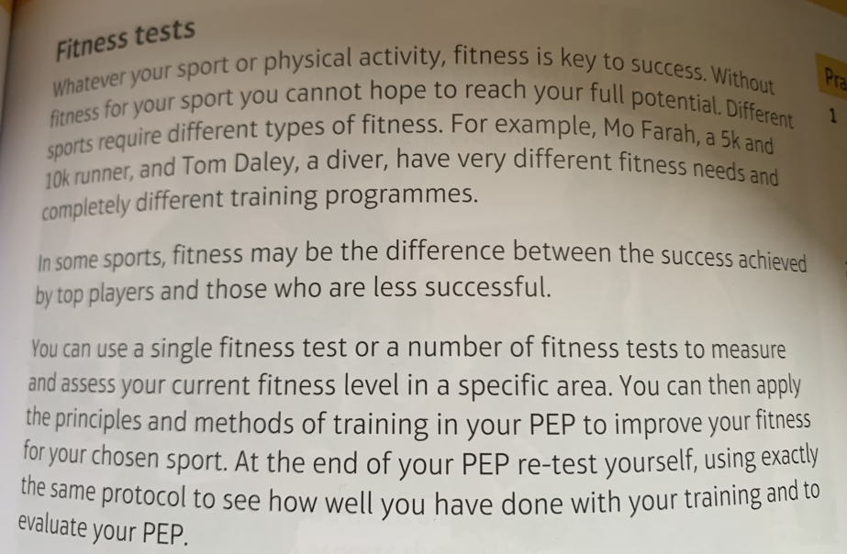

Please research the following about fitness tests:
Identify your strengths and weaknesses
……………………………………………………………………………………………………………………………………………….
……………………………………………………………………………………………………………………………………………….
……………………………………………………………………………………………………………………………………………….
……………………………………………………………………………………………………………………………………………….
……………………………………………………………………………………………………………………………………………….
……………………………………………………………………………………………………………………………………………….
Monitor progress
……………………………………………………………………………………………………………………………………………….
……………………………………………………………………………………………………………………………………………….
……………………………………………………………………………………………………………………………………………….
Give yourself an incentive
……………………………………………………………………………………………………………………………………………….
……………………………………………………………………………………………………………………………………………….
……………………………………………………………………………………………………………………………………………….
Choosing the right fitness
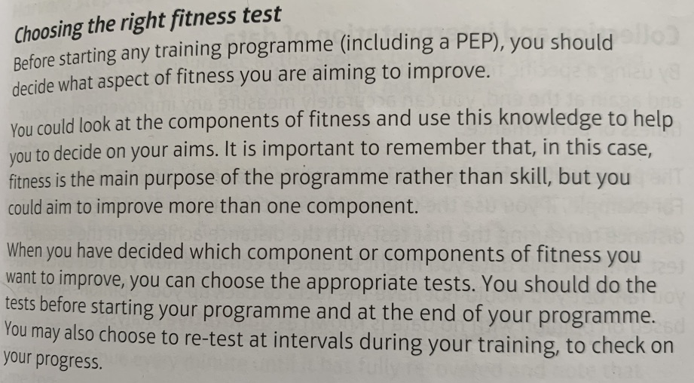
Quantitative analysis
……………………………………………………………………………………………………………………………………………….
……………………………………………………………………………………………………………………………………………….
Qualitative analysis
……………………………………………………………………………………………………………………………………………….
……………………………………………………………………………………………………………………………………………….
Protocol
……………………………………………………………………………………………………………………………………………….
……………………………………………………………………………………………………………………………………………….

Continue overleaf

Research all of these fitness test you must in include the purpose (which fitness component it tests) the Protocol and what type of data the test collects. You can display it any way you like.

Copper 12-minute run test One-minute press-up test

Harvard step test One-minute sit-up test

Hand grip strength test 30m Sprint

Vertical jump/Sargent jump test Sit and reach test

