Alphabet challenge

Learning Outcomes
On successful completion of this module, you will be able to:

- Use a digital camera or camera on your phone as a creative tool to record the alphabet.
- Apply knowledge of composition in setting-up, framing and capturing photographic images.
- Produce a portfolio of photographs that are visually appealing.
- Demonstrate use of image editing software in order to improve/crop photographs.

Project 1.
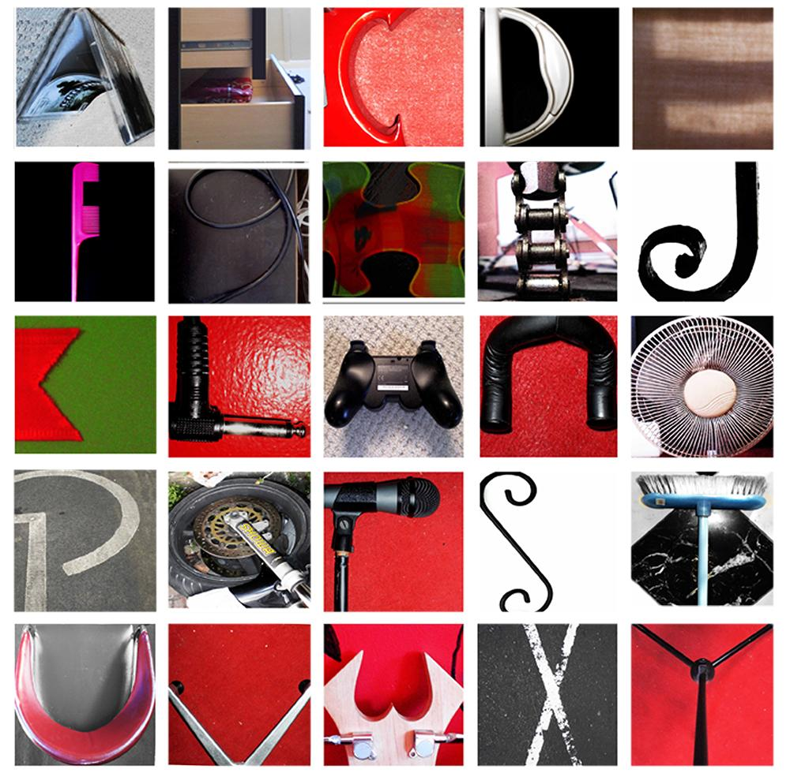
Using the camera find the full set of letters of the alphabet; A – Z from around your home.

Each CAPITAL letter should be framed to occupy and fill a square format.

The following should be considered:
- All photos must be your own work!

- Letters must be identified from either the natural or man-made environment.

- Consider composition – you don’t want a lot of negative space in these photographs

- The letter should be clear, you do not want a distracting background

- Photographs may need minor adjustments in an image editing app. (I will post a list of Photoshop alternatives)

Extension:
- Consider a colour palette – mono chrome, complementary colours, black and white etc.

An example is given to show you what it can look like.

Presentation of the alphabet

There is a template to help you arrange the alphabet in perfect squares

- Copy and paste this template to a PowerPoint slide.

- Drag you photographs in on top of the template.

- Crop the photograph so that is it square (Format > crop)

- Resize (drag photograph from one of the four corners to keep the photograph in proportion)

Alternatively if you can think of a more creative way to display your alphabet feel free to do this.

