Worksheet 1.2.7 Explaining static charge

page 1/2

1 Atoms and static charge >
a) Draw a diagram labelled to show the basic structure of an atom.

b) Describe how an object can become positively charged.

2 Effects of static charge >>
a) Explain how static electricity sometimes causes attraction and, in other instances, repulsion.

b) The arrows show attraction or repulsion in the three pairs of rods. Draw + and – signs on the rods to show the static charge.
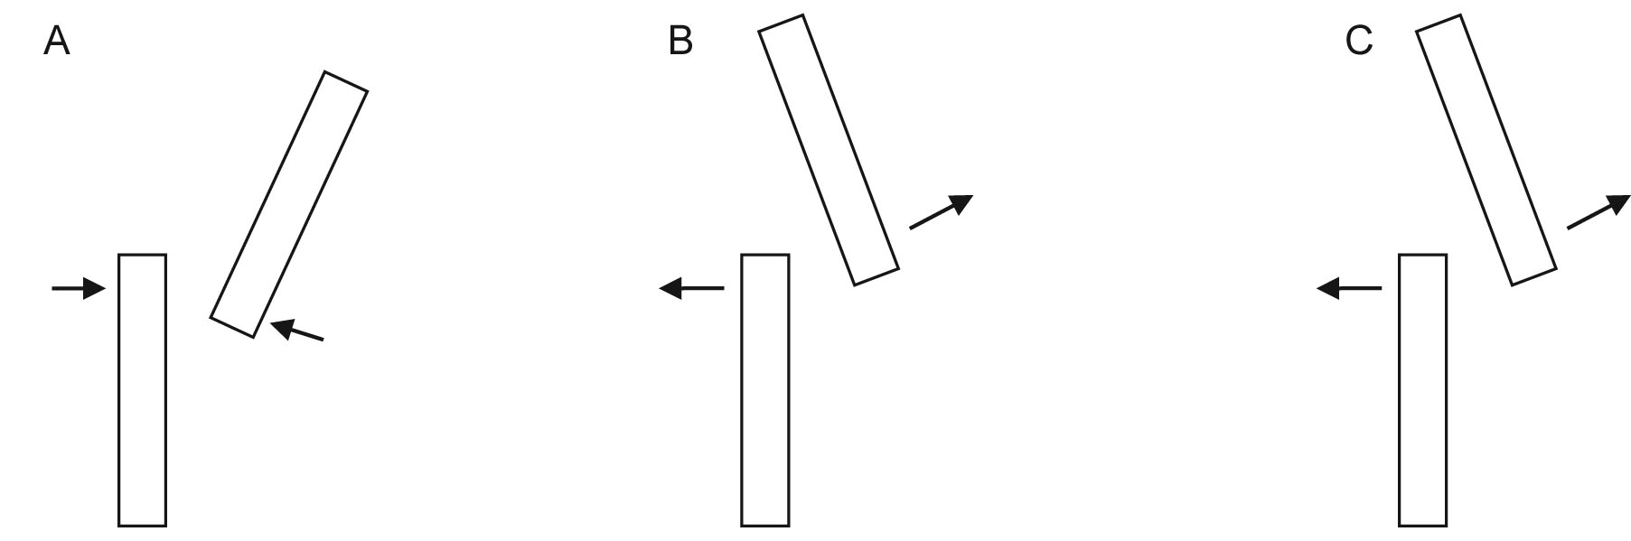

Worksheet 1.2.7 Explaining static charge

page 2/2
c) Draw annotated diagrams to explain at least one of the following:
i) a charged rod attracting fluff;
ii) a van de Graaff generator lighting up a bulb;
iii) a charged balloon stuck to a wall but eventually falling off;
iv) dust sticking to a TV screen;
v) a person walking across a carpet and getting an electric shock from a door handle.

3 Using ideas and evidence to understand static electricity >>>
a) Explain why understanding the structure of the atom helps to explain static electricity.

b) What evidence is there that static charge is an electrical effect?

