Worksheet 1.2.5 Comparing series and parallel circuits

page 1/2

1 Recap series and parallel circuits >
Record what you know about current and voltage in series and parallel circuits.
In a series circuit the current…. | In a series circuit the voltage…
In a parallel circuit the current…. | In a parallel circuit the voltage ….

2 Calculate current and voltage >>
Work out the values of voltage and current on meters A to D in the two circuit diagrams. All the light bulbs are identical. The ammeters and voltmeters do not affect the circuits.

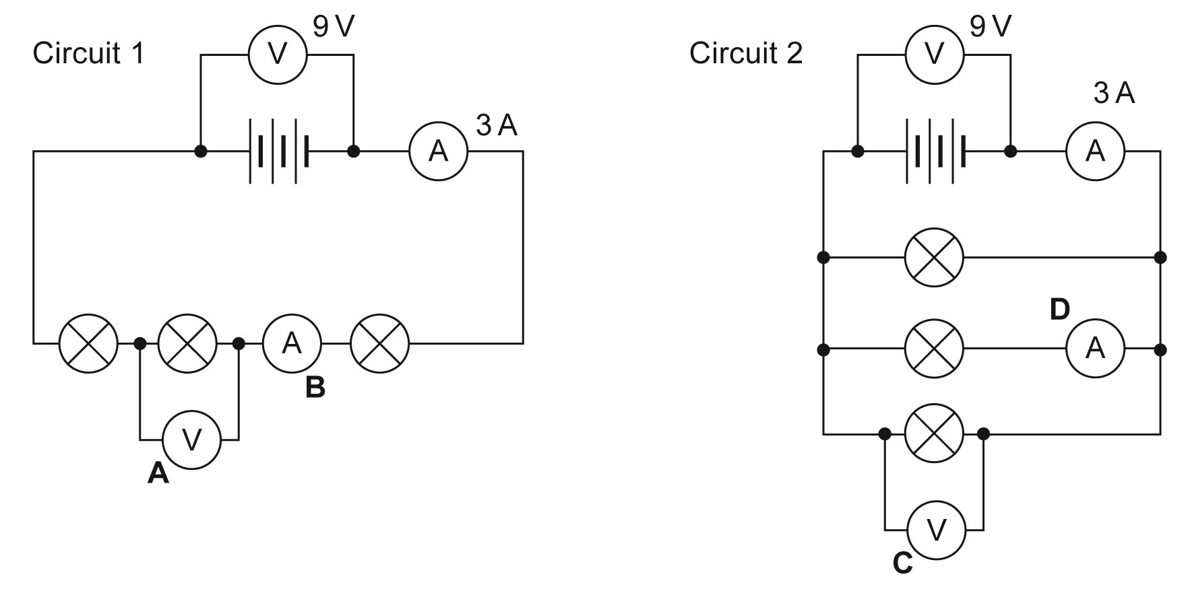

A .............................. C ..............................
B .............................. D ..............................

Worksheet 1.2.5 Comparing series and parallel circuits

page 2/2

3 Make predictions >>>
a) Using V / I = R, calculate the resistance of the series circuit in task 2.

b) What is the resistance of one bulb? (They are all identical.)

c) Another identical bulb and another identical cell are then added to the series circuit.
Calculate the resistance of the circuit with four bulbs.

d) Using I = V / R, calculate the current in the series circuit with four bulbs and four cells.

e) What does this tell you about the brightness of the bulbs in this circuit, compared with the original circuit?

