Worksheet 2.1.8 Explaining sinking and floating

page 1/2

1 Write a true/false quiz >
Write ten statements, a mixture of true and false, about floating and sinking. Work with a partner to test each other’s understanding of the topic.
1
2
3
4
5
6
7
8
9
10

2 Objects in water >>
A large container of water is sitting on a balance. The weight of the container plus the water is 10 N.
An object of weight 7 N, hanging from a forcemeter, is lowered towards the surface of the water.
What readings on the balance and on the forcemeter would you expect:
a) before the object comes into contact with the water?
Balance: .......... Forcemeter: ..........
b) when the object is fully submerged but not in contact with the base of the container? (The water does not overflow from the container.)
Balance: .......... Forcemeter: ..........
c) when the object is only half submerged?
Balance: .......... Forcemeter: ..........
d) when the object is sitting on the bottom of the container?
Balance: .......... Forcemeter: ..........

Worksheet 2.1.8 Explaining floating and sinking

page 2/2

3 Different densities >>>
a) In the diagrams below, sealed boiling tubes are sitting in different liquids. Match the description of the contents to the correct diagram. Explain the reasons for your choices. Write the diagram letter and reasons under the correct description.
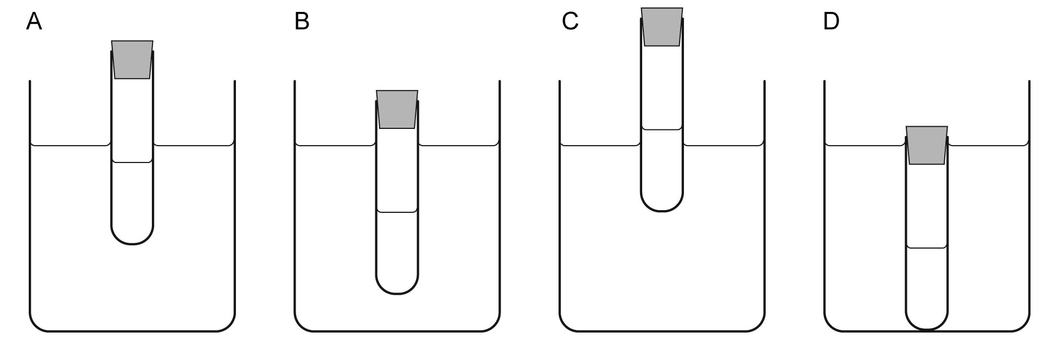

Descriptions:
i) a tube containing lead in a beaker of water ......

ii) a tube containing water in a beaker of water ......

iii) a tube containing water in a beaker of salt solution ......

iv) a tube containing salt solution in a beaker of water ......

b) Suggest why in diagram A the level of the liquid in the tube is different from the level in the beaker.

