Alternative methods of metal extraction: Worksheet 10.5.1

Copper mining and phytomining
1. The diagram maps out different methods of extracting copper from copper ore.
High-grade ore
Smelting (heating)
Electrolysis or displacement to produce/ purify copper metal
Phytomining
Bioleaching
Low-grade ore
a. What is the difference between high-grade ore and low-grade ore?

b. What environmental problems are created by traditional mining methods (digging, moving, waste disposal)?

c. Why are more low-grade copper ores used today than 50 years ago?

d. Most copper ores are copper sulfide, CuS. Traditional smelting involves heating the ore in air (oxygen) to produce copper and sulfur dioxide. Write a balanced symbol equation for the reaction.

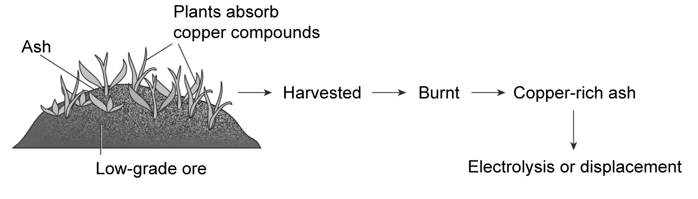
2. The diagram shows the stages in phytomining.

a. Explain the process of phytomining.

b. Why can burning the plants be considered carbon neutral?

c. Phytomining is a new method of extracting copper. It can be also be used on waste rock/ ore from processing high-grade ores. Explain why.

d. Use section 10.5 of the Student Book to find out what a ‘hyperaccumulator’ is.

