Worksheet 1.10.2 Exploring causes of variation

page 1/3

1 Observing variation >
Work with a partner to answer these questions.
a) What is:
i) inherited variation?

ii) environmental variation?

b) Below is a list of characteristics of a Year 9 student. Compile a table to show whether each characteristic is inherited, affected by the environment, or both.
Female Blue eyes
Height 1.6 m Shoe size 5
Blonde hair Can speak French
Good at tennis Has pierced ears
Can roll tongue Has a tan

c) There is a fable that says that the elephant got its trunk because a crocodile pulled the elephant’s nose when it went to drink in the river.
i) Could this fable be true? …………………
ii) Could an elephant with a stretched nose pass on the characteristic to its offspring? Give a reason for your answer.

Worksheet 1.10.2 Exploring causes of variation

page 2/3

2 Sibling variation >>
For this task you will work with a partner.
a) There is a variety of tomato that has yellow skin. When two yellow tomato plants are bred, the seeds grow into plants that produce yellow tomatoes.
i) How is the characteristic yellow skin passed on in tomatoes?

ii) List two environmental factors that could result in different-sized yellow tomatoes.

b) Explain why these sisters do not look the same.
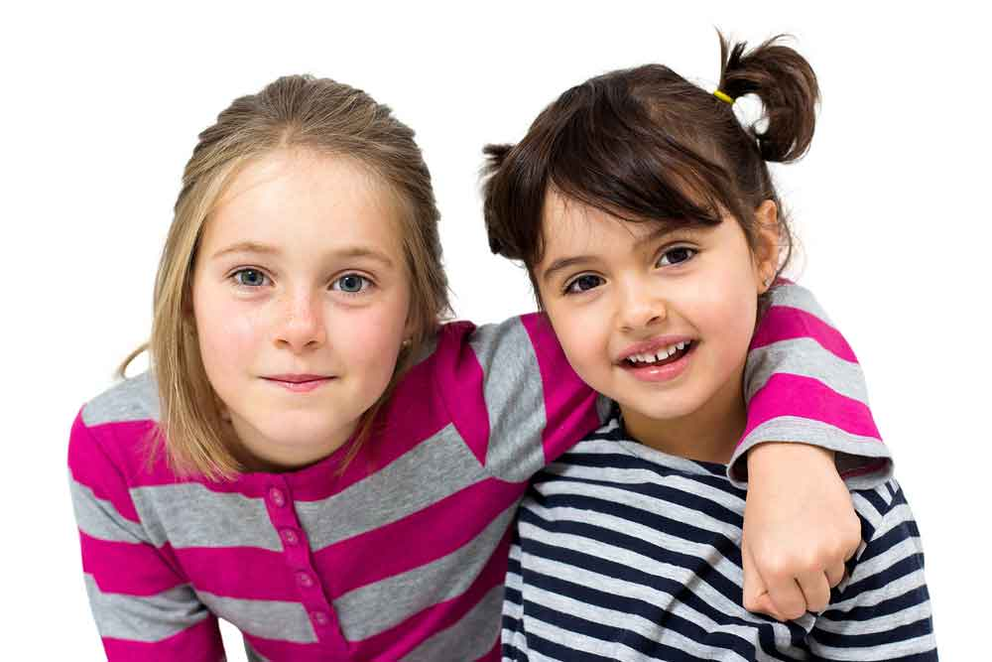

Worksheet 1.10.2 Exploring the causes of variation

page 3/3

3 Analysing variation >>>
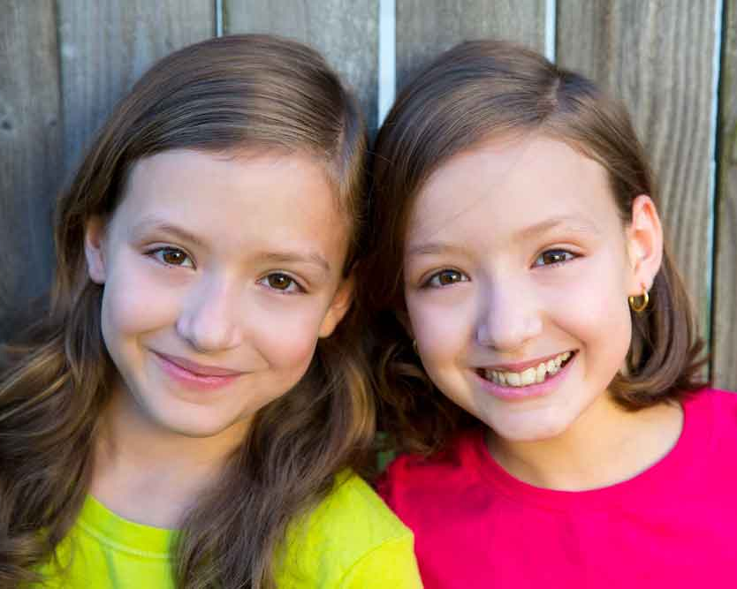
Work on your own to complete this task.
a) Explain, in terms of inherited variation and
environmental variation, why these identical
twins appear slightly different.

b) The giant panda is an endangered species. Explain how each of the following scenarios will
impact on:
- the short-term survival of pandas
- the long-term survival of pandas.
i) A panda mates with a closely related panda.

ii) A panda mates with an unrelated panda.

iii) Bamboo, the only food of pandas, is in short supply as a result of forest clearance.

iv) Bamboo supplies are plentiful.

v) Pandas encounter a new, potentially lethal disease.

