Worksheet 1.10.4b Understanding the female reproductive system and fertility

page 1/2

1 Matching parts to function >
Using the cards from page 2 of this worksheet, match up the parts of the female reproductive system with their jobs. Write down the matching numbers and letters below.
………………………………………………………………………………………………………………………

2 Describing the jobs of different parts >>
Name the parts of the female reproductive system indicated on the diagram.

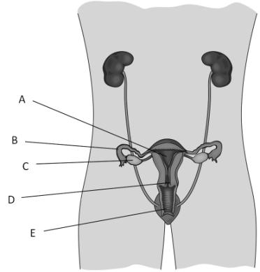

Explain what each part does. (Do not use the cards on page 2 of the worksheet.)

3 Strengths and weaknesses of the female reproductive system >>>
Describe what each part of the female reproductive system in task 2 does, and explain how the part is adapted to carry out its role.
………………………………………………………………………………………………………………………
………………………………………………………………………………………………………………………
………………………………………………………………………………………………………………………
State how problems with different parts of the female reproductive system can lead to infertility.
………………………………………………………………………………………………………………………
………………………………………………………………………………………………………………………
………………………………………………………………………………………………………………………
Worksheet 1.10.4b Understanding the female reproductive system and fertility

page 2/2

Part | Function
A Vagina | 1. Helps to navigate the sperm into the uterus; keeps the developing baby inside the uterus.
B Cervix | 2. Tube leading from the ovary to the uterus. The lining contain cells which push the egg cells along.
C Uterus | 3. Place where penis is received.
D Ovary | 4. This is where the developing baby grows.
E Oviduct | 5. Place where egg cells are made.

