Worksheet 1.10.6 Learning how a foetus develops

page 1/2

1 Development in the uterus >
Look at the diagram of the pregnant uterus.
a) Name all the parts shown on the diagram. Use these words:
placenta, umbilical cord, amniotic fluid, amniotic sac, cervix, vagina, wall of the uterus, mucus plug
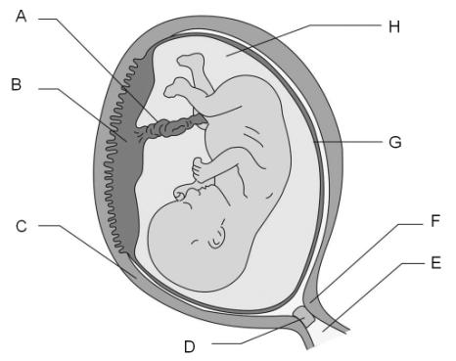

b) Complete the following passage using the words from this list:
protect, uterus, reproducing, amniotic fluid, placenta, oxygen, nutrients, umbilical cord
Growth means that the cells are .................................... The foetus attaches to the wall of the .........................................; this connection develops into the ......................................... The foetus connects to the placenta through the ………………………… This provides glucose, ………………………… and ....…………………… from the mother. As it gets bigger, a sac filled with ………………………… grows around the developing foetus. Its job is to ………………………… the foetus from bumps.

2 How does the foetus change with time? >>
Describe the job of the following parts of the pregnant uterus:
a) placenta b) umbilical cord c) amniotic fluid d) uterus
…………………………………………………………………………………………………………………
…………………………………………………………………………………………………………………
…………………………………………………………………………………………………………………
…………………………………………………………………………………………………………………
Worksheet 1.10.6 Learning how a foetus develops

page 2/2
Look at the images of the foetus as it changes with time and the data below it. Draw a graph to show how the length of the foetus changes during the course of pregnancy. Describe the pattern of the graph.

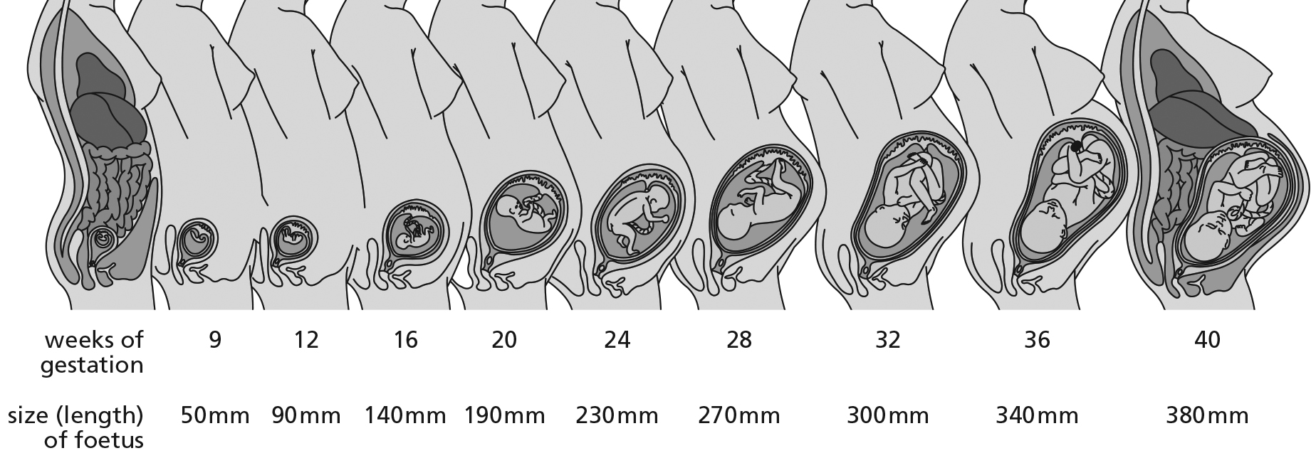

3 Animals without a placenta >>>
Tadpoles and birds are examples of animals that develop without a placenta that links them to the mother’s blood supply.
Do some research and, with the aid of drawings, explain how these organisms develop.
……………………………………………………
……………………………………………………
……………………………………………………
……………………………………………………
……………………………………………………
……………………………………………………
……………………………………………………
……………………………………………………
……………………………………………………
……………………………………………………
……………………………………………………
……………………………………………………
……………………………………………………
……………………………………………………
……………………………………………………

