Worksheet 1.8.1 Exploring the human skeleton

page 1/2

1 The human skeleton >
Name the bones A to N of the human skeleton.

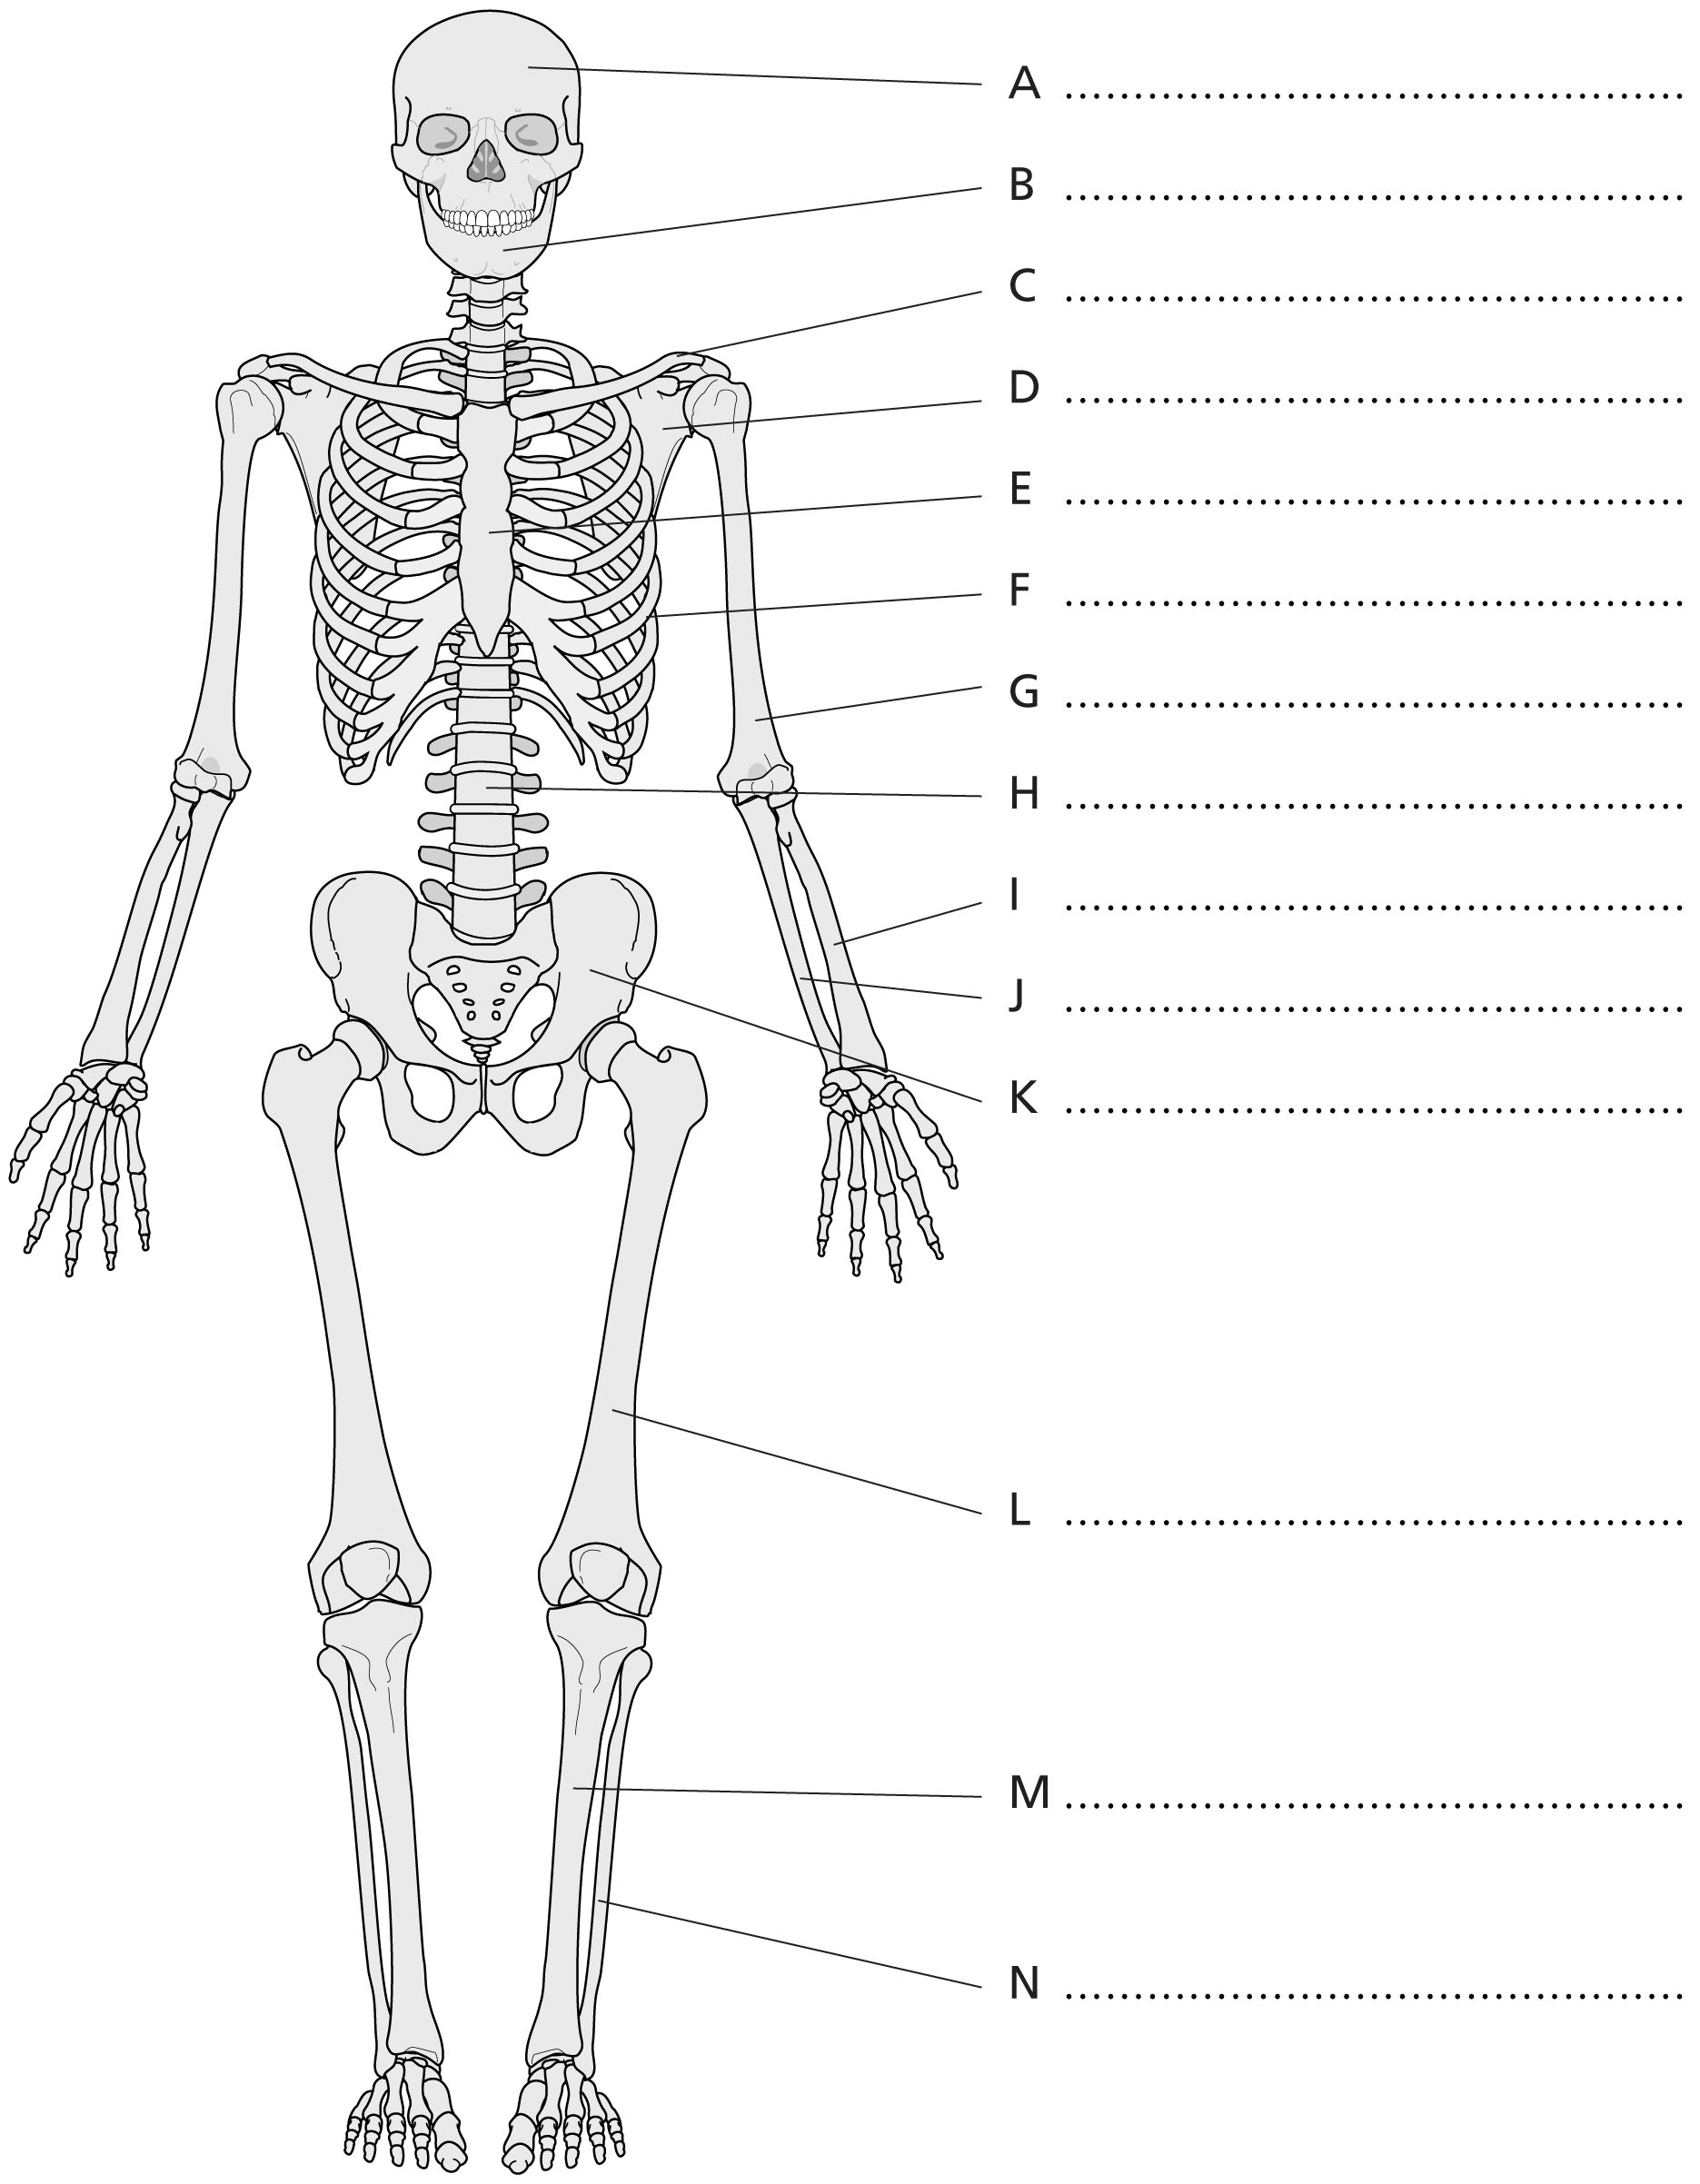

Worksheet 1.8.1 Exploring the human skeleton

page 2/2

2 The importance of bone marrow >>
There are three types of cells in the blood. Red blood cells carry oxygen around the body, where it is used to release energy. White cells are important in fighting infection. Platelets are needed for blood
to clot.
a) Explain the effect of not having enough red blood cells.
…………………………………………………………………………………………………………………
…………………………………………………………………………………………………………………
b) Explain the effect of not having enough white blood cells.
…………………………………………………………………………………………………………………
…………………………………………………………………………………………………………………
c) Explain the effect of not having enough platelets.
…………………………………………………………………………………………………………………
…………………………………………………………………………………………………………………

3 Chemical structure of bones >>>
Calcium is found in bones. Without sufficient calcium, bones become bendy. Calcium is needed in the body for muscle contraction, including the heart muscle. It is also used for blood clotting. If calcium levels in the blood decrease below a certain value, calcium is taken from the bones into the blood.

- Give evidence to support the statement in the box.
…………………………………………………………………………………………………………………
…………………………………………………………………………………………………………………
- Give an explanation to support the statement in the box.
…………………………………………………………………………………………………………………
…………………………………………………………………………………………………………………

We must ensure that we include calcium in our diets for strong bones.

