Worksheet 1.8.2 Understanding the role of skeletal joints

page 1/2

1 The main muscles of the human body >
Identify the main muscles (A to I) in the human body. Use these words:

pectoral muscle abdominal muscle quadricep
jaw muscle calf muscle forearm muscle
bicep tricep shoulder muscle
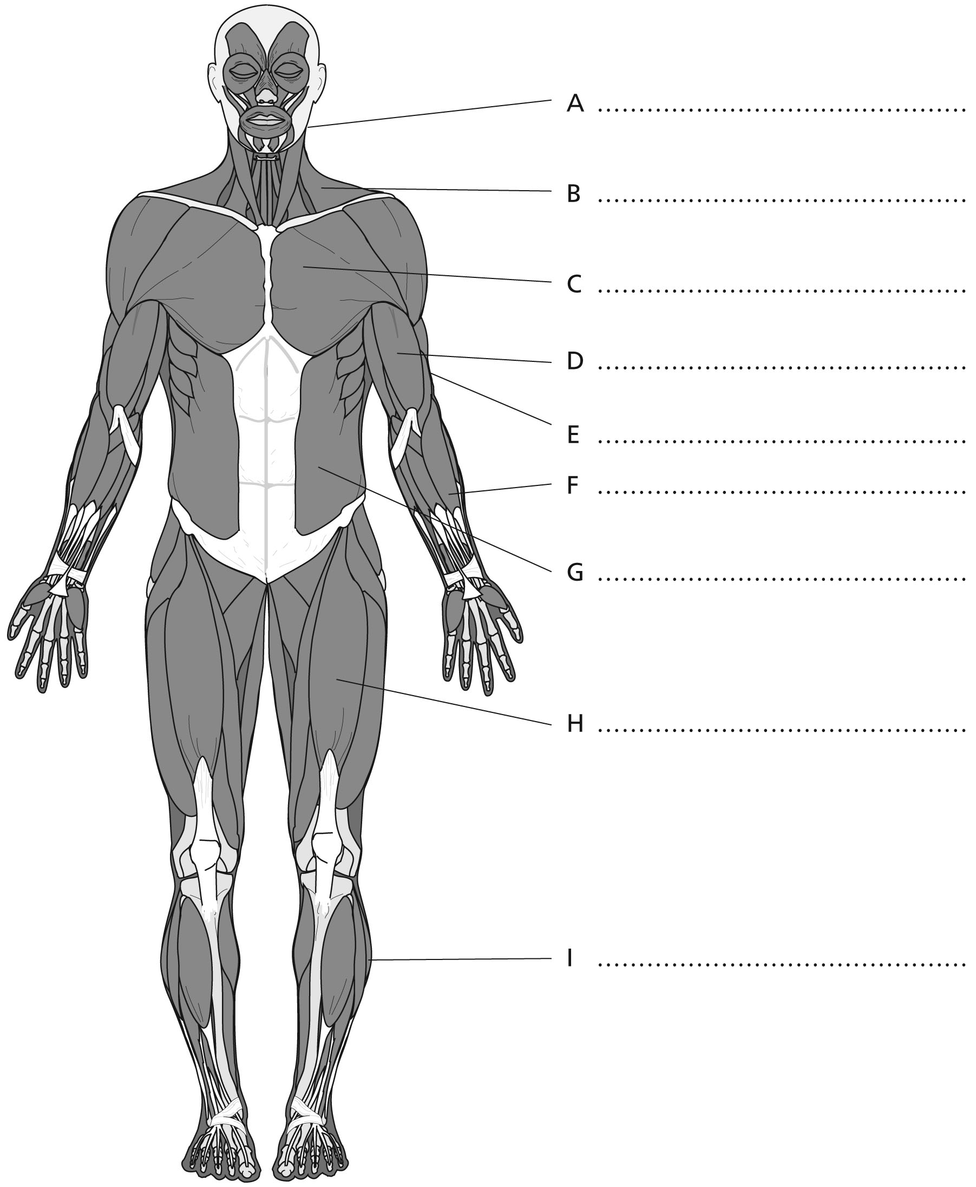

Worksheet 1.8.2 Understanding the role of skeletal joints

page 2/2

2 The roles of different joints >>
Give an example of where each type of joint a) to d) is found.
Then match up each joint with the movement it allows.

Type of joint | Type of movement
a) ball and socket joint  Example ………………………………….. | i) around an axis
b) hinge joint  Example ………………………………….. | ii) in one direction
c) pivot joint  Example ………………………………….. | iii) all directions
d) fixed joint  Example ………………………………….. | iv) none

3 Tendons, ligaments and cartilage >>>
Explain the importance of each of the tissues below, and suggest the consequences of not having each.
a) tendons
…………………………………………………………………………………………………………………
…………………………………………………………………………………………………………………
…………………………………………………………………………………………………………………
b) ligaments
…………………………………………………………………………………………………………………
…………………………………………………………………………………………………………………
…………………………………………………………………………………………………………………
c) cartilage
…………………………………………………………………………………………………………………
…………………………………………………………………………………………………………………
…………………………………………………………………………………………………………………

