Are you GCSE ready?
Test 3: Energy 1 – Energy costs and Energy transfer

  - Know
[Each question = 1 mark]

01. What unit is used on food labels to list the energy content of food?
- Newtons
- Kilowatts
- Kilojoules
- Kilograms

02. A quarterly home energy bill is £224. This covers 2190 hours at a price of 8 p per kWh. What was the average power used over the period?
- 1.28 kW
- 0.78 kW
- 1.28 kWh
- 0.78 kWh

03. What is the power of a device?
- The energy stored in the device.
- The maximum energy the device can transfer.
- The speed at which the device transfers energy.
- The energy required for the device to operate.

04. Which of the following is a renewable source of energy?
- Gas
- Coal
- Nuclear
- Biomass

05. Which of the following is a fossil fuel?
- Nuclear
- Biomass
- Crude oil
- Geothermal

06. What energy transfer takes place when a ball rolls down a hill?
- Kinetic energy to elastic energy.
- Thermal energy to kinetic energy.
- Kinetic energy to chemical energy.
- Gravitational potential energy to kinetic energy.

07. What energy transfer takes place when a kettle is boiled?
- Electrical energy to thermal energy.
- Chemical energy to thermal energy.
- Thermal energy to chemical energy.
- Electrical energy to chemical energy.

08. Which row in this table correctly shows the energy store, useful transfer and dissipated energy when a lightbulb is plugged into the domestic mains and turned on?

 | Energy store | Useful transfer | Dissipated energy
A. | Light | Electrical | Chemical
B. | Thermal | Electrical | Light
C. | Electrical | Light | Thermal
D. | Chemical | Light | Thermal

09. Which of the following transfers chemical energy to kinetic energy?
- An athlete
- A windmill
- A ball rolling downhill
- A battery operated torch

10. If a spring is compressed, what sort of energy is stored?
- Kinetic
- Elastic
- Dissipated
- Gravitational potential

  - Apply
11. Give two advantages and two disadvantages of using coal-fired power stations. Your answers may cover scientific, environmental or social factors. [4]

12. List the energy transfers involved when energy is produced in a hydroelectric power plant and used to run a hairdryer. [3]

13. Explain how energy is dissipated in these situations:
a. An accelerating car [1]
b. A hot cup of tea [1]
c. A swimmer [1]

  - EXTEND
14. Wind farms are a clean source of energy, but many people don’t want to live near one.
a. How would you persuade a government to invest in wind farms? [1]
b. How would you persuade a community that building a wind farm near them would be an asset to the area? [1]

15. Examine this chart which shows energy efficiency for different types of fuel.

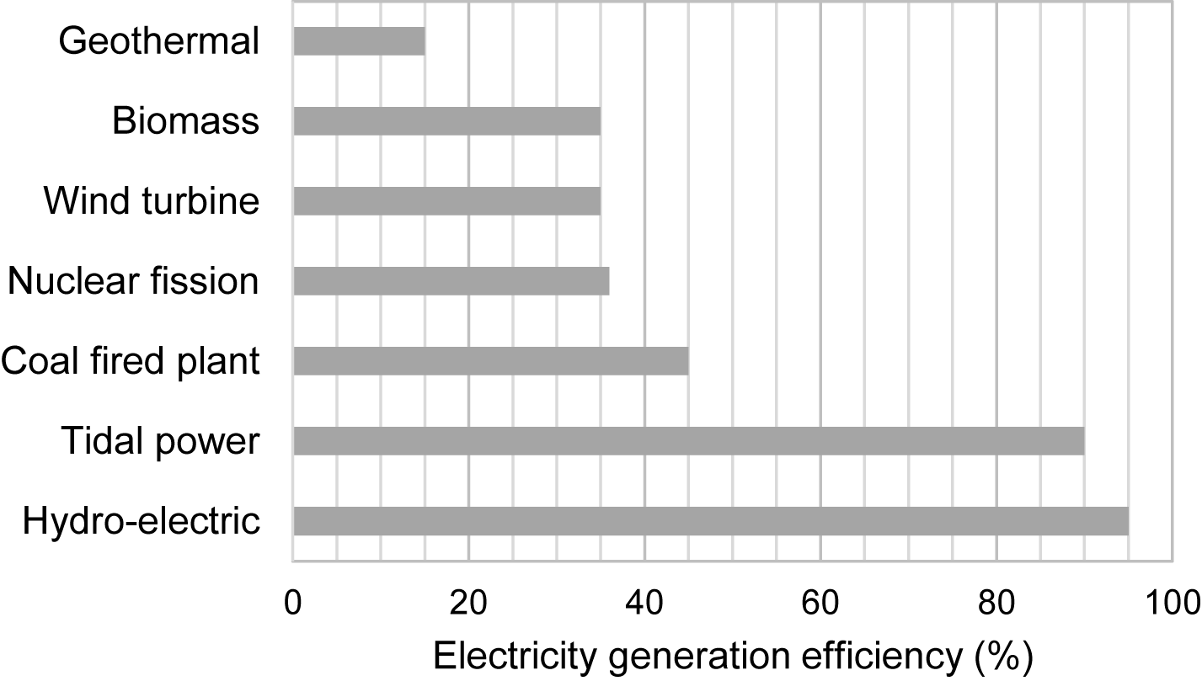

a. What is the equation used to calculate energy efficiency? [1]
b. Why is there a steep change in efficiency between the coal fired plant and the tidal and hydro-electric power stations? [1]
c. How much energy is output for every 1000 J input to a hydro-electric plant? [1]

