Worksheet 2.10.1 Explaining natural selection

page 1/4

1 Survival advantage >
Work with a partner to complete this task.
a) Explain why rabbits that can run very fast are more likely to survive.

b) Fill in the blanks in this table:
- Animal | - Adaptation | - Survival advantage
Giraffe | Long neck
Porcupine | Sharp, stiff quills
Squirrel |  | Means it can avoid winter food shortages
Dolphin |  | Helps it swim
Polar bear | Thick, white fur coat
Camel | Very large feet
Lizard | Able to play dead

Worksheet 2.10.1 Explaining natural selection

page 2/4

2 Explaining theories >>
You should work on your own to complete this task.
a) Outline Darwin’s theory of natural selection

Worksheet 2.10.1 Explaining natural selection

page 3/4
b) Complete the flow diagram by writing the missing statement in the correct box.
The missing statements are:
i) The adaptations are passed on to offspring.
ii) The accumulation of adaptations in a population may result in the evolution of a new species.
iii) These offspring have few or no offspring of their own.
iv) Some offspring inherit features (adaptations) that are an advantage.
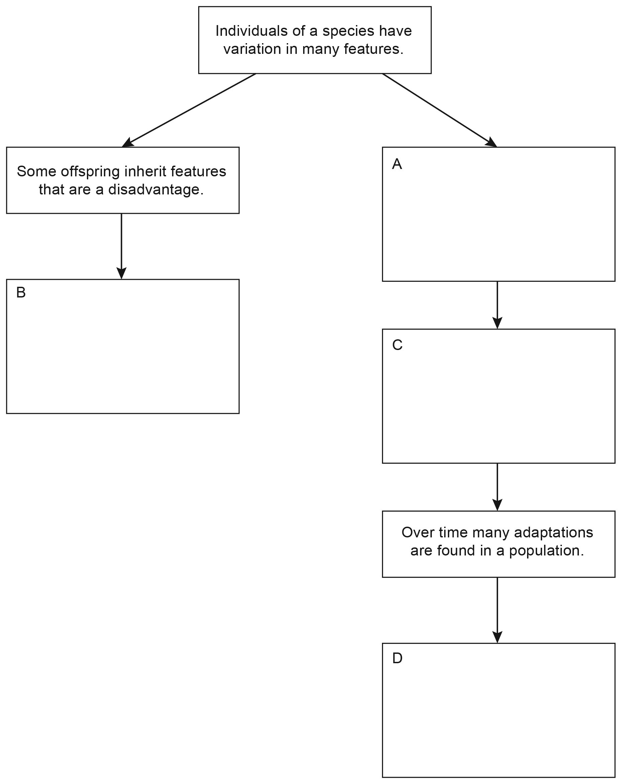

Worksheet 2.10.1 Explaining natural selection

page 4/4

3 Darwin’s finches >>>
Read this passage and then answer the questions with a partner:

Thousands of years ago a group of birds, called finches, were blown out to sea by a storm. They were lost but flew on in search of land.
The finches became exhausted, thirsty and hungry. Then, 600 miles from home, they found an island in the middle of the sea. The birds landed to rest, drink and feed before returning home, but they found that the island was perfect for their needs. It had lots of seeds and other food, plenty of shelter and nesting sites. There were also no predators or other birds to compete with. The finches stayed.
The finches bred and bred, and their population grew until the island could not provide sufficient resources for all of the birds. Some could not find enough food for themselves or their offspring, and young birds were driven away from areas where food was available by the more mature birds. Some birds flew across the sea to islands close by. These islands provided new territories, and again there were no predators or other birds to compete with. The plants and seeds on each island were slightly different. Some finches were better than others at finding and eating the new food sources. Finches that could break open fruits and eat the seeds survived and produced lots of offspring. Eventually, all the islands became occupied by the finches, but the birds had slightly different adaptations on each island.

a) Explain why some finches survived better than others on the same food sources.

b) Why did the finches have slightly different variations on each island?

c) Why were there no predators on the islands? Try to give two reasons.

d) Why was there no competition from other birds?

