Worksheet 2.10.2 Understanding the importance of biodiversity

page 1/2

1 High or low biodiversity? >
For each pair of images, identify which one has high biodiversity and which one has low biodiversity.
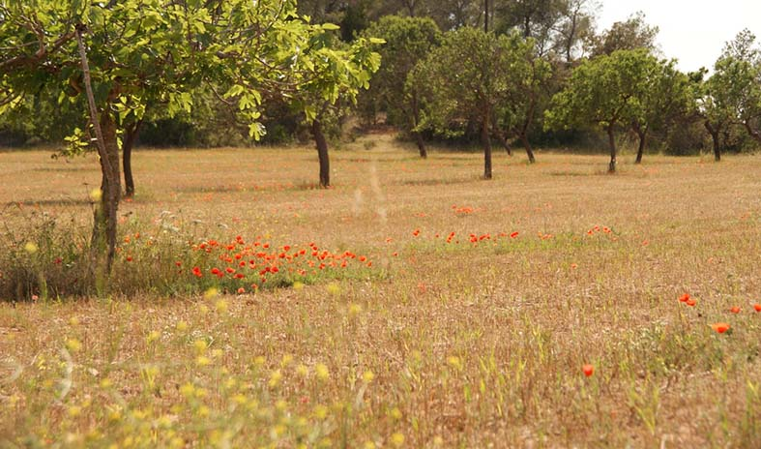
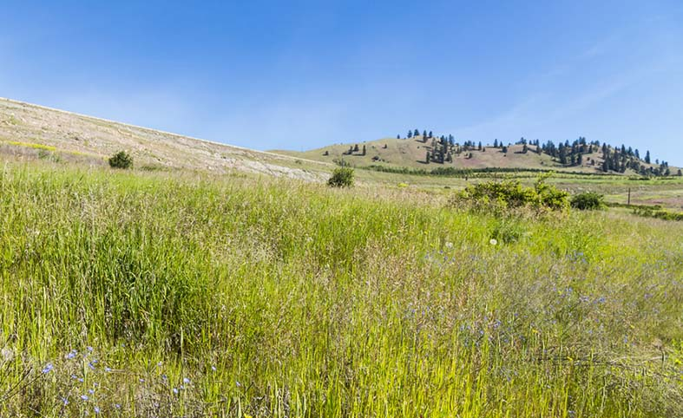
a)
[[Insert image i to

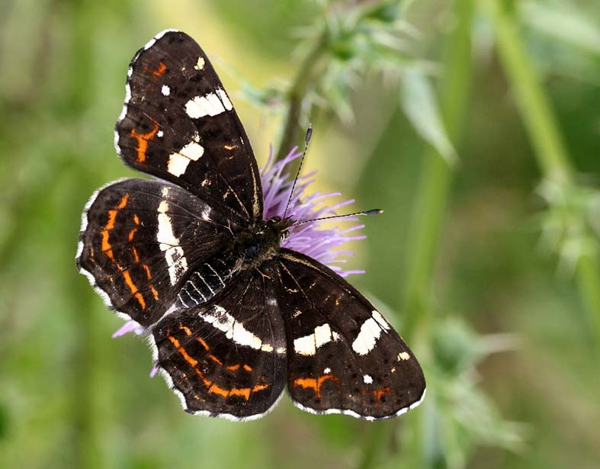
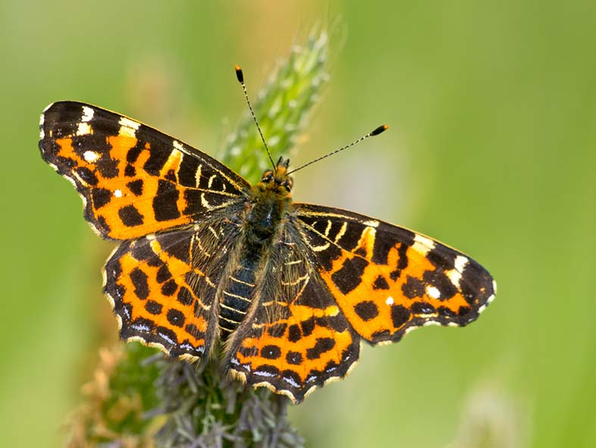
b)

c) Explain each of your answers to a) and b).

Worksheet 2.10.2 Understanding the importance of biodiversity

page 2/2

2 The importance of biodiversity >>
A housing firm has plans to build new properties on a woodland site. Write a letter explaining to the Company Director how these plans will affect the biodiversity of the area and why it is important to preserve the biodiversity.

3 Investigating biodiversity >>>
We can compare the biodiversity of different areas by estimating the number of different species in each area.
One way of doing this is to use a quadrat.
Plan how you would compare an area such as a playing field with an area such as a meadow.
How would you tell from your results which area had the highest biodiversity?

