Worksheet 2.4.4 Comparing transverse and longitudinal waves

page 1/2

1 Key words >
When we’re describing waves, there are certain words we need to understand and use. These definitions have got mixed up; see if you can sort them out:
Draw a line from the word to its definition.

a. transverse |  | A type of wave produced by supplying energy in the direction the wave travels in.
b. longitudinal |  | The distance from any point on one wave to the same point on the next wave.
c. compression |  | The number of waves produced per second.
d. amplitude |  | A type of wave produced by supplying energy at right angles to the direction of wave travel.
e. frequency |  | The distance from the midpoint of a wave to the top of a crest or bottom of a trough.
f. wavelength |  | An area in a longitudinal wave where the medium carrying the wave is squeezed together.

2 Labelling a compression wave >>
This is a drawing of a slinky with a compression wave travelling along it.

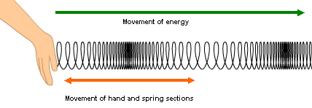

On the diagram, label:
- areas of compression
- areas of rarefaction (opposite of compression)
- distance to measure to find the wavelength.

Worksheet 2.4.4 Comparing transverse and longitudinal waves

page 2/2

3 Labelling a transverse wave >>>
This is a drawing of a slinky with a transverse wave travelling along it.

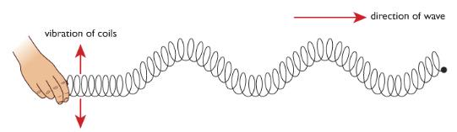

On the diagram, label:
- peaks
- troughs
- distance to measure to find the wavelength
- distance to measure to find the amplitude.

