Worksheet 2.10.6 Understanding variation

page 1/3

1 Inherited features >
Work on your own to complete this task.
a) For each feature, decide whether the trait is inherited, may be inherited, or is not inherited.
i) blood type ………………………………………
ii) immunity to chicken pox ………………………………………
iii) having heart disease ………………………………………
iv) being deaf ………………………………………
v) being left handed ………………………………………
vi) playing the guitar ………………………………………
vii) having freckles ………………………………………
viii) speaking English ………………………………………
ix) having attached ear lobes ………………………………………
x) height ………………………………………

Worksheet 2.10.6 Understanding variation

page 2/3

2 Explaining differences >>
a) Look at the family tree below:
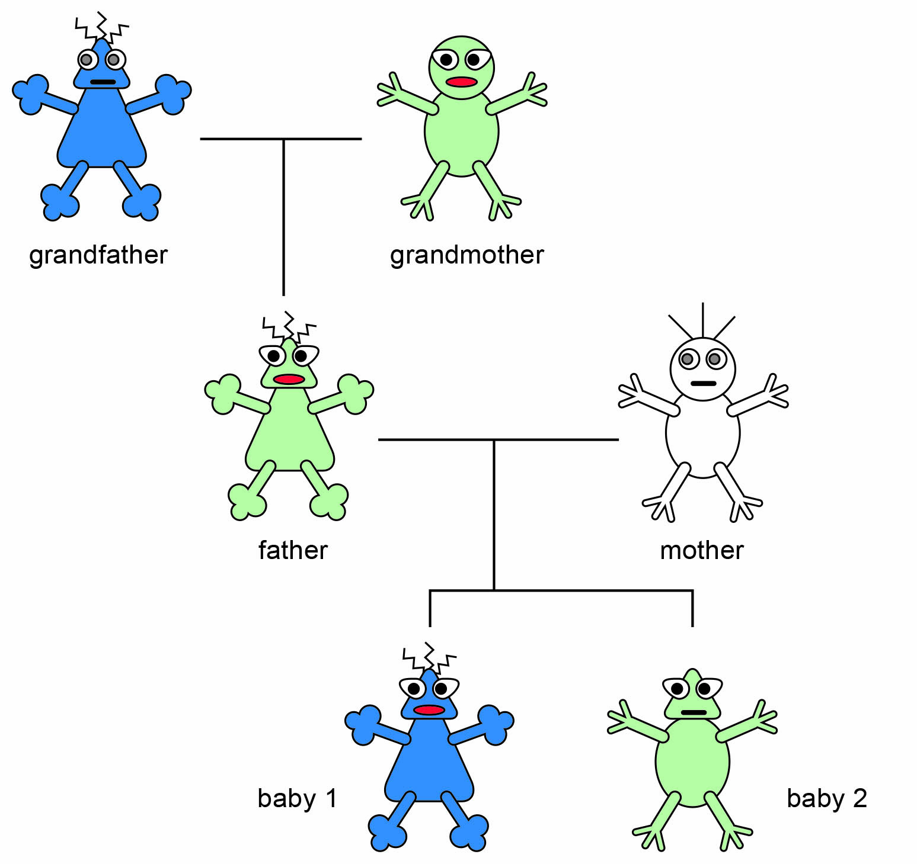

i) List the inherited traits of the creatures.

ii) Explain how the father inherited his:
eye shape:
curly hair:
iii) List the inherited features of baby 1, and who they are inherited from.

Worksheet 2.10.6 Understanding variation

page 3/3
iv) Why is baby 2 different from baby 1?

Work with a partner to answer these questions.
b) Explain why plants grown from the same parent plants are similar but not identical to each other.

c) Name the structures that carry genetic information.

3 Looking at twins >>>
Work with a partner to answer these questions.
a) Explain how identical twins arise and how conjoined twins arise.

b) Explain fully the reasons why identical twins are rarely exactly the same.

