Worksheet 2.3.1 Doing work

page 1/2

1 Where is work done? >
Look at the following situations and identify where work is done.
In the situations where work is done, draw an arrow on the picture to show the direction of the effort force and the distance moved.

a) Pushing a car b) Lifting a book up to put it on a high shelf
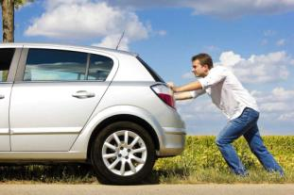

c) Standing carrying books d) Pushing against a wall e) Hitting a cricket ball
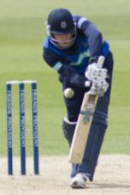
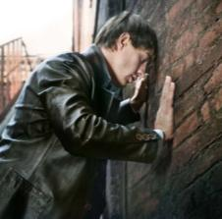

Work is done in……………………………………………………………………………………………………

2 Calculating work done >>
Work done = effort force × distance travelled in the direction of the force.

Work done is in joules, force is in newtons and distance is in metres.

Calculate the work done in each of the following situations:
a) A box of weight 35 N is lifted through a height of 2 m.
…………………………………………………………………………………………………………………

Worksheet 2.3.1 Doing work

page 2/2
b) If a suitcase of 25 N is dragged 5 m.
…………………………………………………………………………………………………………………
c) When a snooker ball is pushed with a force of 2 N and moves 1 cm whilst in contact with the cue. (Hint: be careful with the units.)
…………………………………………………………………………………………………………………

- Using a lever to reduce the effort >>>
a) A short screwdriver is used to lift the lid off a tin of paint. The force applied to the screwdriver handle is 10 N and the distance moved by the screwdriver handle in the direction of the force is 10 cm. What is the work done by the screwdriver?
…………………………………………………………………………………………………………………
…………………………………………………………………………………………………………………
b) The tin lid in part (a) moves a distance of 2 cm. What is the force applied at the lid to open it?
…………………………………………………………………………………………………………………
…………………………………………………………………………………………………………………
c) If the short screwdriver was replaced by a long screwdriver and the same force applied to the tin lid, would it be easier or harder to open the lid? Explain your answer.
…………………………………………………………………………………………………………………
…………………………………………………………………………………………………………………
…………………………………………………………………………………………………………………

