Worksheet 2.3.2 Making work easier

1 Increasing leverage >
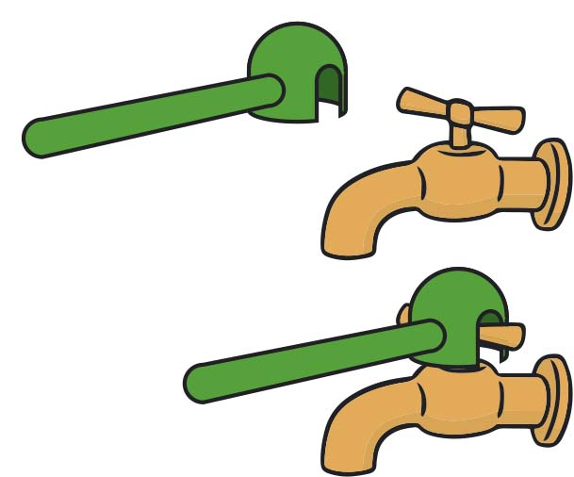
This machine here is an adaptation to a tap for someone who doesn’t have as much strength in their hands.
- How does this make it easier to turn the tap?
- What would happen if the lever was made even longer?
- Can you think of other situations around the home where increasing the length of the lever would make life easier for someone with little strength in their hands?

2 Using a jack >>
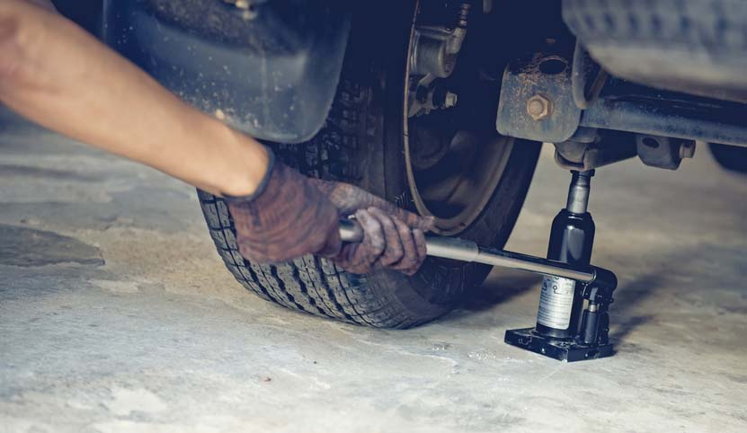
This machine is a jack. It is being used to lift up a car so that the wheel can be changed. The mechanic works the lever up and down; as they do so the car rises up. It’s much easier than trying to lift the car up with bare hands!
- The mechanic is pushing down on the handle with a force of 50 N and in one push moves the lever down 40 cm. Turn the distance into metres and calculate the work done on the jack.
- The jack applies a force of 1600 N on the car, moving it 1 cm. Calculate the work done on the car.
- Compare the force the mechanic applies to the jack with the force the jack applies to the car.
- Compare the distance the handle moves with the distance the car moves.

3 Lifting a crate >>>
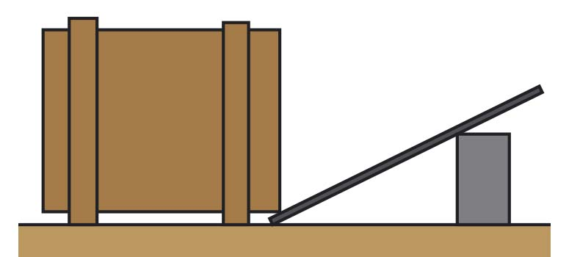
This is an attempt to set up a lever to help lift a heavy crate. The plan is to push down on the right-hand end of the lever to raise the crate up.
- Why would this not be successful in making job easier?
- What would you find if you tried using this?
- How could the arrangement be improved?

