Worksheet 2.4.1 Exploring sound

1 Displaying notes >

These four diagrams represent different notes:
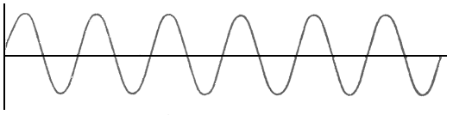
i)
ii)

iii)

iv)

Which of these is:
- a quiet low note? ………………
- a loud low note? ………………
- a quiet high note? ………………
- a loud high note? ………………

2 Echo-location >>
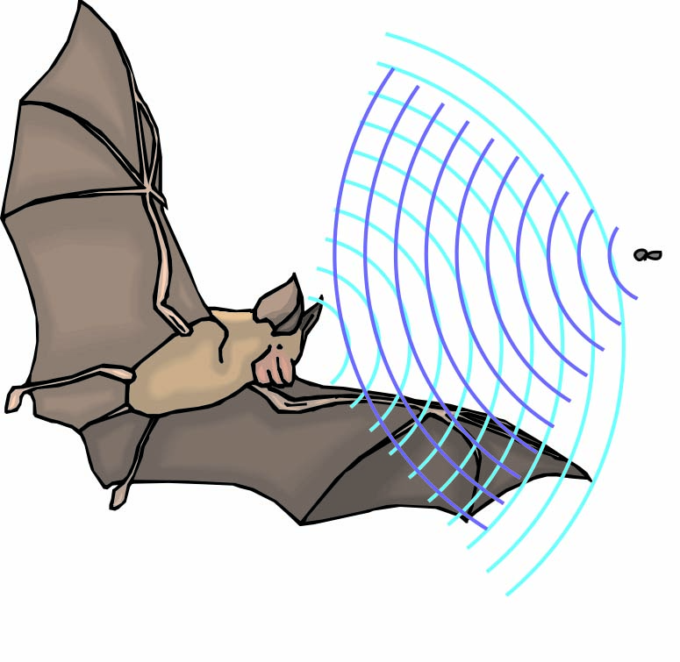
Bats locate their prey in the dark by echo-location. They emit sounds and use them to find the position of moths and other small animals.
- How does a diagram like this help to explain how they find their prey?

- How do they know how far away the moth is?

- Why can’t we hear these sounds?

- Cats can, however, hear these sounds. Why?

3 Cleaning up >>>
Explain why an archaeologist hoping to study some old coins to see where and when they were made might prefer an ultrasound cleaning process to other techniques.

