Worksheet 2.4.3 Exploring light

1 Mixing light >
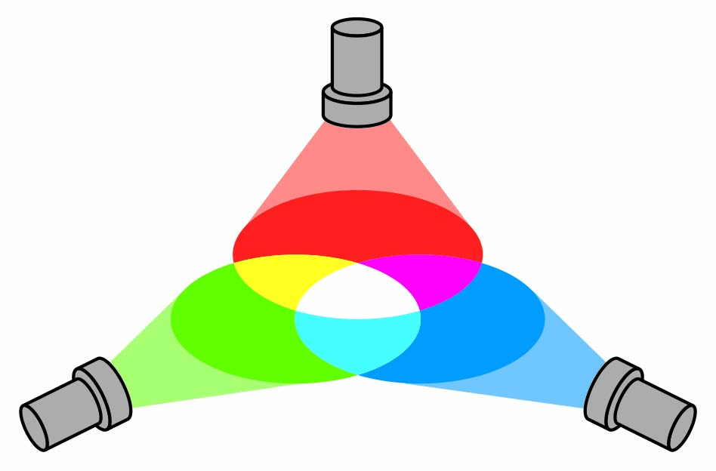
This diagram shows that if you shine red, green and blue light onto a white screen, you get white light.
Read each of these statements in turn and suggest whether the experiment supports it.
- Red, green and blue light combine to make white light.

- Red has a longer wavelength than green light.

- Mixing red, green and blue paint would give white paint.

- Mixing any three colours of light gives white light.

- White light is a mixture of other colours

2 Security pens >>
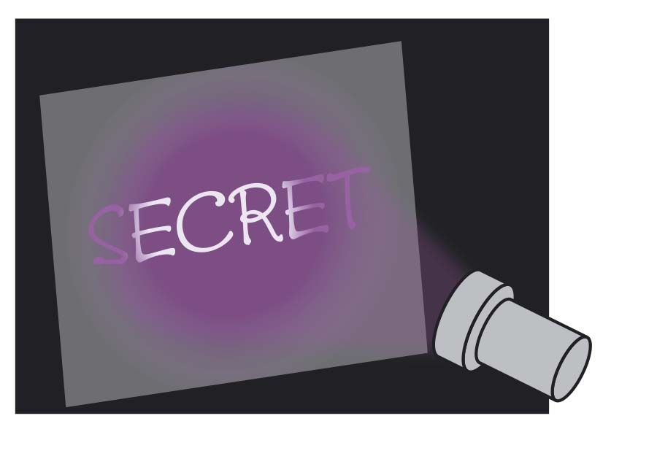
Ultraviolet security pens can be used for security marking. If you use one to write your name on something, the ink cannot be seen. However, if you shine UV light on it, you can read the writing. The ink can be seen glowing.
- How does this help with security?

- How does the wavelength of UV light compare with the wavelength of visible light?

- If UV light is shone on the ink, what changes when the light leaves the ink?

3 Sunbeds >>>
Some people like to use tanning beds to get a suntan.
- Why should their use be restricted to a few minutes each day?

- Why are users required to wear safety goggles?

- If their effect is similar to that of the sun why is there concern about the health of users?

