Worksheet 2.4.5 Exploring waves

page 1/2

1 Describe the movement of water in waves >
If you drop a pebble in a pond you see ripples of water.
Complete the sentences below, using the following words.

away bobs circles pass splash water

There is a …………………… . Ripples of water move away in …………………… from where the pebble hits the water. Anything floating on the pond …………………… up and down as the ripples …………………… but does not move …………………… from where the pebble hit the …………………….

2 Comparing waves in ropes and water >>
a) One end of a piece of rope is tied to a wall. A person holds the other end, pulls it so that it is not too loose and then gives it a quick jerk up and down.
Sketch a diagram to show what the rope looks like side-on before and after the jerk.

b) A shallow tank is half-filled with water. A wooden paddle is moved to create straight line ripples.
Sketch cross-sections of water in the tank before and after the ripples form.

c) Explain why waves through the rope and waves through water are both described as transverse waves.

Worksheet 2.4.5 Exploring waves

page 2/2
d) Describe the difference between the crests and the troughs of a transverse wave.

3 Transverse waves >>>
The diagram shows a transverse wave travelling through water.

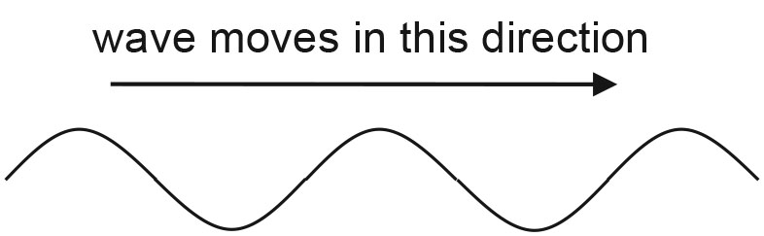
a) Make a sketch of a transverse wave that has a greater distance between crests than the wave shown in the diagram. Label this distance with its scientific name.

b) Make a sketch of a transverse wave that has the same distance between crests as the wave in the diagram, but that has much higher crests and deeper troughs. Label the height of a crest with its scientific name.

c) Outline an experiment you might carry out to show how these different waves might be created.

