Are you GCSE ready?
Test 17: Earth 2 – Climate and Earth resources

  - Know
[Each question = 1 mark]

01. Which of the following is a greenhouse gas?
- Oxygen
- Nitrogen
- Hydrogen
- Carbon dioxide

02. Which of these processes removes carbon dioxide from the atmosphere?
- Respiration
- Decomposition
- Photosynthesis
- Fuel combustion

03. What method of heat loss used by the Earth is reduced by greenhouse gases?
- Radiation
- Convection
- Conduction
- Combustion

04. How much carbon dioxide is in the Earth’s atmosphere?
- 4%
- <1%
- 21%
- 78%

05. Which of the following is a carbon sink?
- An ocean
- A cattle farm
- A landfill site
- A coal-fired power station

06. Which of these natural resources is a mineral?
- Oil
- Wood
- Water
- Iron ore

07. What method is used to extract reactive metals from their naturally-occurring ores?
- Electrolysis
- Combustion
- Carbon displacement
- Thermal decomposition

08. What is the key argument in favour of recycling metals?
- It is safer than mining.
- It is cheaper than extraction.
- It preserves natural resources.
- It is more energy efficient than mining.

09. What method is used to extract less reactive metals from their naturally-occurring ores?
- Electrolysis
- Combustion
- Carbon displacement
D. Thermal decomposition

10. Which of the following is not a natural resource?
- Oil
- Tin
- Coal
- Plastic

  - Apply
11. Label the arrows on this diagram to show the key processes in the carbon cycle:

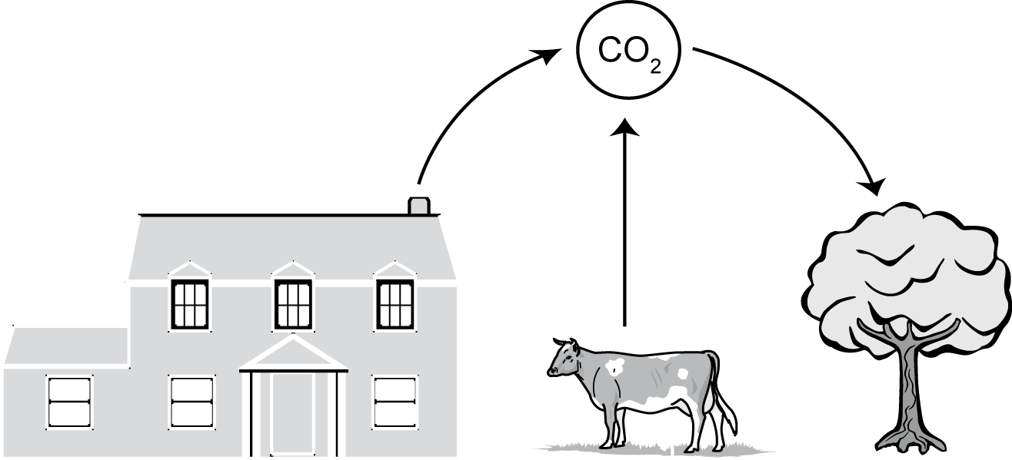 [3]

12. There are increased levels of greenhouse gases in the atmosphere. How has this had an impact on the temperature of the planet? [2]

13. For each of the materials below, give a reason why recycling is particularly important.
a. Aluminium [1]
b. Paper [1]
c. Plastic [1]

14. This chart shows the metal reactivity series, with non-metals in italics.

Potassium | most reactive
Sodium
Calcium
Magnesium
Aluminium
Carbon
Zinc
Iron
Tin
Lead
Hydrogen
Copper
Silver
Gold
Platinum | least reactive

a. Explain what method you would use to extract aluminium from its ore. [1]
b. Explain what method you would use to extract iron from its ore. [1]

  - EXTEND
15. This graph shows the global temperature since the year 1000 AD relative to the average global temperature between 1856 and 1995. It also shows the carbon dioxide levels in the atmosphere over that time:

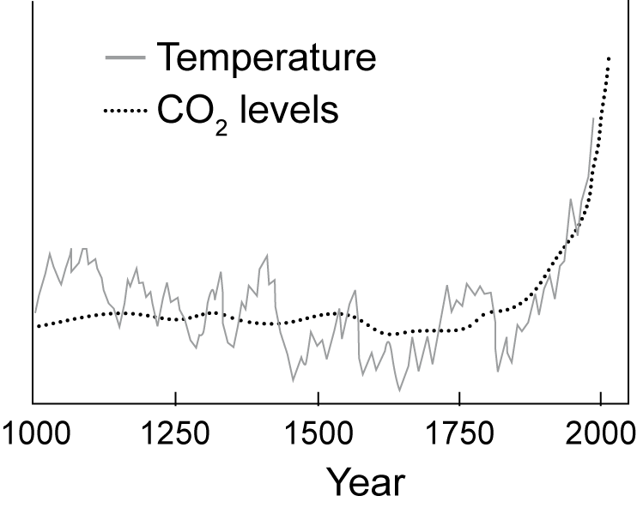

a. Use the graph to explain claims that human activity is causing global warming. [1]
b. Explain why having data over such a large number of years increases the accuracy of the conclusion. [1]

16. Give three ways in which individuals could change their behaviour to reduce consumption of natural resources. [3]

