Strong and weak acids: Worksheet 4.10

Titration curves
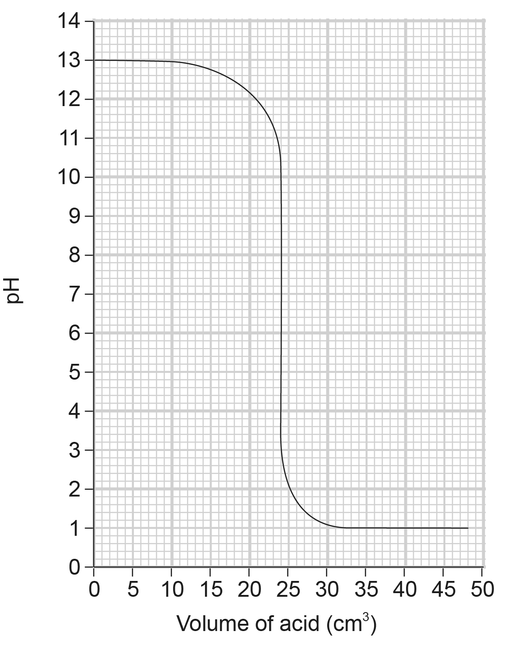
Some students measured 25 cm³ of 0.1 mol/dm³ sodium hydroxide solution into a conical flask. They swirled the flask as hydrochloric acid was added 1 cm³ at a time, and monitored the pH of the mixture.
The titration curve they obtained was:

- Which ion from the sodium hydroxide causes the high pH at the start?

- What reaction takes place as the hydrochloric acid is added?

- Add labels to the titration curve to show what is happening in each part of the graph.
- What volume of acid was needed to neutralise the 25 cm³ of sodium hydroxide?

- Was the acid more or less concentrated than the sodium hydroxide?

- How would that last part of the curve change if ethanoic acid (a weak acid) was used?

- How would that first part of the curve change if a weak alkali was used?

