The process of electrolysis: Worksheet 4.11

Moving ions
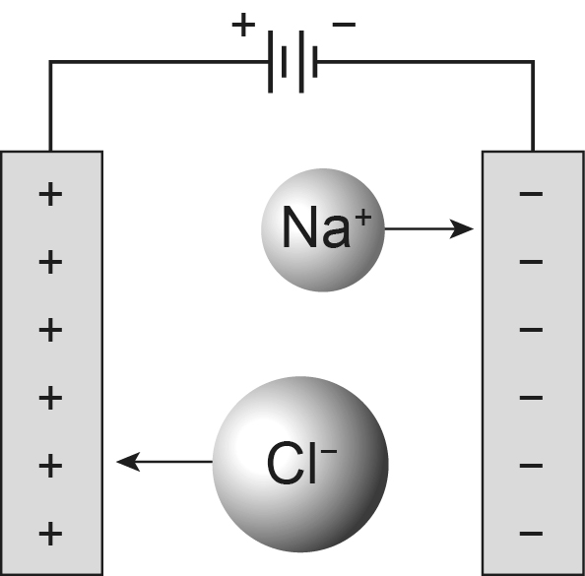

- Molten sodium chloride is an electrolyte, which means it contains ions that can move around, and the compound is broken down as the electric current passes through it. Explain why solid sodium chloride is not an electrolyte and does not conduct electricity.

- Label the cathode, the anode, an anion and a cation in the diagram.
- When a sodium ion, Na⁺, reaches the negative electrode it becomes an atom. Explain how this happens.

- What happens to chloride ions, Cl⁻, when they reach the positive electrode?

- Suggest why the electrolysis of molten compounds is sometimes called ‘electrolytic decomposition’.

- Molten lead bromide is an electrolyte. Predict what would form at each electrode if a current was passed through it.

