Reaction of metals with acids: Worksheet 4.5.1

Making a salt
Many metals can displace hydrogen from acids to form salts. An excess of the metal is added to make sure that all the acid reacts. Then the excess metal is filtered out to leave a neutral solution.
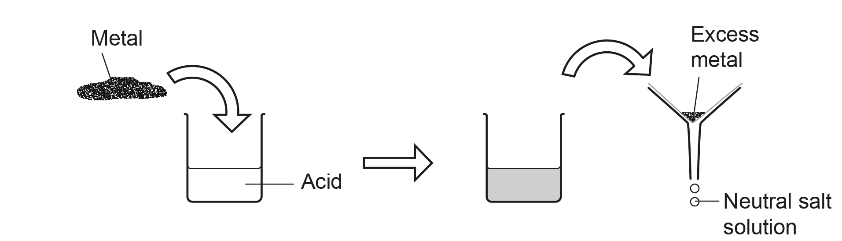

- What is the same about the formulae of these acids:
hydrochloric acid, HCl
sulfuric acid, H₂SO₄
nitric acid, HNO₃?
- What gas is given off when metals react with these acids?
- Explain why the metal is added until the acid stops fizzing.

- How is the salt solution that is formed separated from excess metal?

- How can you get crystals of the salt from the solution?

- Complete these equations:
a. zinc + hydrochloric acid →
b. magnesium + sulfuric acid →
c. hydrochloric acid + iron →

