Neutralisation of acids and salt production: Worksheet 4.6.1

Making sodium chloride
The apparatus shown below can be used to prepare sodium chloride crystals.

- Label the burette, measuring cylinder, conical flask, evaporating basin and crystallising dish.
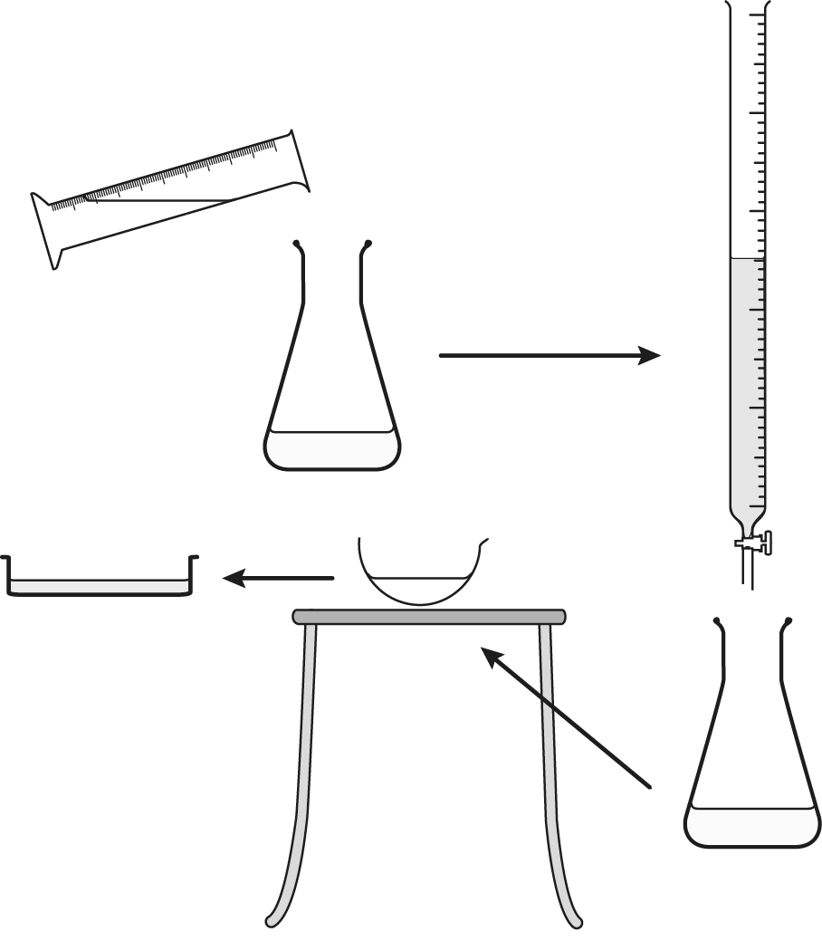

- Label the sodium hydroxide solution, hydrochloric acid and neutral salt solution.

- Explain how you would know when the sodium hydroxide has been neutralised.

- Explain why two equal volumes of sodium hydroxide need to be neutralised – one with indicator in it and one without indicator.

