Soluble salts: Worksheet 4.7.1

Making copper sulfate
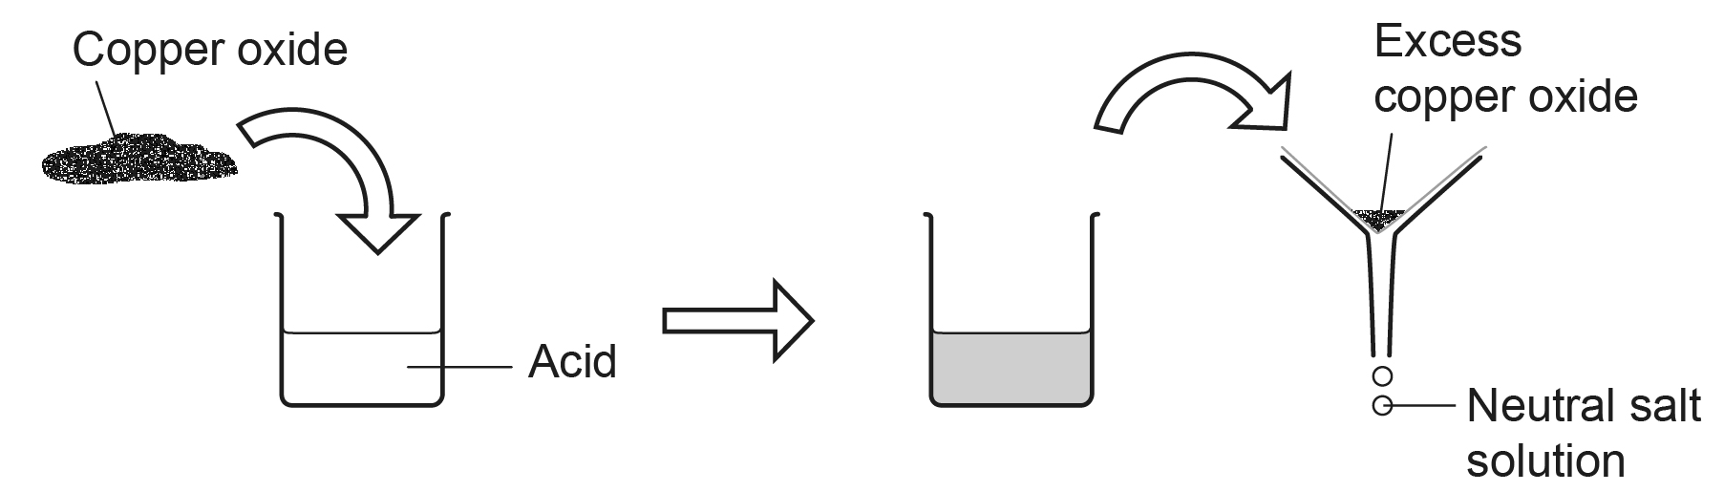
Some metal oxides are insoluble bases. Insoluble bases react with acids but do not dissolve. If too much of the base is added, the excess will not react. It can be filtered out to leave a neutral solution.

- What type of compound is copper oxide?
- Why does the acid mixture turn black if too much copper oxide is added?

- What forms when copper oxide reacts with sulfuric acid?
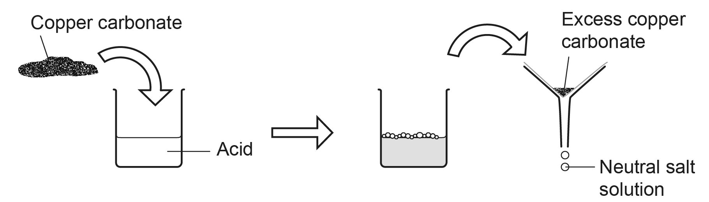

- Insoluble metal carbonates also react with acids. Compare the way copper carbonate and copper oxide react. What is the same about their reactions with acids – and what is different?

