Soluble salts: Worksheet 4.7.2

Equations
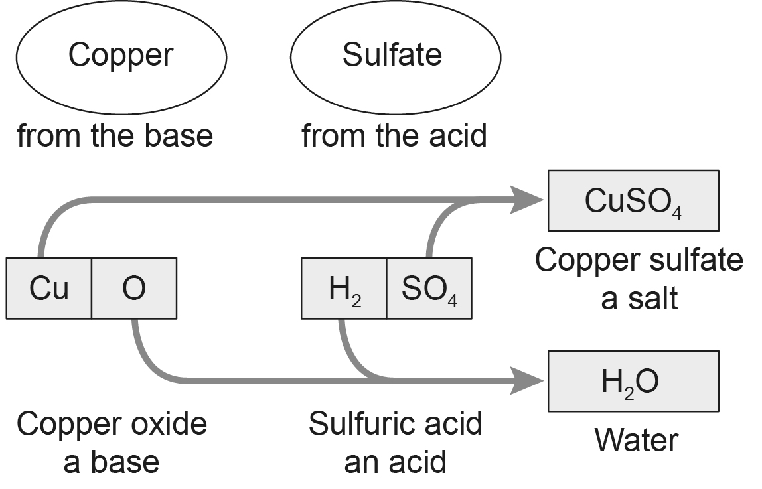
Salt names have two parts – the first part comes from the base or carbonate used to make it; the second part comes from the acid used. For example, when copper oxide reacts with sulfuric acid, the salt made is copper sulfate:

- Chlorides are made using hydrochloric acid.
- Sulfates are made using sulfuric acid.
- Nitrates are made using nitric acid.
Insoluble bases react like copper oxide:
- CuO + H₂SO₄ → CuSO₄ + H₂O
- CuO + 2HCl → CuCl₂ + H₂O
Carbonates react like copper carbonate:
- CuCO₃ + H₂SO₄ → CuSO₄ + H₂O + CO₂
- CuCO₃ + 2HCl → CuCl₂ + H₂O + CO₂

Write symbol equations for the reactions that occur between these pairs of reactants.
- magnesium oxide + hydrochloric acid
- zinc oxide + sulfuric acid
- magnesium oxide + sulfuric acid
- calcium carbonate + sulfuric acid
- zinc carbonate + hydrochloric acid
- magnesium carbonate + sulfuric acid
- magnesium carbonate + hydrochloric acid

