pH and neutralisation: Worksheet 4.9

Neutralisation
- Which ion is present in both of these acids: hydrochloric acid (HCl) and sulfuric acid (H₂SO₄)?

- Which ion is present in both sodium hydroxide (NaOH) and potassium hydroxide (KOH)?

- This equation shows a neutralisation reaction:

hydrochloric acid + sodium hydroxide → sodium chloride + water
(acid) (alkali) (neutral salt)

Explain how water is formed when the acid and the alkali react.

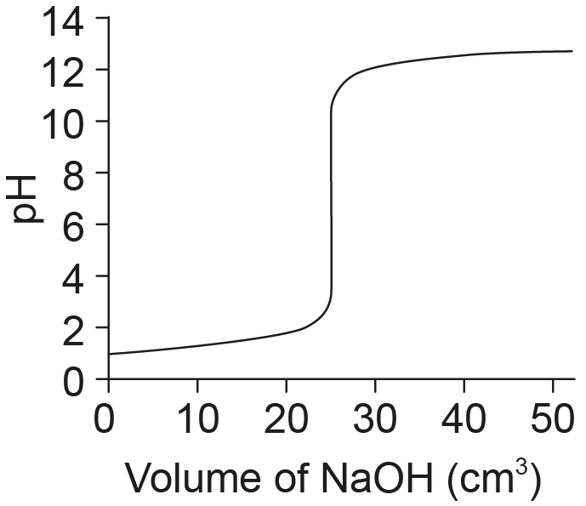
- The graph shows how the pH of the mixture changed when 0.1 mol/dm³ sodium hydroxide was slowly added to 25 cm³ of 0.1 mol/dm³ hydrochloric acid.

  - What was the pH of the acid at the start?

  - What volume of sodium hydroxide was needed to neutralise all the acid?

  - A neutralisation reaction can be written as an ionic equation. This shows only the ions that neutralise each other – the hydrogen ions from the acid and the hydroxide ions from the alkali:
hydrogen ions + hydroxide ions → water
Convert this into a symbol equation and add state symbols to show that the ions are dissolved in water but the product is water itself.

