Electrolysis of molten ionic compounds: Worksheet 4.12

Electrolysis of molten ionic compounds
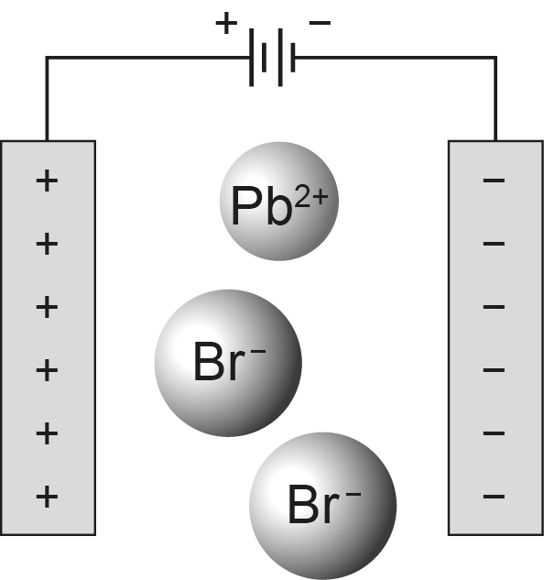

- Add arrows to the diagram to show which way each type of ion moves.
- Add labels to show which electrode is the anode and which is the cathode.
- Name the electrolyte. __________________________________________________________
- Name the cation in the electrolyte and explain what happens to it when the power supply is switched on.

- Explain why this electrolysis should be carried out in a fume cupboard.

- Describe what you would see at each electrode during the electrolysis.

