Using electrolysis to extract metals: Worksheet 4.13

Extracting aluminium

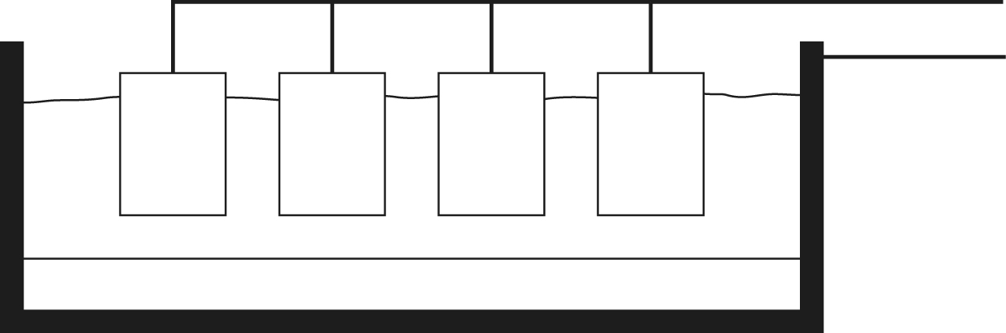

- The diagram shows some electrodes being used to extract aluminium from bauxite. Add labels to show:
a. the carbon cathode where aluminium forms
b. the carbon anode where oxygen forms
c. the electrolyte – aluminium oxide dissolved in molten cryolite.

- Explain why aluminium cannot be extracted by heating its ore with carbon.

- Why is the aluminium oxide dissolved in cryolite?

- The carbon anodes are replaced regularly. Explain why.

- Describe what happens to the ions as aluminium oxide is electrolysed – key words to use are anode, cathode, electrons, gain, lose, ion, atom.

