Electrolysis of aqueous solutions: Worksheet 4.14

Electrolysis of copper(II) sulfate
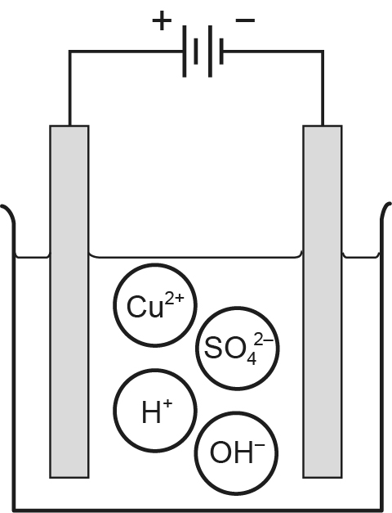
This apparatus was used to electrolyse a solution of copper(II) sulfate

- A solution of copper(II) sulfate contains four different ions – two from the copper(II) sulfate itself and two from the partial ionisation of water. Which two ions are attracted to the cathode?

Electrolysis turns one type of ion into atoms preferentially at each electrode.

- Which ion is turned into neutral atoms at the cathode?

- Explain what happens at the anode.

- How could you identify the element released at the anode?

- As electrolysis continues, the solution becomes more and more acidic. Explain why.

