Metal oxides: Worksheet 4.1.1

Oxidation and reduction
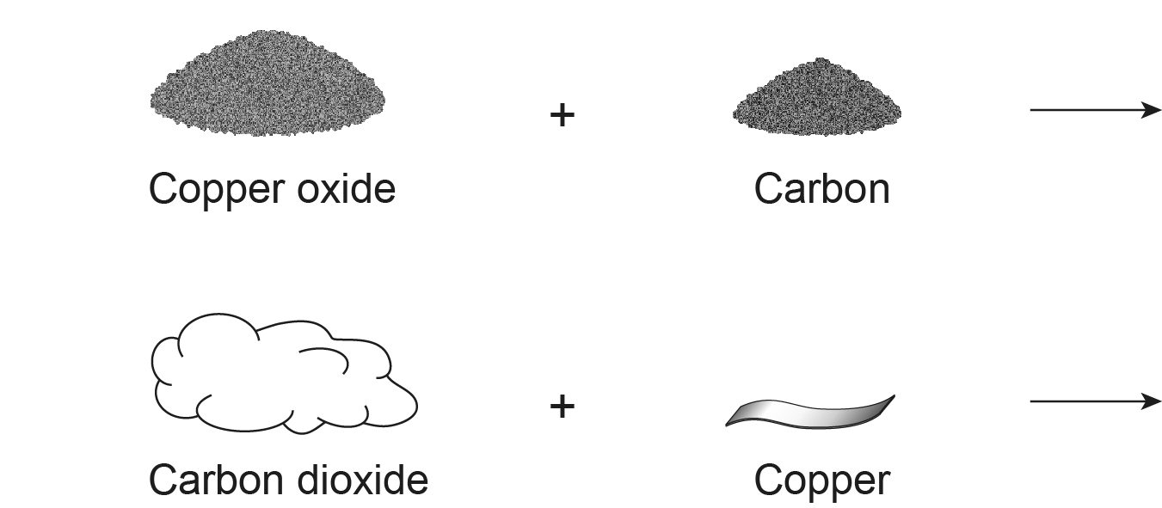

Extracting copper from copper oxide is reduction, because oxygen is removed from the metal. The particle picture below shows what happens to the atoms.

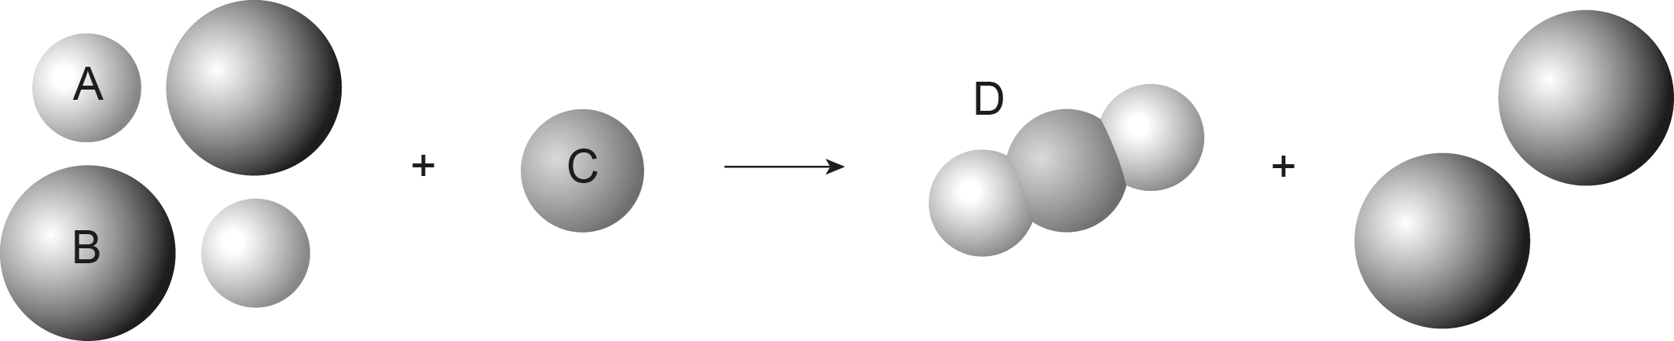

- Identify atoms A, B and C and then molecule D.

- Convert the particle picture into a balanced symbol equation.

- Which element is oxidised during the reaction? Explain why.

- Which substance is reduced? Explain why.

- If a piece of copper is heated the atoms on the surface react with oxygen from the air to form black copper oxide. Draw a particle picture for this reaction, and write a balanced symbol equation.

